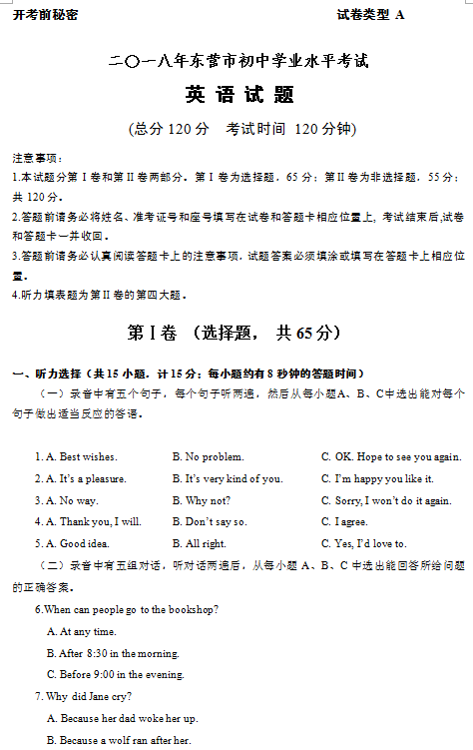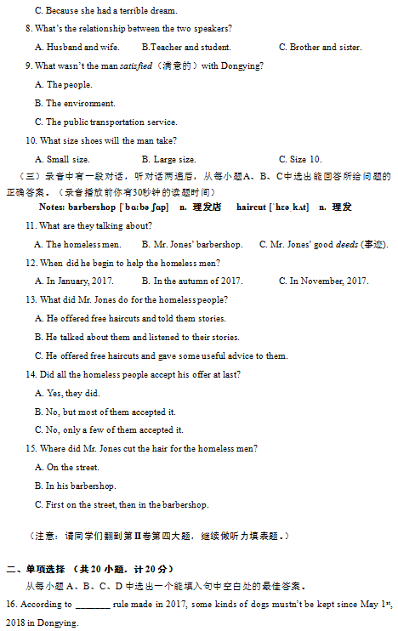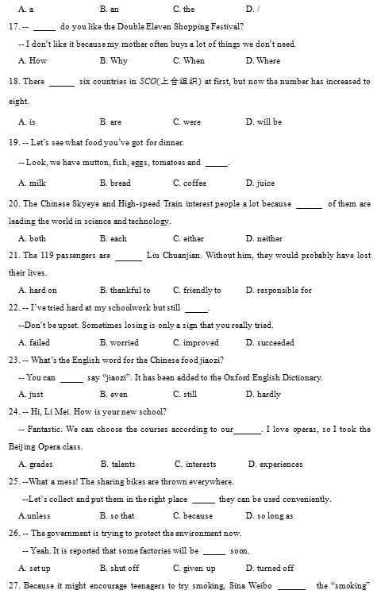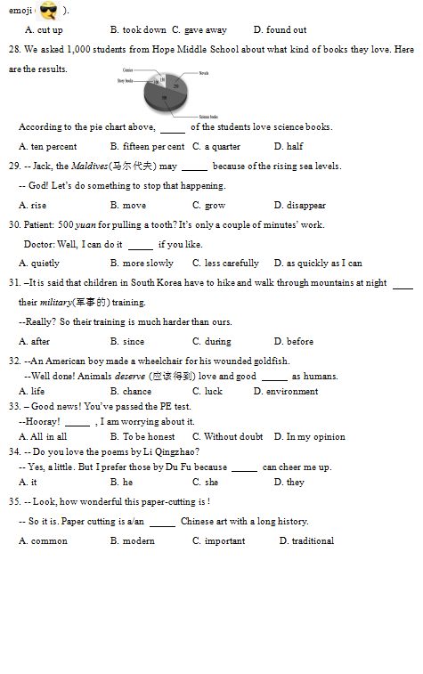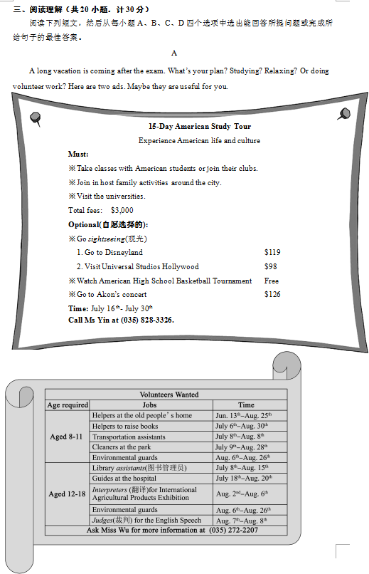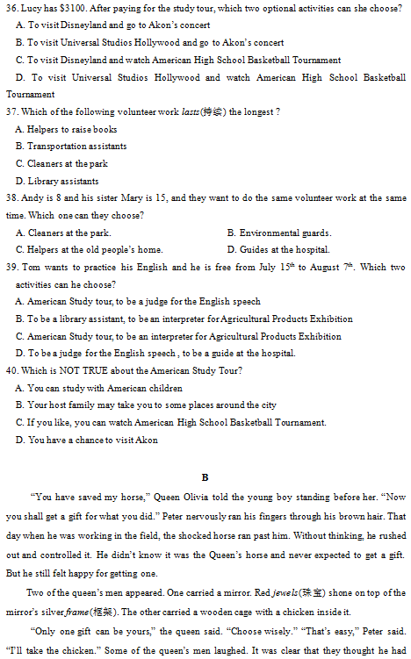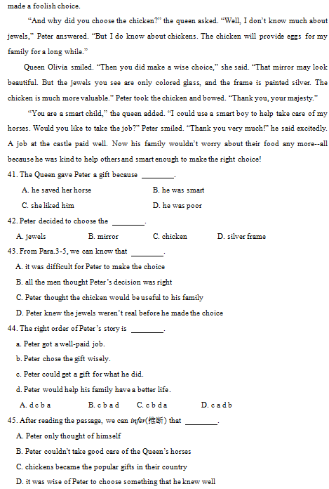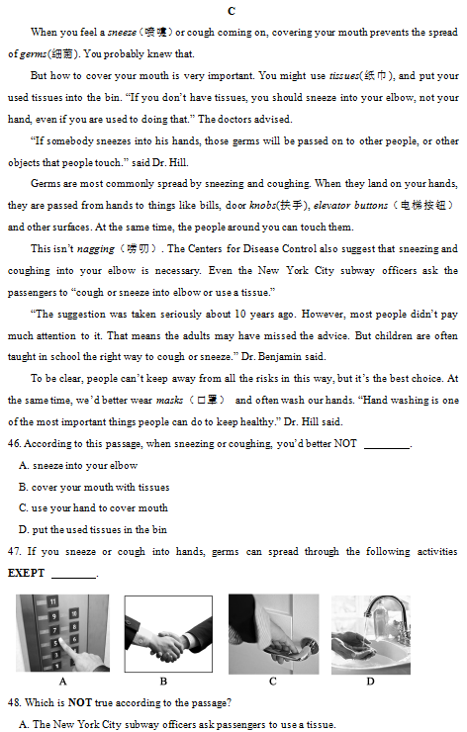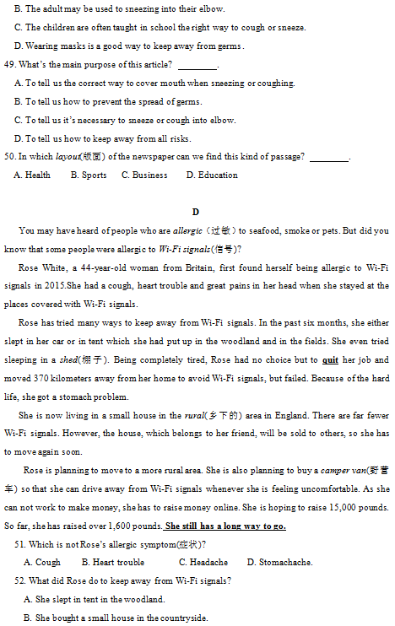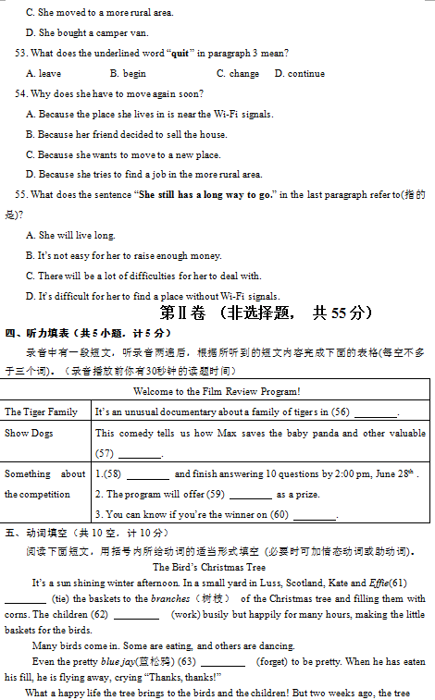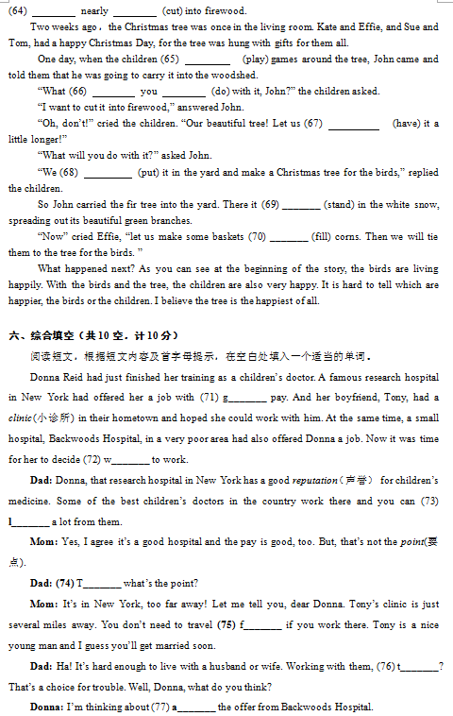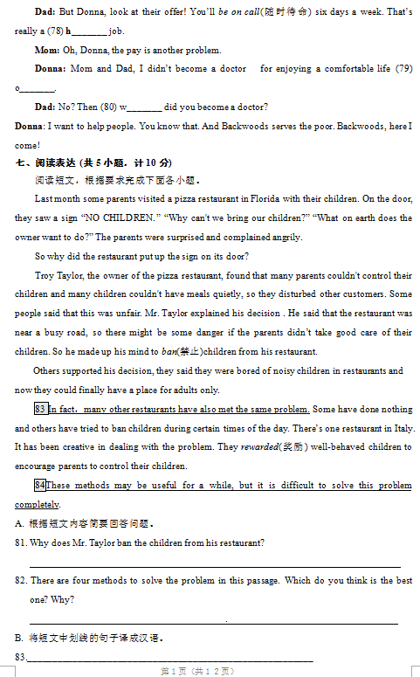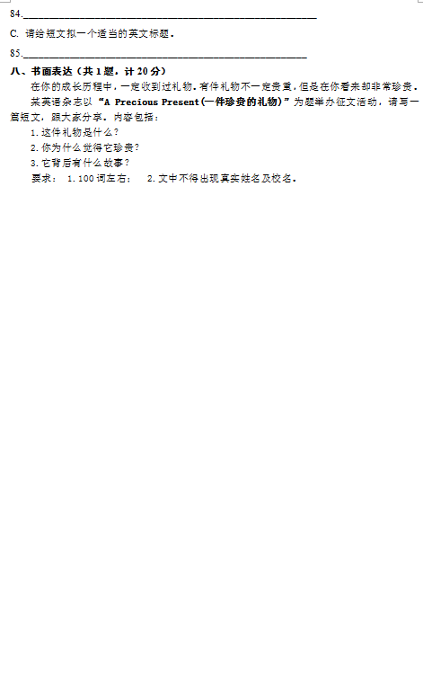

英语试题参考答案及评分标准

第 I 卷 （选择题, 共65 分）
一 ～ 三题
(一) 一 ～ 三题答案：
1-5 CACAB 6-10ACBCB 11-15 CACBC 16-20 CACBA 21 -25 BAACB 26-30 BBDDB 31-35 CABDD 36-40DABCD 41-45 ACCBD 46-50 CDBBA 51-55 DAABC
(二) 评分说明：
1、1-35题，每小题1分;
2、36-55题，每小题1.5分；
3、与答案不符, 不得分。
第 II 卷 （非选择题, 共55分）
四、听力填表
(一) 答案：
56. India 57. animals 58. Go online 59. cinema tickets 60. June 30th
（二）评分说明:
1、本题共5分，每小题1分；
2、与所给答案不符，只要语法、意义、拼写（含大小写）正确，符合逻辑及英语表达习惯也可得分；
3、若大小写错误出现1-3处，都扣0.5分。
五、动词填空
(一) 答案:
61. are tying 62. have worked/ have been working 63. forgets 64. was; cut
65. were playing 66. will; do / are;going to do 67. have 68. can /will put
69. stood 70. to fill
(二) 评分说明：
1、本题共10分，每空1分;
2、未用所给动词者，不得分；
3、与所给答案不同，只要语法正确,也可得分。
4、第62，66，68小题，答上所给答案的任何一种即可得分。
六、综合填空
(一)答案:
71. good 72. where 73. learn 74. Then 75.far
76. too 77. accepting 78. hard 79. only 80. why
(二) 评分说明：
1、本题共10分，每空1分;
2、与所给答案不符，只要语法、意义、拼写正确，符合逻辑及英语表达习惯也可得分；
七、阅读表达
(一)答案:
81. ① Because those noisy children disturbed other customers. And the restaurant was near a busy road, there might be some danger. ②Because many parents couldn’t control their children. And the restaurant was near a busy road, there might be some danger. ③Because many parents couldn't control their children and many children couldn't have meals quietly, so they disturbed other customers. And the restaurant was near a busy road, there might be some danger.
82. ①This way can avoid noisy children disturbing other customers./ This way can help the adults have meals quietly.
②Do nothing. The restaurant is a public place, everybody should be allowed to go in.
③Ban children during certain times of the day. I think people can choose the right time to go to the restaurant according to their needs.
④Reward well-behaved children. This way can encourage parents to control their children.
/ This method can encourage children to behave well.
83.事实上，其他一些餐厅也遇到了同样的问题。
84.这些方法在一段时间内可能有用，但很难彻底解决这些问题。
85. ①Ban or Allow
②Methods to Deal with Noisy Children in the Restaurant
③NO CHILDREN
④Ways to solve the problem
(二)评分说明：
1、本题共10分，每小题2分；
2、第81题，答出①②③中的两个要点，得2分；若只答出其中的一个要点, 得1分。
第82题，答出任何一种办法得1分，只要能给出合理的理由，可再得1分。如果有少量语法错误，只要能达意可以不扣分。
3、第83、84题，若与答案表达方式不同，但与所给参考答案意思一致，符合汉语表达习惯，也可得分；
4、第85小题，⑴答①②中的任何一个，都可以得2分；答③④中的任何一个，得1.5分。
⑵ 若与答案表达方式不同，但与所给参考答案意思一致，无语言错误，符合英语表达习惯，也可得分。
八、书面表达
A possible version
A precious present
The title “A Precious Present” reminds me of quite a few gifts I’ve got. Yet, the first come to my mind is the book, the Adventures of Tom Sawyer.
On my tenth birthday, my father gave it to me as a gift. Because I didn’t like reading, I put it on the bookshelf. One boring day, I picked it up and looked through it. Unexpectedly, the story interested me greatly. I found pleasure in reading books. From then on, I became fascinated in reading.
Though the book is not valuable, it’s precious. I’ll regard it as a treasure forever.
(二) 评分说明：
评分时，要从内容与结构、表达的逻辑性、层次性、连惯性和创造性、语法运用的恰当程度、单词拼写、标点符号的使用等方面综合考虑。本题共20分，分四档评分：
１、短文通顺完整，表达清楚, 语言基本无误，17－20分；
２、短文较通顺完整，表达基本清楚，语言有少量错误，12－16分；
３、能写明基本要点，短文不够通顺完整，语言有较多错误，但尚能达意，6－11分；
４、仅能写明部分要点，短文不完整，语言错误多，影响意思表达，0－5分。

