各位同学在查看时请点击全屏查看

2017年威海市中考英语试题
英 语
2017年威海市中考英语试题注意事项：
1本试卷共8页，共8 0分。考试时间9 0分钟。考试结束后，将本试卷和答题卡一并交回。
2答题前，考生务必用0.5毫米黑色签字笔将自己的姓名、考生号、座号填写在答题卡和试卷规定的位置上。
3需要涂卡的小题，选出答案后，用2B铅笔把答题卡上对应题目的答案标号涂黑；如需改动，用橡皮擦干净后，再选涂其他答案标号，答案选在试卷上无效。
4非选择题必须用0. 5毫米黑色签字笔作答，答案曲颁写在答题卡指定区域内相应的位置，写在试卷上的答案无效：如需改动，先划掉原来的答案，然后再写上新的答案；不能使用涂改液、胶带纸修正带，不按以上要求作答的答案无效。
一、2017年威海市中考英语试题阅读理解（共五篇短文，共25小题，计30分。其中1~20每小题1分；21~25每小题2分）阅读A、B篇，从文后每小题A、 B、C选项中选择最佳答案。请将答案编号涂卡。
A
Mr and Mrs Albina, with 64 children, have the world’s largest family. Not one of their
children is adopted（领养）.
When people hear about the Albinas’ large family, the first question they ask is, "How is it
possible? How can one woman give birth to 64 children in her lifetime?" The answer ls simple:
Every time Mrs Albina gave birth, she had twins or triplets.
Soon after the Albinas got married the children came quickly,in twos and threes. The first 21
children were boys. Mrs Albina loved her sons, but she wanted a daughter very much.
The Albinas spent the early years in Argentina. Then they decided to move to Chile. To travel
from Argentina to Chile, they had to cross the Andes Mountains. Mr and Mrs Albina and their 21 sons made the difficult, two-week joumey on mules. One night there was a tarible snowstorm in the mountains. During the snowstorm, Mrs Albina gave birth to triplets,a boy and-two girls!
The oldest Albina children are in their thirties and forthies. They are on their own now, but 18 of the Albina children still live with their parents The fa:mily lwes in a two-room shack in Colina Chile The shack has electncity but no toilet or running water The children wash in a small bowl in the dusty backyard.
At times there is very little food in the Albinas’ small house When thcre is not cnough food
for everyone, Mrs Albina makes sure the youngest children do not go hungry. "The smallest eat
rirst, and then the bigger ones We’ve always done it that way," she says. Obviously, the Albinas
do not have enough money for their big family Why, then, do thcy continue to have children?
The Albinas do not use birth control because itls against their religion (宗教）They could
let other people take care of their children, but Mrs. Albina will not allow lt "When my two brothers and l were babies: she says，’’our mother left us at an orphanage（孤儿院）and never
retumed We lived there together until we were five Then a couple adopted my brothers, and 1
was left belund l was heartbroken I promised myself that whenI became a mother,l would never
give my children away. Even ifI didn’t have much ruoney,1 would always take care of my children myself“Mrs Albina has kept her promise.
l. How many people are there in the world’s largest family?
A. 66: a mother, a father and their 64 adopted children.
B 66: a mother, a father and their 64 children.
C. 23: a mother, a father and their 21 sons.
2. All ofthe Albina children are .
A. Iivirig in Argentina B. in their thirties and forties C. twins or triplets
3. The Albina family is .
A. poor B. middleclass C.rich
4. The Albinas do not use birth control because .
A. they want to have as many children as possible
B. thcy don’t know about birth control
C. it is against their religion
5. Mrs Albina will not let other people take care of hcr children because_______.
A. she is afraid other people won’t take good care of them
B. she promised that she would always take care of her children herself
C. she has a lot of money and can take care of them herself
B
Many cluldren in England get given lunch at school There arc new niles about whal children may be gwen for these lunches. The reason for this is to gwe children healthier food. There are many foods that children aren’t allowed to eat and they’re only allowed to eat small amounts of fatty or sweet food. If you were at a school there, you might hear this conversation as you wait for your lunch.
Josh: Whats for lunch? I want chips.
Dinner lady: No chips today. You’ve had chips twice this week already.
Josh: Oh! OK, I’ll have a chicken pie with gravy.
Dinner lady: No, sorry. You’ve had a pastry dish (油酥食品) once this week already.
Josh: Really!Oh yes, on Monday. Well, what can I havel? I’d like pasta and sauce.
Dinner lady: No, sorry. Pasta counts as (算作)a pastry dish So you can’t have that, either.
You ‘ve had two pastry dishes this week - a meat pie and a pizza. You can have vegetables or salad. The meatballs are nice today.
Josh: All right. I’ll have meatballs and steamed vegetables. I hope they’re tasty.
Dinner lady: They’re good for you!
Josh: I miss my chips They’re my favorite. I used to have them every day. Before these new rules came in.
Dinner lady: Well, that’s why these rules were brought in. Too many children were eating junk food, especialy chips. Children like chips, but they aren’t a healthy choice.
Josh:I’ll have an apple juice with that, please.
Dinner lady: OK, but its only 150 ml. You aren’t allowed more than that as juice has sugar
in it. The new rules encourage you to drink water. No soft drinks at all.
Students cannot have more than two portions (价额)a week of food that has been deep-fired.They must have at least three different fruits and three different vegetables every week. Whole grains such as brown bread are to be given,instead of "white" grains.
These rules are to teach healthy eating and to stop children putting on too much weight. This will make sure that more people are healthy in the future.
6. The new rules about gwen lunch are brought in to .
A. give cluldren healthier food
B. sell fruit and vegetables C. help students save money
7. What did Josh have for lunch in the conversation?
A. Chips. B. A chicken pie with gravy C. Meatballs and steamed vegetables.
8. The new rules encourage children to have a week
A. 150 ml soft drinks
B. 3 portions of deep-fired food
C. more than 3 kinds ofvegetables
9. Many children in England get given lunch. In that way, children .
A.can eat whatever they like B. must choose food by rules
C. can put on weight quickly
10 The passageis about .
A. healthy schoollunches B. how to order food C. school rules
C
Water is a hquid (渍体) ; but it can also be a solid when it is very cold and turns to ice. It can also be a gas, when it evaporates (蒸发) and become water vapour (水蒸气) .
The water cycle
Water is very important, and without it life on Earth should be impossible. The oceans that
cover three quarters of the Earth’s surface can be thought of as our great water reservoirs. All the
time, water is being evaporated from the ocean’s surface by the warmth of the sun. High in the sky this water vapour, turns into clouds which drift (漂浮 ) over the land, often creating rainfall. As the rain falls,it seeps (滂漏 ) into the soil and then into rivers that flow back into the oceans, where it is ready to begin all over again!
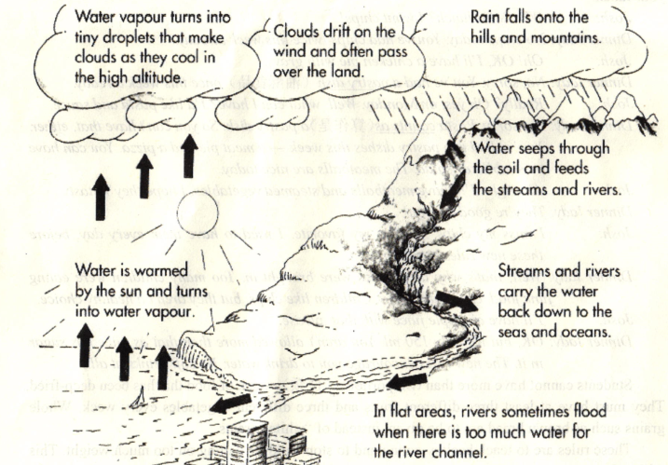

下而是被打乱的有关The water cycle（水循环）的信息，请根据短文内容重新排序。
请将答案编号涂卡。首句己给出：
Water is warmed by the sun and turns into water vapour and rises into the sky.[来源:学_科_网]
11. _________
A. Rains falls from the clouds.
B. The rivers take the water back to the sea.
C. The clouds drift over the land.
D. The water seeps through the soil and back into rivers.
E. At the watch vapour cools,it turns into clouds.
12. _________
13. _________
14. _________
15. _________

D
阅读D篇，根据博文后要求作答。
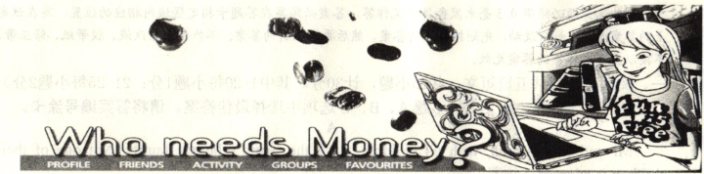
The kids in my class are
doing an experiment.
We want to show that
you don’t need to spend
money to have fun.
We aren’t going to buy
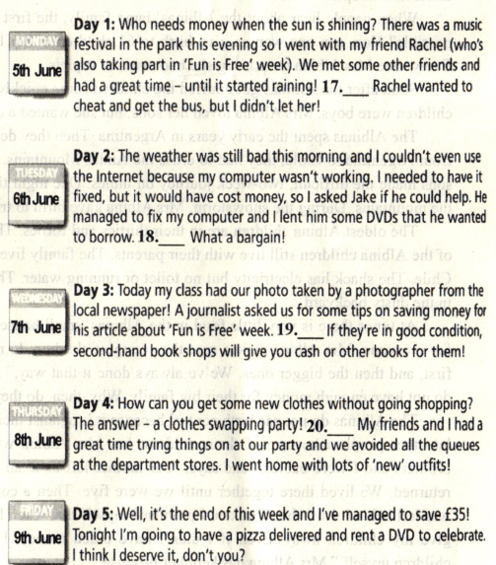
anything for a whole
week! We’ve even had
some’Fun is Free’ T-shirts
specially made. All the
money that we save will
go to charity. 16. _______

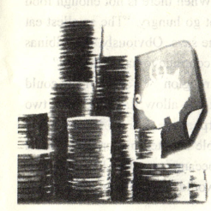
根据博文内容，将下面方框中的句子还原到博文当中，使博文内容完整
请将答案编号涂卡。
A. We were both happy and it cost us nothing
B. Keep reading this blog (博客) to see howit goes!
C. The others went to a cafe and we had to walk home!
D. Mine was: Don’t throw your old books away
E. Everyone’s got things that they don’t wear any more, but that someone else might like.
E
阅读E篇，根据书信内容简要回答问题。请将答案填写到答题卡指定位置。
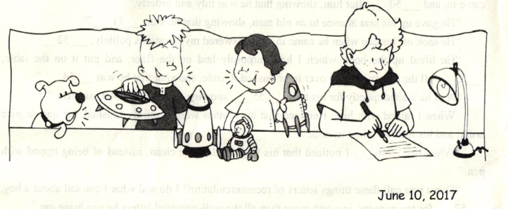

Dear Kids Advice Magazine
June 10, 2017
Hi, my name is Evan and being the eldest child in the family surely has its disadvantages. First of all, I have to share all my toys and games with my younger Siblings, William and Julia. Of course, they don’t need to return the favour because I’m totally uninterested in their things. Besides that, Julia and William are always hanging around me. It’s especially annoying when I have a friend over. We look for a secluded place in the house where they can’t disturb (打扰) us, but within minutes, they’ve found us and are asking to join in.I just can’t seem to get a moment’s peace. At meal times,I have to eat whatever is on my plate regardless of the portion size or taste. William and Julia only need to try one bite when it’s not their favorite food. Not only this, but I’m expected to be cooperative (合作的,配台的) at all times because I’m the oldest and need to be a role model for them.
It doesn’t seem fair either that I have more chores to do around the house than Julia and William put together. Plus, when it comes to practising our musical instruments,I have to practise more than double the time. Oh, and the worst part of it all is the huge quantities of homework I get compared to them.
I’m feeling rather annoyed wilh my sibling situation. Can you please write back with some advice?
Yours truly
Evan Smith

21. How many children are there in Evan’s family?
22 What does the underlined phrase “a secluded place” mean in Chinese?
23. Why is Evan expected to be cooperatwe at all times?
24. How did Evan feel when he wrote this letter?
25. Evan thinks many things unfair, but in fact some of them are not his brother and sister’s fault. List 2 of the unfair things.
二、2017年威海市中考英语试题单词拼写（共8小题，计8分）
根据句意和音标提示以适当形式填写单词。请将答案填写在答题卡指定位置。
26. What can we do to cut down air______/pəˈlu:ʃn/?
27. I’ve got a really bad______/ˈhedeik/ and I want to have a rest.
28. My English _____/ˈlevl/ has greatly improved with my teacher’s help.
29. Junko Tabei _____/səkˈsi:d/ reaching the top of Qomolangma in 1975.
30. Is the bridge strong enough to_____/səˈpɔ:t/ two heavy trucks at the same time?
31. You’ll have more job ____/ˈtʃɑ:nsiz/ if you can speak a foreign language.
32. Li Ming has been ______/ˈæbsənt/ from class three times this week.
33. A classmate of mine was _____/ˈpʌnɪʃt/for breaking the school rules
三、2017年威海市中考英语试题动词填空（共8小题，计8分）
用括号里所给动词的适当形式填空。请将答案填写在答题卡指定位置。
My best friend has two first names. One is Heather, and the others Na-ri. I 34 _____.(never see) her use the name Na-ri. But today, for the first time, she is writing a letter with this name.
She 35_______(bear) in South Korea and adopted by American parents when she was two years old one day, she told me about her childhood When she went out to dinner, some South Korean strangers tried to talk to her in Korean She didn’t understand what they 36.____ (say), so she just looked at them. She said that she still remembered how they looked at her. Their eyes seemed to say, “Poor girl You are an abandoned child.” From that day, Heather tried to keep saying to herself that she was American.
Two days ago, she received a letter from South Korea. The letter 37.___(send) to Na-ri. She
was so surprised that she couldn’t open the letter. So I did it for her. The letter was written in
Korean. I said, “Heather, you should ask someone 38_____(read) this for you. It was written in
Korean.” But she was silent.
Yesterday, on the way home,I saw her 39.____ (cry) on a bench near my house. “What is it,
honey?” I said. She told me that her birth mother had blood cancer, and the only cure for her
illness might be Heather’s blood. I asked how she knew this. Heather said she had learned Korean
secretly. Crying hard, Heather only repeated, “What should I do? What should I do?” I really had
no answer.
This monung, Heather called me. “40.____you____(be) with me when I write a letter to
South Korea?” I gladly went over to her house Heather didn’t seem to have slept at all. I hugged her and told her everything would be okay. Now I 41.___(sit) in front of Heather watching her write a letter. She hasn’t told me what she is writing, but I can guess. Heather is writing, “Na-ri is coming, mother.”
四、2017年威海市中考英语试题完成句子（共6小题，计12分）
根据所给汉语句子完成英语句子，词数不限。请将答案填写在答题卡指定位置
42. 他发现戒烟很难。
43. Tom和Tim都没有看过这部电影。
44. 明天学校礼堂里有音乐会吗？
45. 树种得越多，空气越清新。[来源:Z。xx。k.Com]
46. 我想知道他刚才为什么没有接电话。
47. 尽管天很热，但是工人们没有停止工作。
五、短文填空（共10小题，计10分）
根据短文内容，选择适当的单词或短语填空，使短文意思完整。每个选项至多使用一次。请将答案编号填写在答题卡指定位置。
A. many B. closed the door C. wrote his name D. careful E. kind F. by using my eye G. sent the others away H. while I. showing that he was well-edcated
J. instead of pushing the others aside

A man once advertised for a person to work in his office, and nearly fifty people applied for the place. From all the applicants (应聘者) , in a short time, he chose a boy and 48 .
“I would like to know,” said a friend, “how you came to choose that boy, He had not a single recommendation (推荐信) with him.”[来源:Z§xx§k.Com]
“You are mistaken.” said the man. "He had 49 .” “He cleaned his shoes before he
came in, and 50 after him, showing that he was tidy and orderly.”
“He gave up his seat at once to an old man, showing that he was 51 .”
“He took off his cap when he came in, and answered my questions politely, 52 ”
“He lifted up the book which I had purposely laid on the floor, and put it on the table,
53 all the others stepped over it, or pushed it aside, showing that he was 54 .”
“ And he waited quietly for his ture, 55 showing that he had good manners.” [来源:Z|xx|k.Com]
“When I talked with him, I noticed that his clothes were carefully brushed, his hair in nice
order, and his teeth as white as milk.”
“When he 56 , I noticed that his fingernails were clean, instead of being tipped with
pen.”
“Don’t you call these things letters of recommendation? I do and what I can tell about a boy,
57 for ten minutea,is worih more than all the well-prepared letters he can bring me”
六、书面表达（共1小题，计12分）
58假如你是“Kids Advice Magazine”的编辑，请针对本试卷第5页阅读理解E篇中Evan
的烦恼，用英语给他写一封80ia]以上的回信，对他进行开导。信的开头和落款已给出，不
计八词数。请将答案填写在答题卡指定位置。
要点提示：
1.陈述有兄弟姐妹的优势：弟妹的崇拜、不孤单、学会与人相处或分享……
2.说明不同年龄段有不同的责任和义务：自己的，父母的，弟妹的……
3.建议、鼓励：不比较、不抱怨，做好自己所能做的事
词汇提示（仅供参考）：complain抱怨（w.&vt），admire，compare……..
Dear Evan,
It’s not easy being in your situation. It’s normal to have these feelings. But every coin has
two sides

Yours truly
Ron Todd

2017年威海市中考英语试题
参考答案及评分标准
阅读理解（共五篇短文，25小题，计30分。）
(1-20小题，每小题1分)
1-5 BCACB 6-10 ACCBA 11-15 ECADB 16-20BCADE
（21-25小题，每小题2分）（大小写错误不扣分。）
21. There’re 3 /three children in the family.
22. 一个安静所被打扰，私密／隐蔽的地方。（答对意思即可。）
23. Because he is the oldest and needs to be a role model for them.（答对处即可得分。）
24. He felt unfair.／He was annoyed／angry /unhappy.
25. He has to eat whatever is on his plate regardless of the portion size or taste.
He is expected to be cooperative at all times.／He needs to be a model for his
brother and sister.
He has more chores to do around the house than Julia and William put together.
He has to practice musical instruments more than double the time
He has the huge quantities of homework.
(以上任意两个答案，答对1处得分。列出要点也可得分。）
二、单词拼写（共8小题，计8分。每小题1分。）
26. pollution 27. headache 28. level 29. succeeded 30. support
31. chances 32. absent 33. punished
三、动词填空（共8小题，计8分。每小题1分）
34. have never seen 35. was born 36. were saying 37. was sem 38.10 read
39. crying 40. Will … be (Are …going to be也可得分) 41. am sitting
四、完成句子（共6小题，计1 2分。每小题2分。）
考生要能准确运用适当的句式，恰当的时态、语态以及正确的单词和短语来完成句子。
时态、词序、句子结构错误分别扣1分，其他语法错误每处扣0。5分，个别单词拼写错误
不扣分。
42. He finds it (is/difficult／hard to give up/stop smoking.
He found it (was) difficult/hard to give up /stop smoking.
43. Neither Tom nor Tim has seen the film /movie（说明：用both… and，但时态正确
且主谓一致，可得1分；仅时态正确，得0.5分。）
44. Will there be a concert in the school hall tomorrow?
Is there going to be a concert in the school hall tomorrow?
45. The more trees are planted. the fresher the air will be／become.
The more trees people／we plant, the fresher the air will be /become
46. I wonder /want to know why he didn’t answer the phone just now /a moment ago.
47. Although /Though it is hot, the workers won’t/don’t stop working.
Although /Though it was hot. the workers didn’t stop working.
It is hot, but the workers won’t /don’t stop working.
It was hot, but the workers didn’t stop working. (说明：同时使用Although／
Though+but,扣1分)
五.短文填空 (共 l0小题，共 10分，每小题 1分)
48. G. sent the others away 49. A. many 50. B. closed the door 51. E. kind
52. I. showing that he was well-educated 53. H. while 54. D. careful
55. J. instead of pushing the others aside 56. C. wrote his name 57. F. by using my eyes
六.书面表达 (共 1小题,计 12分.)
58.参考例文
Dear Evan,
It’s not easy being in your situation. Il’s normal to have these feelings. But every coin has two sides. Being the eldest child in the family surely has its advantages.
Firstly. you used to enjoy all the love from your parents. You’re loved and admired by your
brother and sister. You won’t feel lonely with them around you and you can leam how to share[来源:Zxxk.Com]
and how to get on with others. Together with them you’ll grow up more quickly.
Secondly, people of different ages have different duties. Think of your parents how hard
they are working! As you are growing older. you are supposed to do more and do better than
your brother and srster. Everyone has to grow up and we all have to do what we should do. We
have to be responsible for ourselves
So I tlunk if you don’t compare with babies, just think of your duty, you will feel much
better. Don’t complain about your situation. Try your best to do the things of your age.
Attitude is evetything. You are sure to grow into an outstanding young man.
Yours truly,
Ron Todd
讦分标准
1．考生能采用适当的时态、语态，运用适当的句式和词语进行表述，说理恰当，论述
充分，层次精楚，阅卷教师根据具体情况判分，不受参考答案影响。
2．对于语言结构运用丰富，表述充分，说理恰当，语言流畅，能充分显示出考生灵
活运用语言能力的文章，可以给满分。
分四档评分：
第一档：内容完整，表述充分，层次结构清晰，语言丰富、流畅、规范、准确。10-12分
第二档：内容完整，表述比较充分，层次结构比较清晰，语言比较流畅、规范，有少量语
言错误。7--9分
第三档：内容不够完整，表述不够充分，层次结构不够合理，有较多语言错误。4—6分
第四档：内容不完整，语言表述错误较多或仅几个单词可读，不能完整表达意思。0-3分

