各位同学在查看时请点击全屏查看
2017年龙东六市中考
英 语 试 题
2017年龙东六市中考英语试题考生注意：
本考场试卷序号
（由监考填写）
1、考试时间120分钟
2、全卷共六道大题，总分120分
题号 | I | II | III | IV | V | VI | 总分 | 核分人
得分

第一部分2017年龙东六市中考英语试题语言知识运用(共计65分)
Ⅰ. Multiple choice (本题共20分,每小题1分)
得分 | 评卷人

Choose the best answer from A, B or C according to the meaning of the sentence.[来源:Zxxk.Com]

( ) 1. Dear children, this is ______ unusual exam. ______ exam is very important to you.
Please take it easy. Wish you good results.
A. an; The B. a; theC. an; An
( ) 2. — My grandmother was ill in hospital yesterday. — ______.
A. That’s all right B. I’m sorry to hear that C. That’s a good idea
( ) 3. Chairman Xi Jinping ______ the president of the USA ______ April 6th, 2017.
A. will meet; in B. met; on C. meets; on
( ) 4. My cousin is ______ heavy because he often eats ______ fast food.
A. much too; too many B. too much; too much C. much too; too much
( ) 5. — There is little pollution in that village, _______?
— No. The air there is quite fresh and clean.
A. is there B. isn’t there C. is it
( ) 6. If you want to keep your teeth healthy, you’d better not eat ________ a lot.
A. something sweet B. anything sweet C. nothing sweet
( ) 7. My teacher often encourages me ______ at least one hour a day reading books.
A. to pay B. cost C. to spend
( ) 8. Everyone plays an important part in society. As members, we should try our best to do
______ to make the world better and better.
A. what we should do B. what should we do C. how we should do
( ) 9. — Would you mind ______ here?www.ccutu.com
— Of course not. I’ll ______ my cigarette at once.[来源:Zxxk.Com]
A. not smoking; put away B. not smoking; put out C. not to smoke; put off
( ) 10. It’s time for me ______ goodbye to my mother school. I will never forget all my ______ love.
A. to say; teachers’ B. saying; teachers’ C. to say; teacher’s
( ) 11. ______of the students in our class ______ going to the summer camp in Beijing
next week.
A.Two fifths; are B. Second fifths; areC. Two fifths; is
( ) 12. As for learning English, students ______ read a lot can do much better than ______ who don’t.
A. who; that B. which; those C. that; those
( ) 13. — Look! The man at the school gate _________ be our headmaster. He is always standing there to welcome us every morning.
—No, it _______ be him. He is holding a meeting in the office now.
A. must; can’t B. must; mustn’t C. can’t; mustn’t
( ) 14. — ______ shocking news! It is reported that the UK is repeatedly under terror attack.
— So it is. We should call on the people all over the world to be against terrorism（恐怖主义）.
A. What an B. How C. What
( ) 15. —I saw Jim ______ into that new building just now.
—Oh, it’s our new library. It ______ to the public for a week.
A. walk; has opened B. walk; has been open C. walking; has opened
( ) 16. Neither he nor I was playing computer games at this time yesterday. We ______ trees in the neighborhood.
A. were planting B. planted C. are planting
( ) 17. The number of the old people is increasing in China. With the development of
China, they _____ better care of in the future.
A. will take B. are taken C. will be taken
( ) 18. —Alice, could you tell me when your sister ______ from Harbin ?
—I’m not sure. I will call you when she ______.
A. will come back; will return B. comes back; will return C. will come back; returns
( ) 19. The TV play Journey to the West is ______ interesting ______I would like to watch it again.
A. such; that B. too; to C. so; that
( ) 20. Which of the following signs means DON’T GET WATER HERE?
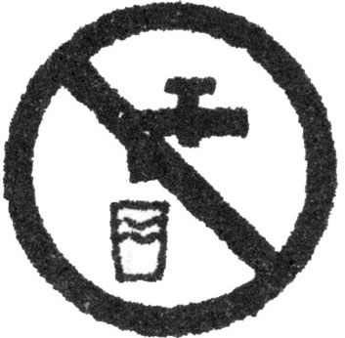
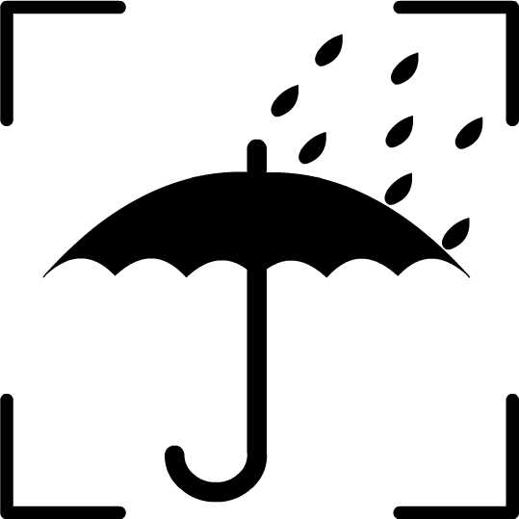
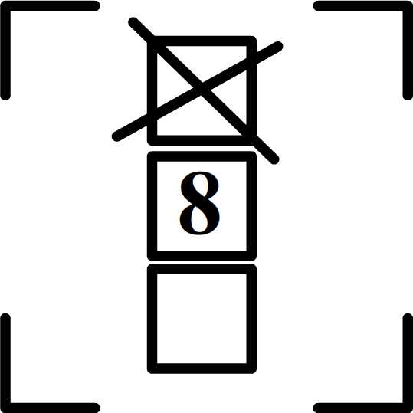
A.B. C.

得分 | 评卷人
Ⅱ. Close test (本题共15分,每小题1分)

Choose the best answer to complete the passage.

China is a nation of etiquette（礼仪）. Chinese people are 21the most hospitable（好客的） people in the world. If 22visit a Chinese family, they would be 23at the warmth that they would receive as guests.
When you visit a Chinese family, the host usually makes tea for you and 24 you snacks
like biscuits or candy. Someone in the family will also chat with you, never letting you feel 25 .
At the same time, other family members will be busy 26a meal for you. Chinese people treat their guests 27a big meal. They always present more food than the guests can eat. On the table, the guests must be the 28to eat. Perhaps one of the things that surprises a (an) 29guest most is that the Chinese host likes to pick food for guests, which won’t happen at western tables. The Chinese family 30to make you feel at home. As you finish eating, the host usually says, “It seems that you didn’t eat much. Please have 31 .” You tell them you are full, 32they still put more food in your bowl.
33warm and hospitable has been an important part of Chinese culture and tradition. As Confucius（孔子）said 34years ago:
To meet friends from a place far away, how 35we are!
( ) 21. A. between | B. among | C. during
( ) 22. A. foreign | B. foreigner | C. foreigners
( ) 23. A. surprised | B. surprise | C. surprising
( ) 24. A. serve | B. serving | C. serves
( ) 25. A. lonely | B. alone | C. happy
( ) 26. A. prepare | B. preparing | C. prepared [来源:学。科。网Z。X。X。K]
( ) 27. A. with | B. as | C. for
( ) 28. A. first | B. second | C. last
( ) 29. A. eastern | B. southern | C. western
( ) 30. A. get in their way | B. go out of their way | C. lose their way
( ) 31. A. more | B. less | C. many
( ) 32. A. although | B. but | C. because
( ) 33. A. Be | B. Been | C. Being
( ) 34. A. thousands of | B. thousand | C. thousand of
( ) 35. A. happily | B. unhappy | C. happy

得分 | 评卷人
Ⅲ. Vocabulary (本题共10分, 每小题1分)

Complete the sentences with the proper forms of the words given. Only one word for each blank.
36. When we walk __________ (cross) the road, we should follow the traffic rules.[来源:学科网]
37. Though the little boy is only three years old, he can dress __________ (he).
38. When you learn English, you should pay more attention to your __________ (pronounce).
39. Henry is a(an) __________ (dishonest) boy, so his friends all like him.
40. —Who jumps __________ (far), Mike or George?
—Mike does.
41. __________ (luck), this man lost his wife and two children in the earthquake.
42. —What are you doing?
—I am reading a book __________ (write) by Mo Yan.
43. Bill wants to invite some friends to his __________(nine) birthday party.
44. Some __________ (German) came to this international school last Friday.
45. Everyone is looking forward to __________ (have) a bright future.
Ⅳ. Communication (本题共20分, 每小题2分)

(A) Choose the best choice from A to F to finish the dialogue. You have one more answer. Each choice should be used only once.
得分 | 评卷人
A: Excuse me, sir ? Could you tell me the way to the nearest bank?
B: 46You can ask the lady over there.
A: Thank you all the same.
(A moment later)
A: Excuse me. 47
C: No, there isn’t a bank near here, but there is one near the People’s Hospital.
A: 48
C: It’s about fifteen minutes by bus.
A: 49
C: The No. 10 bus.
A: 50
C: It is over there, across from the bookstore.
A: Thank you very much.
C: You’re welcome.
A.Is there a bank near here? B. How far is it from here?
C. Where is the nearest bank?D. Which bus can I take?
E. Sorry, I’m new here. F. By the way, where is the bus stop?
4647 48 49 50
(B) Complete the dialogue with proper words or sentences.
A: Hello, is that Lingling speaking?
B: Speaking. 51 ?
A: This is Meimei. I want to go to the movies now. 52 ?
B: I’d love to, but I’m watching a TV program called Readers. 53?
A: No, I haven’t watched it. 54 ?
B: It’s great. In this program, many people who have great influence in our life tell their own stories and share some wonderful articles with us. You know, reading is very important to
everyone and Chinese classical books are our treasure. I think we should read as much as
possible.
A: 55 . I can’t wait to enjoy it.
B: Why don’t you turn on the TV and watch it at once?
A: Good idea. I’ll do it right now. Goodbye!
B: Bye!
第二2017年龙东六市中考英语试题部分阅读理解(共计40分)
得分 | 评卷人
Ⅴ. Reading comprehension (本题共40分, A, D每小题1分, B, C,E每小题2分)

( A )
Tips for Writing Better Articles
( ) 56. When we are not sure which word is the right one for a sentence, look it up in a dictionary. Many of us choose words in a hurry and don’t take the time to decide if they are proper. Good word choices are necessary for good writing.
( ) 57. If we want people to believe what we write, we must make sure our facts are true. We should use dependable facts.
( ) 58. Making a list is necessary for writing a good article. Such a list includes: Is there a proper title? Have we explained every point? Are all the parts of the article included? This can help us to make sure that we have covered everything.
( ) 59. Sometimes it’s easier to find problems with spelling, word usage and grammar when we read aloud. Reading aloud helps us not only find out our problems but also develop our writing.
( ) 60. A common problem is that we don’t like to rewrite. In fact, rewriting is the best way to find out and correct some mistakes, like grammar and spelling mistakes. Rewriting makes our writing better, though it takes more time and more work.
Choose the best topic from A to F according to the meaning of the passage.
A. Rewrite. | B. Read aloud.
C. Check facts. | D. Collect information.
E. Prepare a list. | F. Make good word choices.
( B)
More than anything else in the world, Lion liked being King of the jungle. He walked all around, showing off his power and pride.
Each day, Lion took a long, lazy sleep under the shade of his favorite tree. He always
dreamed of weaker animals bowing before him.
One day, Mouse ran through the jungle and tripped over Lion’s huge paws. “How dare you wake me up!” he shouted angrily. Lion grabbed（抓住）Mouse with one paw. “I’m hungry now, and you’ll be my delicious meal.” he said.
Mouse cried out, “King Lion, please spare（饶恕）me! If you let me live, I will always remember your kindness. And some day, I might be able to help you.”
“How could such a powerless little mouse ever help me?” That thought made Lion laugh so much that he decided to let Mouse go. A week later, Lion was walking through the jungle on the way to his favorite tree when he stepped onto a hunter’s net. The net scooped（勾）him up. No matter how he twisted and turned, he couldn’t escape.
When Mouse heard Lion’s frightened shouts, he ran to help. Mouse quickly chewed（咬） through the ropes to make a hole in the net. Soon, Lion moved out and was free. Lion looked down at the little mouse. “Thank you for saving my life.” said Lion, smiling his widest smile. “I was wrong. You are not a powerless little mouse. You are a great friend!”
Judge the following sentences true (T) or false (F) according to the passage.
( ) 61. Lion liked being King of the jungle best.
( ) 62. One day, Lion grabbed Mouse with his two huge paws.
( ) 63. Mouse said he could help Lion when Lion was in trouble.
( ) 64. A week later, Mouse was scooped up by a hunter’s net again.
( ) 65. Mouse became Lion’s friend at last.
( C )
Choose the best choice from A, B or C according to what you read.
 |  | 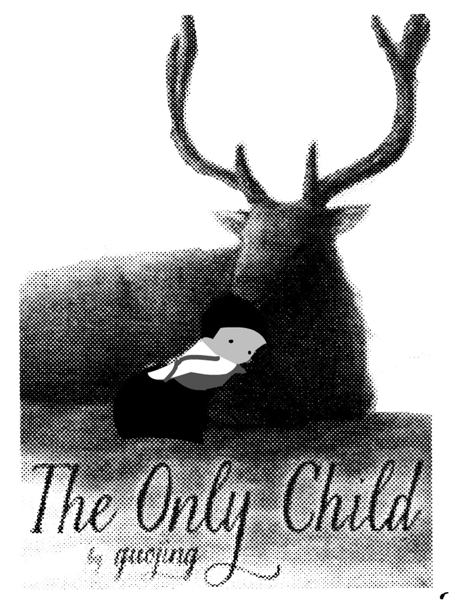 |  | 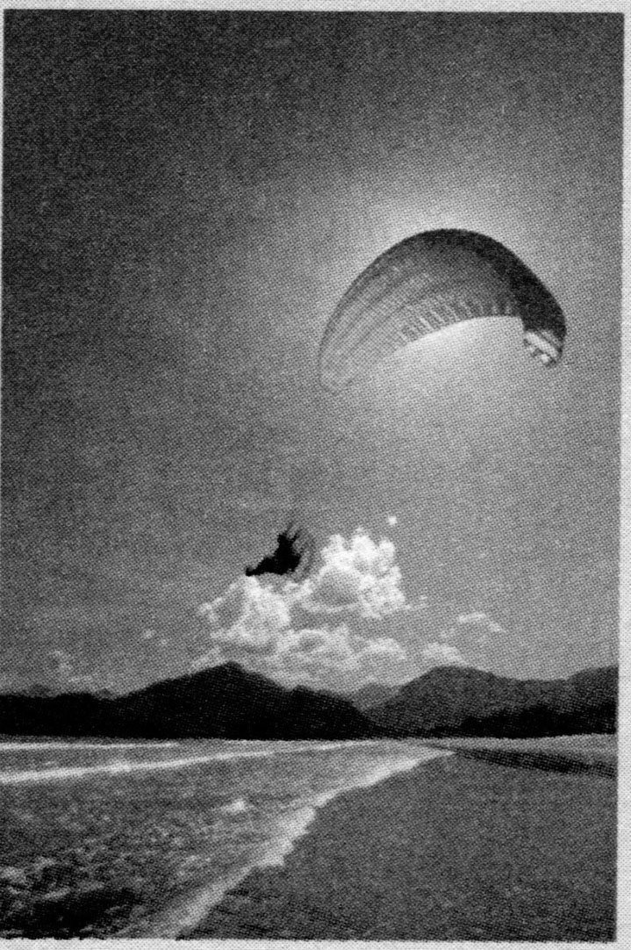
Welcome to LCF  Music & Gym Clubs  The music & gym activity for pre-schoolers.  It’s fun, educational and great for the development of social skills.  English is the only  language needed.  Phone: 02392 370863 |  | The Only Child  By Guojing  Age: For 5-9 years old  Price: $ 15.99  A little girl, lost and  alone, follows a stag deep into the forest. She finds herself in a strange world.  How will she get back  home? |  | Enjoy a Wonderful Trip  on the Sea  Time: 5:00 p.m.  Price: Adult: $200  Child under 10: $100  Start/Stop:  The River Bank (Near the City Shopping Centre)  Ticket Office:  New Life Company
( ) 66. If you want to join an LCF club, you CAN’T ________.
A. post a letterB. look through the website C. make a phone call
( ) 67. The LCF clubs are for children who can speak ______ .
A. ChineseB. EnglishC. French
( ) 68. The Only Child is mainly about ______ .
A. the only girl in the family
B. a girl lost her way in the city
C. a lost girl in the forest
( ) 69.Where does the trip start?
A. The River BankB. New Life CompanyC. The City Shopping Centre
( ) 70. If Mr. and Mrs. White with their eight-year-old daughter go on the trip on the sea,
how much will they pay?
A. $400B. $500 C. $600
（D）
Three travelers, Allan, Carl and Paul were sitting on the chairs in a train station. They were waiting for a train that was very late.
To pass the time, they began talking to each other.
At first, they talked about the weather and their work. Then Paul asked, “What would you most like to do if your doctor told you that you have only three months to live?”
The other two men thought about this for a while, then Carl spoke first.
He said, “Well, if I have only three months to live, I’ll take all my money out of the bank and go to foreign countries for holidays with my best friend, Eric. I’d like to travel to many places in the world as possible as I can. And I’ll stay at the best hotels and then eat the best food. I think I’ll have a wonderful time.”
“That’s very interesting.” Paul said.
With these words, he turned to the other man, saying, “And what about you, Allan?”
“I’ll tell you a secret.” Allan said. “I always want to be a racing driver. So if I have only three months to live, the first thing I’d like to do is to sell my house. With the money I’ll buy the fastest car in the world. Maybe I can go into all the big motor races.”
“Now it’s your turn.” Allan went on, “If your doctor told you the bad news, what would you most like to do?”
“Oh,” said Paul with a smile. “I’ll go and see one more doctor.”
Fill in the blanks according to the passage. Only one word for each blank.
There were three travelers chatting together while waiting for a train. One of them , Paul, asked a question,“What would you most like to do if your doctor told you that you have only 3 months to live?”Carl said he would take all his money to go 71for holidays with his best friend. And he would travel to as 72places as possible in the world. Allan wanted to sell his house to buy the fastest car in the world to be a racing driver and perhaps he could 73
all the big motor races. But Paul’s answer 74them surprised. He said he would go to see
75doctor.
71 727374 75
( E)
Every morning my father buys a newspaper on his way to work. Every evening my mother looks through magazines at home. And every night, I look at the posters with photos of David Beckham and Yao Ming on my bedroom wall before I go to sleep. Can we imagine life without paper or printing?
Paper was first created about 2,000 years ago, and has been made from silk, cotton, bamboo, and since the 19th century, from wood. People learned to write words on paper to make a book. But in those days, books could only be produced one at a time by hand. As a result, they were expensive and rare. And because there weren’t many books, few people learned to read.
Then printing was invented in China. When printing was developed greatly at the beginning of the 11th century, books could be produced more quickly and cheaply. After that, knowledge and ideas spread quickly.
Today information can be received online, downloaded from the Internet rather than only
found in books. And information can be kept on CD-ROMs or machines such as iPads.
Computers are already used in classrooms, and newspapers and magazines can already be read online. So will books be replaced by computers one day? No, I don’t think the Yao Ming poster on my bedroom wall will be replaced by a two-metre-high computer!
Answer the questions according to the passage.
76. When was paper first created?

77. Before the invention of printing, were books produced by hand or by machine?

78. What happened after books became cheaper?

79. According to the passage, where can information be kept?

80. Can newspapers and magazines be read online now ?
第三部分2017年龙东六市中考英语试题书面表达 (共计15分)
Ⅵ.Writing ( 本题共15分，其中81题5分，82题10分)
得分 | 评卷人
（注意：文中不能出现考生真实姓名、校名和师名，否则不得分）
81.假如你是Mary，初中学习生活即将结束，请向你的老师(Mr. White)致谢，感谢他对你一直以来的教育、关心和帮助，并祝福老师健康快乐。
Dear Mr. White,

Yours,
Mary
82.(A) 话题作文：近几年来，校园欺凌（school bullies）事件时有发生，学会自我保护是我们中学生需要具备的一种意识和能力，我们应该珍惜生命，注意自己的人身安全，做好自我保护。请以How Can We Protect Ourselves 为题写一篇英语短文，谈谈在生活中我们应该怎样自我保护（self-protection）。
提示：1.不单独游泳；
2.谨慎交友；
3.遇到危险报警或向老师求助；
4.饮食及交通安全等……
(B) 图示作文：仔细观察下列六幅图片，展开合理想象，写一篇短文。
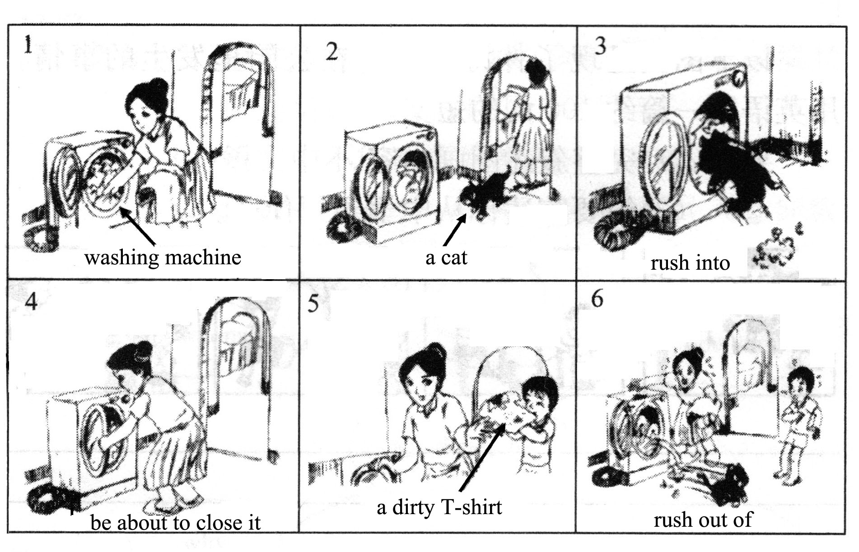
要求：1. 话题作文或图示作文任选其一。
2. 词数在80～100词之间。
3. 字迹工整，语法正确，意思连贯，合乎逻辑，可适当发挥。

