请点击全屏查看
2017年安徽省中考英语试题
英语试题
第一部分 听力（共五大题，满分30分）
I. 2017年安徽省中考英语试题关键词语选择（共5小题；每小题1分，满分5分）
你将听到五个句子。请在每小题所给的A、B、C三个选项中选出一个你所听到的单词或短语。每个句子读两遍。
1. A. milk B. drink C. chalk
2. A. risk B. mix C. fix
3. A. road B. boat C. coat
4. A. loud B. proud C. round
5. A. copy down B. turn down C. bring down
II. 2017年安徽省中考英语试题短对话理解（共10小题；每小题1分，满分10分）
你将听到十段对话，每段对话后有一个小题。请在每小题所给的A、B、C三个选项中选出一个最佳选项。每段对话读两遍。
6. What does Lucy want to buy for her mum?
A.  B.  C. 
7. What animal does the woman like?
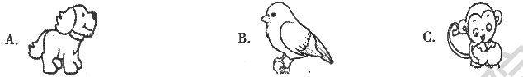
8. What are the speakers talk about?
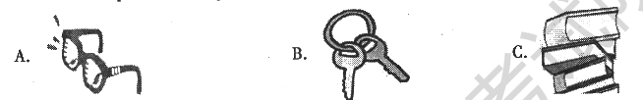
9. What is the woman’s favorite fruit?
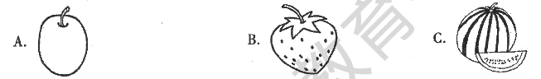
- What will the speaker’s grandparents do this Sunday?
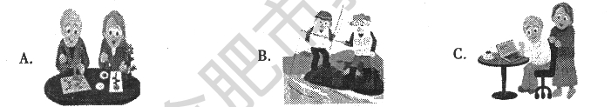
11. What could the woman like to drink?
A. Coffee. B. Juice. C. Water.
12. Why does the man feel nervous?
A. Because he isn’t good at dancing.
B. Because he doesn’t know most of the guests.
C. Because the woman won’t introduce him to others.
- How will the man probably go to Washington Square?
A. By car. B. By bus. C. On foot.
14. What does the woman want to do?
A. Stay with Alan. B. Send Alan to school. C. Find Alan a teacher.
15. Where did the woman study English?
A. In London. B. In Beijing. C. In New York.
III. 2017年安徽省中考英语试题长对话理解（共5小题；每小题1分，满分5分）
你将听到两段对话，每段对话后有几个小题。请在每小题所给的A、B、C三个选项中选出一个最佳选项。每段对话读两遍。
听下面一段对话，回答第16 至17小题。
16. What is wrong with the woman?
A. She has a headache. B. She has a fever. C. She has a cough.[来源:Zxxk.Com]
17. What’s the relationship between the two speakers?
A. Classmates. B. Doctor and patient. C. Father and daughter.[来源:学科网ZXXK]
听下面一段对话，回答第18至20小题。
18. Who will spend the weekend with the man?
A. His parents. B. His friends. C. His teachers.
19. Where will the man go camping?
A. By a lake B. On a hill C. Near a river.
20. What does the woman ask the man to be careful of?
A. Weather. B. Traffic. C. Fire.
IV. 2017年安徽省中考英语试题短文理解（共5小题；每小题1分，满分5分）
你将听到一篇短文，短文后有五个问题。请根据短文内容，在每小题所给的A、B、C三个选项中选出一个最佳选项。短文读两遍。
21. How old are the speaker’s parents?
A. Under 60. B. About 65. C. Over 70.
22. What happened at the speaker’s home village?
A. A big rainstorm. B. An earthquake. C. A car accident.
23. How long will the speaker stay at home?
A. For three days. B. For five days. C. For a week.
24. What can the speaker do to help?
A. Do some repair work. B. Call the police. C. Buy a new house.
25. What is the listening text?[来源:Z&xx&k.Com]
A. A public speech. B. A phone message. C. A news report.
V. 2017年安徽省中考英语试题信息转换（共5小题；每小题1分，满分5分）
你将听到一篇短文。请根据短文内容，写出下面表格中所缺的单词，每空仅填一词。短文读两遍。
A School Day
Who | The students of Class Eight, Grade 26
When | Last 27
What | ●Some students acted as 28 to help the visitors.  ●The speaker told the visitors about the 29 of the school.  ●Other students put on a 30 for the visitors.

第二部分 英语知识运用（共两大题，满分45分）
VI. 2017年安徽省中考英语试题单项填空（共15小题；每小题1分，满分15分）
从每小题所给的A、B、C、D四个选项中选出一个可以填入空白处的最佳选项。
31. ---I’m afraid I can’t do well in the game.
---_____. It’s just for fun.
A. Sounds good B. What a pity C. Thank you D. Take it easy
32. ---Is this iPad yours?
---Yes. My parents bought _____ for my language learning.
A. one B. it C. other D. another
33. The New Silk Road will offer a good _____ for more nations to communicate.
A. chance B. habit C. question D. price
34. I am surprised at the new look of my hometown, for it _____ a lot over the years.
A. changed B. changes C. will change D. has changed
35. ---What do you think of the movie?
---Great! I have never seen a _____ one.
A. good B. bad C. better D. worse
36. Hold your dream, _____ you might regret some day.
A. and B. or C. but D. so
37. It is necessary for schools to _____ the need of all the students’ development.
A. cut B. hide C. refuse D. satisfy
38. To my pleasure, my family is always _____ me whatever I decide to do.
A. above B. behind C. from D. through
39. ---Mum, I’ve signed for the box. What’s in it?
---I’m not sure. It _____ be a present from your uncle.
A. need B. must C. may D. will
40. My deskmate is really _____. She likes to attend different activities after school.
A. active B. quiet C. lazy D. honest
41. ---Do you know _____ Ann goes to work every day?
---Usually by underground.
A. why B. how C. when D. whether
42. Mr. Green _____ to sing an English song at the party and he sang well.
A. was invited B. invited C. is invited D. invites
43. There are many beautiful places to visit in Anhui, _____ Mount Huang in autumn.
A. simply B. finally C. luckily D. especially
44. Our geography teacher told us to _____ more information about our city and share it next week.
A. find out B. keep away C. turn off D. use up
45. ---May I do some sports after finishing my homework?
---_____. It is good for your health.
A. I hope not B. Sorry, you can’t C. Of course D. Yes, I’d love to
VII. 2017年安徽省中考英语试题完形填空（共20小题；每小题1.5分，满分30分）
阅读下列短文，从每小题所给的A、B、C、D四个选项中选出一个最佳选项。
A
Henry Bond was about seven years old when his father died. His mother found it _____(46) to support the large family. However, she tried her best to do so. Also, she _____(47) Henry, the eldest son, to school.
At one time, Henry needed a grammar book for his study. His family was so _____(48) that his mother could not afford one.
One morning, Henry found that a deep snow had fallen, and the _____(49) wind was blowing. “Ah,” he said, “it is an ill wind that blows nobody good.” With these words, he ran to the house of a neighbor, and offered his _____(50) to move away the snow around it. The offer was accepted. When he finished the work, he received his _____(51). Then he went to another place for the _____(52) purpose, and then to anther, _____(53) he had earned (挣得) enough to buy a grammar book.
From that time, Henry was _____(54) the first in all his classes. He knew no such word as “_____(55)”, and he succeeded in all he tried to do. Having the will, he always found the way.
46. A. easy B. fun C. difficult D. possible
47. A. returned B. sent C. followed D. lent
48. A. large B. small C. rich D. poor
49. A. cold B. warm C. cool D. hot
50. A. service B. choice C. money D. interest
51. A. book B. pay C. letter D. study
52. A. last B. strange C. same D. boring
53. A. if B. because C. since D. until
54. A. always B. never C. already D. seldom
55. A. help B. fall C. try D. give
B
Bike-sharing is a new choice for short journeys in cities. It is good to the _____(56) development of the big cities.
A _____(57) by a company found that shared bikes started the nation’s _____(58) for bikes again. Now more and more Chinese people are _____(59) bikes instead of cars to make short journeys in cities.
An engineer of that company says that since the _____(60) of shared bikes, people have made fewer trips by car. The love for shared bikes is not only among _____(61) people, who were born in the 1980s and 1990s, but also among people over sixty.
At weekends, the number of the riders in Shenzhen reaches the _____(62) of all cities. On weekdays, the number of people who use shared bikes to travel to word is _____(63) in Shanghai.
It is said that bike-sharing will help _____(64) the cities’ environment. It not only helps solve the traffic problems, but also will help to make more use of _____(65) in cities. Take Beijing as an example if more people choose shared bikes, an area of five Bird’s Nest stadiums (体育场)will be saved.
56. A. slow B. healthy C. harmful D. sudden
57. A. rule B. plan C. report D. suggestion
58. A. search B. worry C. preparation D. love
59. A. choosing B. pushing C. repairing D. locking
60. A. end B. start C. control D. fall
61. A. strong B. weak C. old D. young
62. A. top B. side C. corner D. line
63. A. coming over B. putting off C. going up D. giving away
64. A. discover B. separate C. experience D. improve
65. A. air B. time C. space D. money

第三部分 阅读理解（共两大题，满分45分）
VIII. 2017年安徽省中考英语试题补全对话（共5小题；每小题1分，满分5分）
根据对话内容，从方框内的选项中选出能填入空白处的最佳选项，其中有两个为多余选项。
Li Lei: hey, Bruce. I’m going home this weekend.
A. Well done!
B. For what?
C. That’s great.
D. What kind of festival is it?
E. I have never tasted them.
F. How will you celebrate it?
G. Would you like to go with me?
Bruce: 66
Li Lei: To celebrate the Mid-Autumn Festival.
Bruce: 67
Li Lei: It is an important time for family.
Bruce: 68
Li Lei: We’ll have dinner together, watch the moon and eat mooncakes.
Bruce: Mooncakes? Are they delicious?
Li Lei: Yes. 69 We can celebrate it together.
Bruce: 70 Thank you!
Li Lei: You are welcome.
IX. 阅读理解（共20小题；每小题2分，满分40分）
阅读下列短文，从每小题所给的A、B、C、D四个选项中选出一个最佳选项。
A
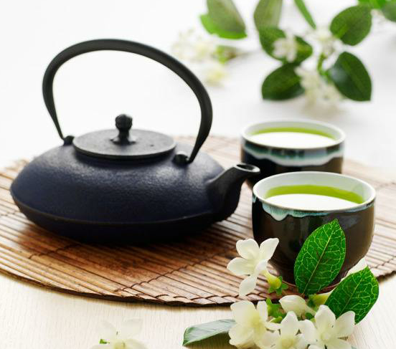
Once upon a time there was no tea at all in England. People there used to drink a light beer(啤酒). No coffee or milk but large glasses of beer stood on the breakfast table!
When tea was first brought to England, an old couple got some as a special treat. But they did not know how I t should be used. They cooked the leaves in hot water, and spread them on a piece of bacon(熏肉) which they were going to have for dinner. They ate the leaves, and threw the tea away! However, tea is becoming as popular as coffee and milk in England today.
Tea is the leaf of a plant which grows widely in China, Japan and some other countries. Tea famers usually grow many tea plants on a large piece of land. When the tea leaves are ready to be picked, it is the busiest time for tea farmers in a year. They pull off on the leaves and dry them. In their spare time, they pick out the best leaves and get them ready for market. In china, whenever a visitor comes into a house, he is served with a cup of tea.
71. What was served for breakfast in England long ago?
A. Beer. B. Tea. C. Coffee. D. Milk.
72. How did the old couple deal with the tea leaves?
A. They sold them. B. They ate them.
C. They burnt them. D. They threw them away.
73. Tea farmers are the busiest in a year when they _____.
A. serve visitors at home B. sell tea in the market
C. pick and dry tea leaves D. look for a piece of land
74. In which part of a magazine can read the text?
A. Nature. B. Culture. C. Environment. D. Technology.
B
Still remember the following poems? Memories return every time I read or hear them.
①  Hush now, my little one.  Hush now, my sunshine.  Hush now, piece of my heart.  Go to sleep, my little one.  Go to sleep, my love.[来源:Zxxk.Com]  Go to sleep, piece of my heart.  Sleep, my little one,  While I sing to you.  Sleep, my little one,  Who is already asleep. | ②  My mama feeds me,  And washes my fur.  The first thing I see every morning is her.  The last thing I kiss every night is her face.  My mama is the very best one, [来源:Zxxk.Com]  And sings like a bird,  And knows how I feel.  When I don’t say a word,  My mama is warm. | ③  I can set the table.  I can sweep the floor.  I can wash my clothes  And count to forty-four.  I can wash dishes.  And clean my bedroom.  There is so much I can do.  Now ask you.
Notes: 1. hush v. 安静 2. fur n. 皮毛 3. sweep v. 打扫
75. The first poem is sung to _____.
A. babies B. mothers C. relatives D. friends
76. In the second poem, the last thing “I” will kiss at night is _____.
A. the fur B. mum’s face C. a bird D. mum’s bed
77. What do you think of “I” in the third poem?
A. Helpful. B. Lucky. C. Crazy. D. Shy.
78. What are the three poems mainly about?
A. Food and health. B. Hobbies and sports.
C. Family and love. D. Animals and humans.
C
Dear Sunday Globe,
I am writing to tell you about your article Smartphones Make Life Easier in last Sunday’s newspaper. You did an excellent job explaining the good points of smartphones, but you didn’t talk about their bad points at all. So, I hope you’ll let me give your readers some advice on smartphone etiquette (礼仪).
The first point I’d like to address is loudness. When you talk on your smartphone in public, please don’t shout. In fact, the microphones in smartphones are very sensitive (灵敏的). So, you can be heard even if you speak quietly.
Another point is about personal space. I don’t think it is polite to make calls in small spaces full of people. This makes others uncomfortable and forces them to listen to your personal business. What’s worse, it stops many face-to-face conversations from ever beginning.
Lastly, doing two things at the same time is dangerous. For example, making calls while driving is a bad habit. Pay attention to the road! Similarly, when staying with your friends, turn off your smartphone and enjoy their company.
Yours truly,
Amber Jala
79. Amber Jala wrote the letter to ________ .
A. find a good job B. provide advice
C. make her life easier D. buy a smartphone
80. What does the underlined word “address” in Paragraph 2 probably mean?
A. 致函 B. 称呼 C. 陈述 D. 选址
81. According to Paragraph 3, what makes people around you uncomfortable?
A. Discussing face-to-face. B. Speaking quietly on your phone.
C. Minding your own business. D. Calling in small spaces full of people.
82. What can we learn from the last paragraph?
A. It is dangerous to drive on the road.
B. It is easy to start a company with others.
C. It is bad to turn off our phones while driving.
D. It is important to use our smartphones properly.
D
Kaitlin Riffel’s dream to end poverty(贫困) started when she was visiting her father, who worked for the homeless.
“I never realized there were people in the world who didn’t have a home or food before,” said Kaitlin, who is now sixteen. “I knew there was something I had to do about that.”
At age eight, she started raising money to build a playground. "It took me two years," Kaitlin said. "We started small. We wanted to do something to make a difference.”
In 2014, When Kaitlin was thirteen, she visited Central America, and saw people going hungry and families living in houses made of cardboard. That year, we set Kids on a Mission, which has helped hundreds of people there.
“The rooms were smaller than my bedroom, but there would be eight people living in each one," Kaitlin said. “We also got to see the dirty rivers that those people were drinking out of.”
Providing clean drinking water, food and clothes for people living in poverty is now an important task for Kids on a Mission. “This young lady is changing the hearts of people, and also changing the world," said the headmaster of Kaitlin's school.
83. The job of Kaitlin's father was to__________
A. sell foods B. build playgrounds
C. visit schools D. help homeless people
84. When did Kaitlin set Kids on a Mission?
A. In 2009. B. In 2011. C. In 2014. D. In 2017.
85. What was people's life like in Central America according to Kaitlin?
A. They lived in strong houses. B. Their drinking water was dirty.
C. Their bedrooms were very big. D. They had enough food and clothes.
86. What can we infer from the headmaster's words?
A. Kaitlin is always ready to give and help.
B. Kaitlin has many chances to travel around.
C. Kaitlin often changes schools for her study.
D. Kaitlin has a serious problem with her heart.
87. What might be the best title for the text?
A. School life in America B. Gift from a headmaster
C. Father’s duty in the family D. Girl's dream to end poverty
阅读下面短文，并用英语回答问题（请注意每小题后面的词数要求）。
E
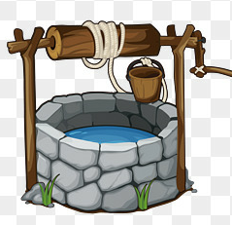
There was once an old and deep well. People got water by dropping a bucket(木桶) tied to a rope. The rope passed over a wheel just above the well. On the other side of the rope was another bucket.
A strong pull brought one bucket to the top while the other down to the water. They always passed each other on the way up and down, but never had time to speak.
At last, the rope became worn. So a new rope had to be put in its place. While this was being done, the two buckets were left standing together near the well.
“What a boring life we have!” said one bucket to the other. “I am quite tired of it. No matter how full we come up, we are always sent down empty.”
But the other bucket laughed and said, “What a funny way you have of looking at things! Don’t you see that whenever we are sent down empty, we always come up full?’
Boys and girls sometimes talk like these two buckets. You may hear one of them say, “Just as we are having a good game, we are made to stop and go to work again.” “Yes,” the other will reply, “but as soon as work is over, we always get to go out and have fun again.”
There are two ways of looking at things. If you want to be happy, look at the bright side.
88. What were the buckets tied to? （不超过10个词）
____________________________________________
89. Where did the two buckets talk with each other?（不超过10个词）
____________________________________________
90. What does the story tell us?（不超过15个词）

第四部分 写（共两大题，满分30分）
X. 2017年安徽省中考英语试题单词拼写（共5小题；每小题1分，满分5分）
根据首字母及汉语提示，完成下列单词的拼写，使句意明确，语言通顺。
91. For a w (明智的) man, a mistake is a lesson.
92. My father’s T-shirt has completely lost its s (形状).
93. Look! The boys are k (踢) the ball around in the yard.
94. An old man began to collect rubbish along the river b (岸) years ago.
95. Please follow the rules. Don’t t (触碰) the photos in the museum.
XI. 2017年安徽省中考英语试题书面表达（共1小题；满分25分）
假如你是李华，你们学校将举行“弘扬中华传统文化——戏曲进校园”展演活动，你打算邀请你的美国朋友Mike参加。请你根据以下提示用英文给他写一封电子邮件。
1. 时间：7月1日下午2点；
2. 地点：学校操场；
3. 内容：文化展览、节目表演等。
提示词：戏曲opera n. 表演performance n.
注意：1. 词数80～100；
2. 可适当增加细节，以使行文连贯；
3. 信中不能出现与本人相关的信息；
4. 开头和结尾已为你写好，不计入总词数。
Dear Mike,
I know you are interested in Chinese traditional culture.
______________________________________________________________________
Yours,
Li Hua

