2017年大庆市中考英语试题
2017年大庆市中考英语试题考生注意：
1 考生将自己的姓名、准考证号填写到试卷和答题卡规定的位置。
2 选择题每小题选出答案后，用2B铅笔把答题卡上对应题目的答案标号涂黑，如需改
动，用橡皮擦干净后，再选涂其它答案标号。
3 非选择题用黑色墨水签字笔在答题卡上书写作答，在试题卷上作答无效。
4 考试时间120分钟。
5 全卷共分两部分，听力部分25分，笔试部分95分，总分120分。

第一部分 听力（共计25分）
Listening（本题共25分，Part One每小题1分，Part Two每小题2分，Part Three每小题1分）
Part OneChoose the right picture according to the dialogue you hear.
( ) What is Linda doing ?
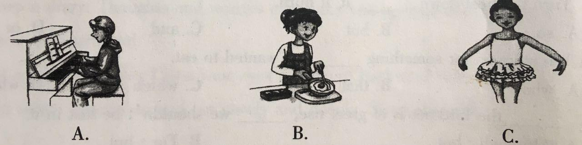

( ) 2. What will the weather be like tomorrow ?
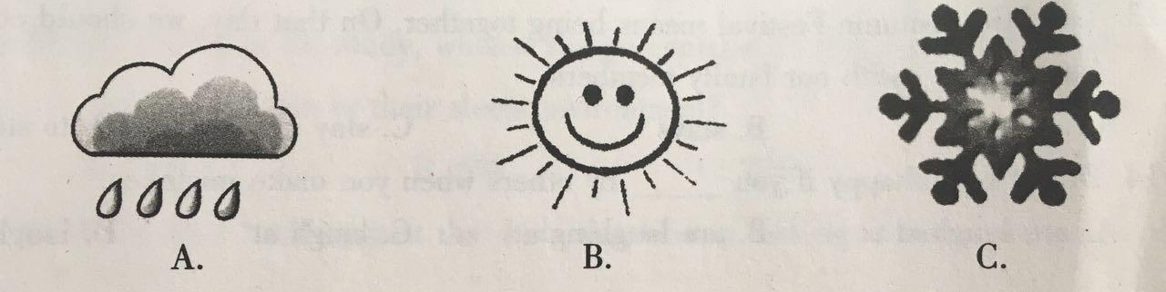

( ) 3. What is the second lesson ?
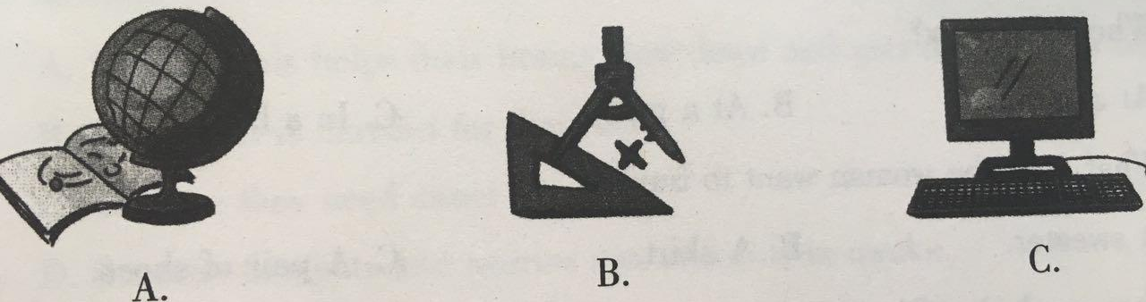

( ) 4. What’s Betty’s father ?
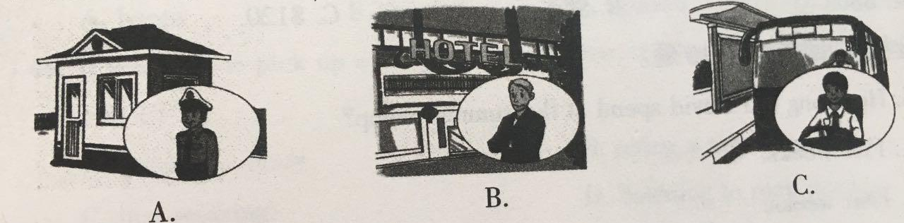

( ) 5. What is Tony going to do next week ?
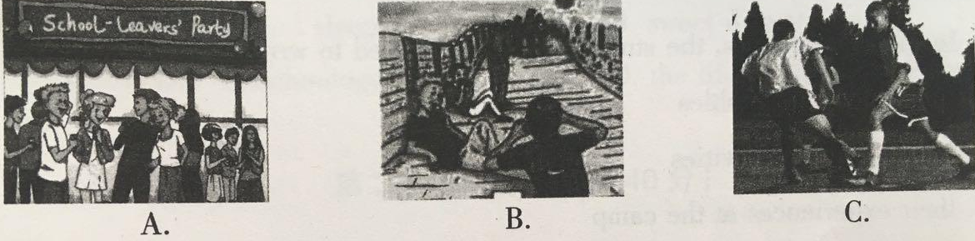

Part Two Match the best choice from A to G according to the dialogue you hear.
When will LIngling’s birthday party be held ?  What present will Daming give to Lingling ?  What will they do at the party ?  How will they go to Lingling’s house?  What are they talking about ? | By taxi.
 | On Sunday morning.
 | Celebrating the New Year.
 | Lingling’s birthday party.
 | A T-shirt.
 | Eat a chocolate cake.
 | Dance to music.

Part Three Choose the right answer according to the dialogue or passage you hear.
听第1段材料，回答第1-2题。
( ) 1. What’s wrong with the man?
He’s caught a cold. B. His leg hurts. C. He’s got a fever.
( ) 2. Where are they?
At home. B. At the hospital. C. At the hotel.
听第2段材料，回答第3-5题。
( ) 3. Where are they?
At a store. B. At a party. C. In a hotel.
( ) 4. What does the woman want to buy?
A sweater. B. A skirt. C. A pair of shoes.
( ) 5. How much does the woman pay?
$80. B. $40. C. $120.
听第3段材料，回答第6-10题。
( ) 6. How long did David spend at the summer camp?
Five weeks
Four weeks.
Three weeks.
( ) 7. In the writing class, the students are encouraged to write about ____.
their favourite hobbies
some unusual activities
their experiences at the camp.
( ) 8. What happened to David in 2012 ?
He got a prize.
He won a match.
His book came out.
( ) 9. David’s future book may be about ____.
his school life
a 16-year-old boy
his volleyball team
( ) 10. The passage is mainly about ____.
David hobbies
David’s summer camp
David’s writing experience

2017年大庆市中考英语试题第二部分笔试部分（95分）
2017年大庆市中考英语试题第一节选择题（共55分）
Ⅱ.Multiple Choice(共15小题，每题1分，共15分）
( ) 1. — What do you think of ____ party last night?
— Great! All of us had ____ good time.
A. a; a B. the; the C. the ; a D. a ; the
( ) 2. When you walk ____ the street, you can’t be too careful.
A. across B. through C. over D. for
( ) 3. If he drove more carefully, he wouldn’t have hurt ____ .
A. him B. herself C. his D. himself
( ) 4. We ____ our foreign teacher since he ____ to America.
A. haven’t heard from; returned B. didn’t hear from; returned
C. didn’t hear from; returns D. haven’t heard from; returns
( ) 5. I wouldn’t like to go to the library this Sunday, and I wonder ____ .
A. whether you can go with me B. that you can go with me
C. whether can you go with me D. can you go with me
( ) 6. Never ____ , and your dream will come true.
A. give away B. give up C. give out D. give back
( ) 7. Mr. Wu is a ____ teacher. He is always telling jokes.
A. humorous B. strict C. careful D. handsome
( ) 8. I bought this medicine but it doesn’t work ____ .
A. good B. well C. better D. the best
( ) 9. — Tony wasn’t chosen for the team. That was a bad ____ .
— You are right. We lost the game after all.
A. information B. promise C. decision D. introduction
( ) 10. Turn the heat down, ____ it’ll burn.
A. so B. but C. and D. or
( ) 11. We stopped for something is of great use, ____ we shouldn’t be lost in it.
A. who B. that C. which D. what
( ) 12. ____ the Internet is of great use, ____ we shouldn’t be lost in it.
A. Although; but B. For; but C. Although; / D. Because; and
( ) 13. The Mid-Autumn Festival means being together. On that day, we should
come back ____ with our family members.
Stayed B. stays C. stay D. to stay
( ) 14. Don’t be unhappy if you ____ by others when you make mistakes.
A. are laughed at B. are laughing at
C. laugh at D. laughed at
( ) 15. — Thank you very much for sending the postcard.
— ____.
A. No way B. Take it easy
C. Never mind D. You are welcome

Ⅲ.Cloze Test（共10小题，每小题1分，共10分）
Choose the best answer to complete the passage.
I worked for a short time as a cashier（收银员）at a restaurant a few months ago. I also helped to clean up the tables when it was very16 .
One night, just before Christmas, I found a large black17on the floor near one of the tables. I guessed I should check it to find out who the owner was, but I was very busy at the time. And I imagined that if there was something valuable in the wallet, the owner would be back. Sure enough, an hour later a man18the restaurant and asked if anyone had found a wallet. I asked him to describe the lost wallet. After he described it19, I gave him the wallet. He expressed20thanks when I handed it to him. He asked me if I had21it, and I told him “No” . At once he opened it and showed that it had nearly $800. He took out a twenty-dollar bill and thanked me again for my honesty. Then he22and walked away.
Thinking about the whole thing later, I wanted to know whether I would have been honest if I had known23was in the wallet ! I thought that if I had no way to find the owner24no one returned to get it, I might keep it. But it also came into my mind that I actually saved someone’s Christmas plan by finding and returning the wallet. The good feeling it gave me was25anything I could buy.
( ) 16. A. quite B. small C. busy D. hot
( ) 17. A. wallet B. schoolbag C. hat D. handbag
( ) 18. A. came out B. came back to C. left from D. looked for
( ) 19. A. sadly B. exactly C. silently D. happily
( ) 20. A. her B. my C. its D. his
( ) 21. A. opened B. shown C. made D. repaired
( ) 22. A. sat B. jumped C. passed D. turned
( ) 23. A. which B. when C. what D. where
( ) 24. A. but B. and C. so D. for
( ) 25. A. less than B. no more than C. more than D. not more than

Ⅳ. Communication(共5小题，每小题1分，共5分）
Choose the sentences from the box to complete the dialogue. (There are two extra sentences.)
( ) 26. Jack isn’t here today. Is he ill?
( ) 27. Shall we join in the summer camp?
( ) 28. Can I use your dictionary?
( ) 29. What’s wrong with you?
( ) 30. What is your new English teacher like ?

A. Good idea
B. I’m afraid so.
C. Relax.
D. She is friendly.
E. Come on, better get going!
F. Well, I’ve got a pain in my head.
G. No problem.

V. Reading Comprehension（共20小题，A，B，C每小题1分，D每小题2分，共25分）
(A)
Once a king showed two men a large basket in the garden. He told them to fill it with water from a well. After they began their work, he left them, saying , “ When the sun sets, I will come and see your work.”
One man said, “It is foolish of us to do such a thing. We can never fill the basket.”
The other man said, I’ll try it anyway.”
The first man said, “You may do as you like, but I’m not going to work at something foolish.”
He threw away his bucket(桶）and went away. The other man said nothing and kept on carrying water. Finally, the well was almost empty.
As he emptied the last bucket of water in the well, he saw a bright thing in it. He picked it up. It was a beautiful gold ring.
Just then the king came back. As soon as he saw the ring, he knew that he had found the kind of man he wanted. He told him to keep the ring for himself “You did so well in such a little thing,” he said, “I know I can believe in you.”
Judge the following statements True (T) or False (F).
( ) 31. The king said he would go to see the two men’s work when the sun set.
( ) 32. The first man went away with his bucket.
( ) 33. The second man emptied the last bucket of water in the well.
( ) 34. Finally, the second man found a basket in the well.
( ) 35. The second man was the person that the king wanted.

(B)
Books play an important role in our life. Gorky once said, “Books are the ladder of human progress.” Then which books is your favourite?
As a book lover, my favourite book is Robinson Crusoe. This book is written by Daniel Defoe, and it has already influenced many students like me. Every time I read it, I see a tall and strong Robinson. He is a brave man. I like him so much.
When Robinson was young, he dreamed of sailing on the sea day and night. Unluckily, after he grew up, he actually lived on an island for 28 years, where no people lived. During those years, he had to experience hunger and fight against natural disasters. Finally, the great man succeeded in dealing with a lot of difficulties and went out of the island because of his fighting spirit and hard work.
The book encourages me deeply. Our life cannot be lucky all the time. But no pain, no gain, and only hard work can lead us to a better life.
Choose the right answer according to the passage.
( )36. According to the passage, the book Robinson Crusoe ______.
A. is written by Gorky B. is written by Robinson
C. is written by Daniel Defoe D. is written by unknown person
( )37. What did Robinson dream of when he was young?
He dreamed of living on an island.
He dreamed of sailing on the sea day and night.
He dreamed of growing up.
He dreamed of fighting against difficulties.
( ) 38. Which of the following is NOT TRUE ?
Robinson experienced hunger on the island.
Robinson fought against natural disasters on the island.
Robinson managed to deal with a lot of difficulties on the island.
Robinson didn’t go out of the island.
( ) 39. From the passage we can know that ________.
our life can be lucky all the time.
hard work cannot lead us to a better life
Robinson is strong, brave and hard-working.
Robinson lived on the island for 20 years.
( ) 40. The best title of the passage is ____.
A. My Favorite Book B. A Book Lover
C. Life on an Island D. How to live on an Island

(C)
Things You Can Do to Help the Environment
CARS
Cars are getting bigger. Bigger cars burn more gas and increase problem with air pollution .So try to walk, ride, or take buses. If you drive a car, keep it in a good state. This can save gas and make less pollution.
ENERCY
The biggest use of home energy is heating and cooling .So turn down the heat, especially at night. Use energy-saving lights. And remember to turn lights off.
PRODUCTS
Each American throws away 10 kilograms of litter every day. Try to make less waste. Ask yourself before you buy something. Do I need it? Buy products that you can use over and over again.
WATER
Showers use a lot of water. In one week, a common American family uses as much water as a person drinks in three years! Take shorter showers or buy a special small showerhead. This can cut water use in half.
Choose the right answer according to the passage.
( ) 41. If you drive a car, you should ____.
burn more gas B. not drive too fast
C. keep it in a good state D. drive a bigger car
( ) 42. What’s the biggest use of home energy?
Heating and cooling B. Using energy-saving lights.
C. Taking showers. D. Driving cars.
( ) 43. If you want to take showers, you can read ___for information.
A. CARS B. NERGY C.PRODUCTS D.WATER
( ) 44. According to the passage, who is right?
Mary’s home is near the office, but she still drives to work.
Tom leaves the lights on at home during the day.
Ann asks herself before she buys something.
Mike always takes long showers in the morning.
( ) 45.The passage is most probably taken from ___.
a news report B. a diary C. a storybook D. a magazine

(D)
Cellphones are keeping children and teenagers awake at night. Researchers made a study of children and teenagers aged 6 to 19.Accorging to the study .72% of the children use their cellphones in their sleep environment .And they also have found a “strong connection” between the use of cellphones at bedtime and poor sleep.
One reason is not just that kids are sleeping too late with cellphones .Using them can also excite the children’s mind too much .The light from a smartphone influences how the body normally works and then leads to poor sleep. So many kids could be at risk.
Getting good sleep is very important for learning difficult subjects like math and foreign languages.
The American Academy of Pediatrics (AAP) suggests that kids should stop looking at cellphones at least half an hour before bedtime, because this helps their brains slow down and gets their bodies ready for sleep.
If you want to pick up a cellphones at bedtime, try the following activities instead:
•Keep a diary: Thoughts and worries can make you anxious at night .Writing thoughts on paper can clear your mind.
•Try a mind exercise: Close your eyes and count backward from 100 to 1.
•Just relax: Breathe in and out slowly and deeply. Sweet dreams!
Choose the right answer according to the passage.
( ) 46. According to the study, what is the percentage of the children who use their
cellphones in their sleep environment?
A.27% B.6% C.72% D.19%
( ) 47.Why does AAP suggests that kids should stop looking at cellphones at least
half an hour before bedtime?
Because this helps their brains slow down and gets their bodies ready for sleep .
Because it is harmful for their eyes.
Because they need sweet dreams.
Because thoughts and worries can make them awake.
( ) 48.What is the meaning of the underlined word “anxious”?
happy B. worried C. relaxed D. surprised
( ) 49. If you want to pick up a cellphone at bedtime, try the following activities
EXCEPT ____.
keeping a diary B. tryinga mind exercise
C. just relaxing D. listening to rock music
( ) 50. The passage is mainly about ____.
A. cellphones and sleep B. sweet dreams
C. the use of technology D. the life of children and teenagers

2017年大庆市中考英语试题第二节非选择题（共40分）
VI. Vocabulary （共5小题，每小题1分，共5分）
Complete the sentences with proper forms of the words given.
51. Tom usually ______ (play) football on Sunday afternoon.
52. We were beaten last year, but this year we want to do better and train ______ (hard).
53. I’m looking forward to ______ (receive) your letter.
54. It is ______ (surprise) that you have finished reading the book in just one day.
55. Chinese people often shake ______ (hand) and smile when meeting visitors.
56. In England, afternoon tea is often ______ (drink) as a light meal.
57. The play Snow White was very ______ (success) last night.
58. My teacher advises us ______ (do) sports between classes.
59. If everyone pays more attention to the environment, our life ______ (be) better.
60. Lao She, as a great ______ (write), is famous for his play Teahouse.

VII. Reading Comprehension（共15小题,A题每小题1分,B题每小题2分,共15分）
（A）
Fill in each blank with a proper word with the help of the first letter.
Reality show (真人秀) is a very p （61）with people, especially the show about how fathers get along with their children.
I notice that the kids of the Olympic champions (冠军) have a strong w(62) to win. When their fathers l(63) in the game, the kids will be very sad or even angry. They think that their fathers should be always Number One.
No one can win all the time. We have to learn to a(64) the bad result. Sometimes a strong wish is not good f(65) the kids to grow up.

61. p________ 62. w________ 63. l________ 64. a________ 65. f________
(B)
Dogs like living with people. They are very friendly. They can do many things for people.
Some dogs help people to look after sheep. Some dogs help people to find the lost children. Some dogs can help the blind, and they are the Seeing Eye Dogs.
Now we can see this kind of dogs all over the world. They are working for the blind. The Seeing Eye dog is strong and easy to train. He helps the blind to walk from place to place. Before a dog becomes a Seeing Eye dog, he must learn in a training school for about three months. First the dog has to learn to sit or stay when he hears the trainer’s call. In his next lesson the dog learns to take his trainer to cross busy streets. The dog has many things to learn. At the end of the training he must take tests. When he passes the tests, the Seeing Eye dog will do things by himself.
The new master (主人) may be a man, a woman, or even a child. It takes the dog and his blind master about a month to learn to work and live together.
Answer the questions according to the passage. (必须使用完整语句作答)
66. Besides helping people to look after sheep and find the lost children, what else can dogs do?
___________________________________________________________________
67. Where can we see the Seeing Eye Dogs now?
___________________________________________________________________
68. How long must a dog learn in a training school before he becomes a Seeing Eye dog?
___________________________________________________________________[来源:学§科§网Z§X§X§K]
69. What must the dog do at the end of the training?
___________________________________________________________________
70. Who may be the new master of a Seeing Eye dog?
___________________________________________________________________

Ⅷ.Writing（本题共2小题，A题5分，B题10分，共15分）
（A）
目前，共享单车（public bicycles）变得越来越受欢迎。请根据下面的表格用五句话写出它的优缺点。

优点 | 使我们的生活更容易  有助于环保  免费
缺点 | 有时不能被及时归还  占据空间

71._____________________________________________________________
72._____________________________________________________________
73._____________________________________________________________
74._____________________________________________________________
75______________________________________________________________
(B)
你即将初中毕业，美好的暑假生活就要开始了。如何有意义地度过初中的最后一个暑假呢？请你以How to Spend a Meaningful Summer Holiday 为题写一篇短文，要点如下：
生活习惯
休闲娱乐
社会实践活动
注意：1. 词数80词左右；（开头已写好，不计入总词数）
2.不得出现真实的人名，校名等相关信息。
How to Spend a Meaningful Summer Holiday
The wonderful summer holiday is coming. ______________________________
___________________________________________________________________________________________________________________________________________________________________________________________________________________________________________________________________________________________________________________________________________________[来源:学,科,网Z,X,X,K]_

