
2017年苏州市初中毕业暨升学考试试卷
英 语
注意事项：
1．本试卷共七大题，满分100分（不合听力口语30分），考试用时100分钟；
2．答题前，考生务必将自己的姓名、考点名称、考场号、座位号用0.5毫米黑色墨水签字笔填写在答题卡相对应的位置上，并认真核对条形码上的准考号、姓名是否与本人相符合；
3．答选择题必须用2B铅笔把答题卡上对应题目的答案标号涂黑，如需改动，请用橡皮擦干净后，再选涂其他答案；答非选择题必须用0.5毫米黑色墨水签字笔写在答题卡指定的位置上，不在答题区域内的答案一律无效，不得用其他笔答题；
4．考生答题必须答在答题卡上，答在试卷和草稿纸上一律无效。
第一部分单项填空（共15小题；每小题1分，满分15分）
请认真阅读下面各题，从题中所给的A、B、C、D网个选项中，选出最佳选项，并在答题卡上将该项涂黑。
1. Nora opened the box. To her surprise, ______ was a gold watch
A. outsideB．insideC. beside D. behind
2. You are speaking too fast. Can you speak a little ______?
A. more slowly B. most slowly C. more loudlyD. most loudly
3. Dad doesn’t always come to you. You have to fight and save ______
A. yourself B. himselfC. myselfD. herself
4. —Jack, why have you decidedChinese folk music as a course.
—To learn more about Chinese culture.
A. take B. takenC. taking D. to take
5. Mom, have you seen my toy bear? I don’t know _____ I have left it.
A. why B. when C. how D. where
6. — Sorry, I've forgotten your name. Can you _____me?
—I'm Daniel.
A. remindB. receive C. respect D. remember
7. —I'm afraid I can't come to your wedding, Julia.
— ! But why?
A. How happy B. How luckyC. What a pity D. What nice news
8. You will never achieve success ____ you devote yourself to your work.
A. afterB. ifC. becauseD. unless
9. —Shall we go on Friday or Saturday?
—Either day is OK. It makes no to me.
A. choicc B. changc C. diffcrcncc D. decision
10. — Excuse me, what time does Flight BA 2793 leave?
—Just a minute. I____for you.
A. check B. checked C. will check D. havc checked
11. Dogs_____run through soccer games at the park. It's dangerous
A. should B. shouldn'tC. need D. needn't
12. Millie, now go to have a nice bath and an early night, so that you will be for the
journey tomorrow.
A. safe B. patient C. freshD. natural
13. —Why hasn't Tony come?
—The invitation letter to Toby by accident
A. was emailed B. has emailed C. is emailed D. emailed
14. As soon as sheat home, Sally knew she had bought the wrong dress.
A. handed it inB. tried it onC. cut it outD. made it up
15. —He is too short to be a succcssful basketball player.[来源:学。科。网Z。X。X。K]
—_______. Every dog has its day.
A. I think soB. It's hard to sayC. That’s rightD.You'd better not
笫二部分完形填空(共10小题；每小题1分，满分10分)
请认真阅读下面短文，从短文后各题所给的A、B、C、D四个选项中，选出最佳选项，并在答题卡上将该项涂黑。
Humans are mammals（哺乳动物）．Most mammals are born able to do many things.
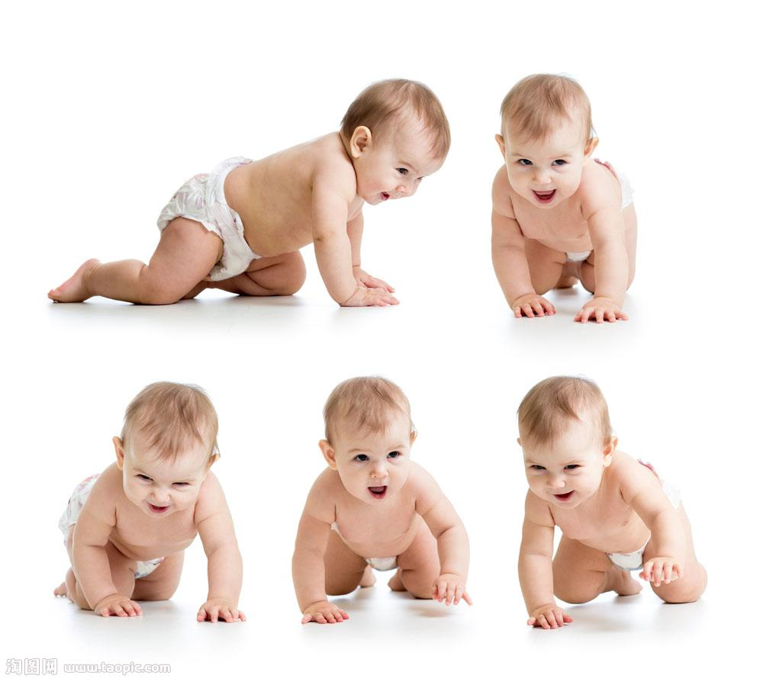
Some can walk within a few minutes of being born. They have to be able to run away if
16is near. But human babies are born17. They need the care of adults to live.
In the first month of life, babies cannot smile or sit up. They cannot even hold up their own heads 18 some help from grown-ups.
In the next few months, babies grow a lot. They learn to roll over, support their heads, and 19 sit up while being held.
Babies also have to learn to use their 20 . It takes months for them to learn to reach for objects. At around six months old many babies can 21 an object from one hand to another.
Babbling is22 a human baby learns to speak. Babies all seem to make similar
sounds by babbling. They try to imitate (模仿) the sounds they hear from adults. It will take about nine months 23 a baby can say real words.
Somewhere around a baby's first birthday he or she may stand or walk with help. Soon
the baby will 24 around on his or her own!
The first year of a baby's life is a time of growing and 25 . Growing sure takes a lot
of work!
16. A. food B. danger C. waste D. peace
17. A. carelessB. harmless C. hopeless D. helpless
18. A. of B. forC. without D. by
19. A. even B. never C. everD. still
20. A. legsB. heads C. eyes D. hands
21. A. keepB. move C. hold D.make
22. A. why B. how C. which D. where
23. A. before Bsince C.afterD. while
24. A. look B．showC. run D. sit
20. A. speaking B.smilingC. crying D. learning
第三部分 阅读理解（共12小题；每小题2分，满分24分）
请认真阅读下面短文，从短文后各题所给的A、B、C、D四个选项中，选出最佳选项，并在答题卡上将该项涂黑。

ON SALE
SUNSHINE SHOE FACTORY
THE WORLD’S BEST
All types of shoes half price or less*
Every shoe you've ever dreamed of!
Sports shoes, soccer boots, running shoes,
dance shoes, ballet shoes, hip-hop shoes,
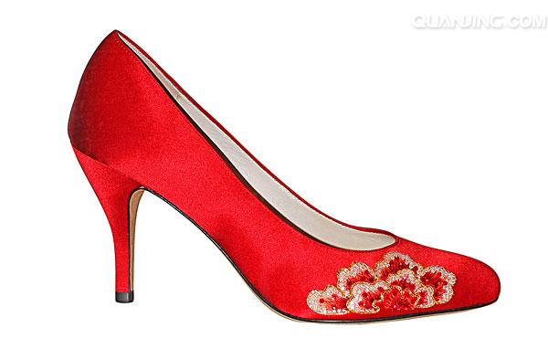beach shoes, boat shoes, fashion shoes,
high-heeled shoes, flat shoes ...
All stock must go!
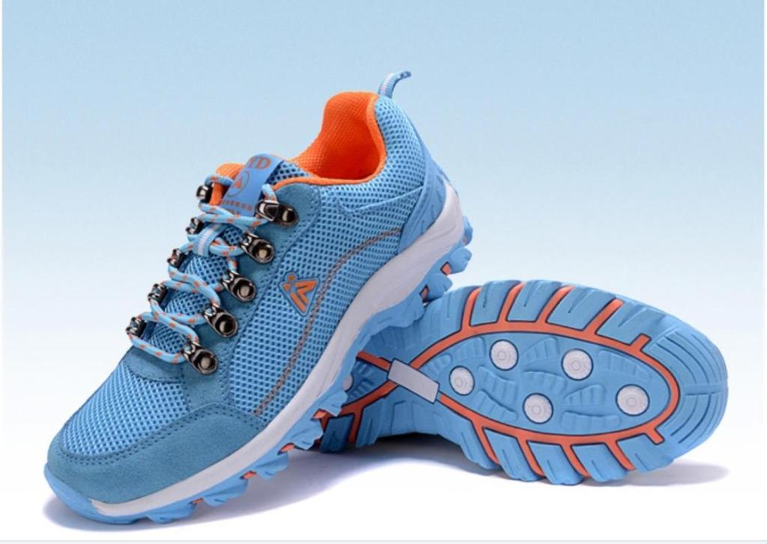WHEN
Saturday 8 July
9:00a.m. — 3:30p.m.
Forget all the other sales. Come and see us!
You’ll be sorry if you miss out!

A
26. The material above is __________.
A. a letter B. an advertisement C. a reportD. a ticket
27. The material mentions all the information below EXCEPT_________.
A. the types of shoesB. the time of the sale
C. the address of the factory D. the name of the factory
B
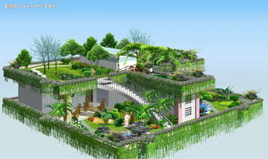
Last summer, Maria and her mother moved from their house in the countryside to building in Chicago. Maria really liked some things about the city, but she missed her house and yard in the countryside.
One day, Maria was in her flat building when she noticed her neighbor, Mrs. Garcia, carrying a gardening tool and a bag of soil. Maria wondered how Mrs. Garcia was able to garden in the city.
“My mom used to grow the most delicious vegetables, and I know she misses her garden now that we don't have a yard,” said Maria.
Mrs. Garcia laughed. “I’ll show you,” she said.
Maria thought that Mrs. Garcia would take her to the park, but she took her to the roof (屋顸). When the door opened, Maria was surprised to see rows of flowers and vegetables on the roof.
“What a wonderful garden! “ said Maria.
Mrs. Garcia told Maria that for a long time the roof was just an empty space. Then some of the people in the building asked the owners to turn it into a community garden. The building owners liked the idea because the plants not only helped to keep the air clean, but they also helped to keep the building cooler during warmer weather.
“I plant flowers in my own place,” Mrs. Garcia said, but you would be surprised by how different the plants are up here. Some people grow vegetables just like your mom. You can do some of the same things in the city as in the countryside. You just have to be creative ! "
28. Which of the following is NOT the advantage of the community garden?
A. It used the empty space well.B. It helped keep the air clean
C. It helped keep the building cooler. D. It made the building stronger
29. After Maria visited the garden, she would most probably ask her mom to_______.
A. go back to the countrysideB. pick flowers from the garden
C. grow vegetables on the roof D. show her around the park
30. What is the best title for this passage?
A. A Creative Lady B. A Rooftop Garden
C. An Empty Roof D. A Special Building
C
Do you have brown hair? Are you taller than other kids your age? These characteristics
were decided before you were born. You got your traits from your parents. They passed their
traits on to you through genes (基因).
Genes carry codes (代码) for blue eyes or brown eyes. Genes say how tall you will get
and what color hair you will have. You got half of your genes from your mother. You got half
of your genes from your father. So you have your own set of genes. Each person gets different genes for each body part. That is why you look like but not exactly like your brother or sister.
A dominant (显性的) gene shows up most of the time. Brown eyes are dominant over
bluc eyes. A recessive (降性的) gene shows up less often. Light hair comes from a recessive
gene. Dark hair is more common. Look at the eye color and hair color of the people around
you. You will see that this is true.
Genes help to make you who you are. But they don't tell the whole story. Your genes
may help you to be fast and strong. But you still need to learn how to run or swim or skate
wel.
31. The underlined word “traits” in Paragraph 1 means________.
A. charactcristicsB. expericncesC. achievements D. possibilities
32. According to Paragraph 3, you can see most of the people around you have______.
A. brown eyes with dark hair B. brown eyes with light hair
C. blue eyes with dark hair D. blue eyes with light hair
33. What is the passage mainly about?
A. Genes carry codes for eyes and hair. B. Genes help to make you who you are.
C. Genes help you to be fast and strong. D. Genes make brothers look similar.
D
Lizzie-s diary from Antarctica (南极洲)
Day 3: Tuesday December 2
We planned to go to Rothera that morning. We’d be staying there for the next two weeks. Because Antarctica is the windiest place on earth, sometimes you can’t fly at all.
We had a nervous wait over breakfast to find out if we’d be leaving that day. People have to stay in Stanley for weeks while the pilots wait for good weather
It turned clear at 9:30 and we took off at 10:30 on a little red plane called a Dash-7. But even when we were in the air, there was still a chance we wouldn’t be able to fly the whole day.
[来源:学科网]
Day 4: Wednesday December 3
After waking up in the Antarctic for the first time today I can understand why
everybody who comes here falls in love with the place. It is really beautiful.
We’re staying at Rothera Survey base with mountains of ice all around. It s about minus 20C today, which for me is very cold, but the regulars(常客) here are often seen walking around in T-shirts !
Day 5: Thursday December 4
I woke up to another beautiful sunny day here in the Antarctic. I’m told it’s a bit colder
today, about minus 50C , but it’s not very windy so it feels warmer. Those of us who are
new to the bas have to do a spccial training course before we're allowed to go off base to
other stations or to go snowboarding over the nearby hill.
Day 7: Saturday December 6
Not a cloud in the sky and it’s warm enough to sit outside (in a jacket).
The most amazing thing about this place is how the scenery (凤景) changes every day.
At first I thought I was going mad. I’d step outside in the morning and think, “I’m sure that big mountain of ice wasn’t there yesterday.” It’s because the sea ice is always moving—slowly thankfully !
34. Lizzie sat outside wearing a jacket on_______.
A. Tuesday B. WednesdayC. ThursdayD. Saturday
35. What could stop Lizzie from leaving Stanley for Rothera?
A. Strong winds. B. Thick clouds.C. Mountains of ice. D. Low temperatures.
36. How did Lizzie feel during her stay in the Antarctic?
A. Afraid. B. Nervous. C. Amazed.D. Bored.
37. What impressed Lizzie most about Rothera was that _______.
A. people walked around in T-shirts B. there was a special training course
C. the weather was sometimes warmD. the scenery changed every day
笫四部分词汇检测（共10小题；每小题1分，满分10分）
根据下列句子及所给汉语注释或通过上下文，在答题卡标有题号的横线上，写出空缺处各单词的正确形式。每空只写一词。
38. ▲(最后), I would like to thank you all for coming here today.
39. In Switzerland, some of the old clothes are▲ (卖) in charity shops.
40. Life is like a race. I’m ready to take on new▲ (挑战) any time.
41. Everyone, you need to have a dream. The future of China▲ (依靠) on you
42. My grandma always tells me ▲ (没有什么）is more important than health.
43. It took him much longer - hundreds of ▲ （额外的）hours to improve his skills.
44. Juice is to drink as pork is to▲ .
45. —Can I have some more sweets?
—OK, but eating too much sugar can▲ to tooth problems.
46. —Why are you all wet?
—It’s ▲ heavily. I forgot to take my umbrella
47. —Do you still take the bus to school?
—No. Now I can come to school by underground ▲ of by bus.
第五部分句子翻译（共5小题；每小题3分，满分15分）
将下列句子译成英语，并将所译句子写存答题卡标有题号的横线上。
48.苏州有着2500多年的历史。
49这座城市以其美丽的园林而出名。
50.这几年苏州发生了很大的变化。
51.住在这样一个现代化的城市里很舒适。
52.我们会尽力使苏州成为一个更美好的地方。
第六部分 阅读表达（共3小题；53题1分，54题2分，55题3分，满分6分）
请认真阅读下面短文，用英语回答短文后的问题，并将答案写在答题卡标有题号的横线上。
Book Review by Patricia Ann Turner
It is school holiday time and Mitch Morrow’s family have just moved to a new home
In a new place. Mitch can’t stop worrying about what his new school is going to be like. He
is not even sure about the neighbours. Next door live the Bull family and they have two
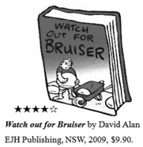
children, Di and Bruce.
The older of the two, Bruce, is a large boy, about Mitch’s age. Mitch. Watches him carry big rocks. He looks really strong and unkind. Mitch gives him the name Bruiser（彪形大汉）
because he has a black eye. Did he get it in a fight? Mitch imagines all the worst possible things about Bruiser. He is probably the class bully (恶霸). In his mind Mitch thinks of him as the enemy.
Things seem to get more worring for Mitch. He finds out he will be in the same class as Bruiser. Then on the first day of school he learns that Bruiser is his buddy for the day.
This is a lovely story for young readers to read or listen to. It has a wonderful message for all children about facing their fears —real and imagined.
The pictures in the book catch the worry Mitch feels and make Bruiser rcally look like a bad guy.
My only complaint is the colour of the printing of the text. Why there are pages of different coloured print I cannot tell. They may create problems for children with poor eyesight.
I give it four stars.
53. Who is the book Watch out for Bruiser for?
54. What does Mitch imagine Bruce to be?
55. After reading the book review, do you think the book is worth reading? Why or why not?
第七部分书面表达（共1题；满分20分）
To: suhua@ china.com
From: davidsmith@ britain.com
Subject: School life
Dear Su Hua,
Glad to hear you’re graduating from junior high. I’m interested in how you feel about those three years of school life. Would you please tell me the following things?
●What do you like best about your school life?
●What-s the biggest problem as a junior student?
●Who has helped you most? And why?
● Do you enjoy your school life? Why or why not7
I look forward to hcaring from you soon.
All the best,
David

假定你是苏华，你最近认识的英国笔友David给你发了一封电子邮件，想了解你初中三年来在学习和生活方而的一些收获、困惑和感受。请认真阅读下而的邮件，根据信中的内容及你的实际用英语回复。
洼意：1．词数90左右，开头和结尾已经写好，不计入总词数；
2．回复须包括所有要点，可适当发挥，使全文连贯、通顺；
3．文中不得提及真实的人名、校名等相关信息。
Dear David，
Thank you so much for your email. I’m very happy to tell you about my school life. __________________________________________________________________________________________________________________________________________________________________________________________________________________________________________________________________________________________________________________________________________________________________________________________________________________________________________________________________________________________

How about your school life? Write to me soon.
Best wishes,
Su Hua
2017年苏州市初中毕业暨升学考试
英语试题参考答案
第一部分单项填空（共15小题；每小题1分，满分15分）
1．B2．A3．A 4.D5.D
6．A7．C8．D 9. C 10. C
11．B12．C13．A 14.B 15. B
第二部分完形填空（共10小题；每小题1分，满分10分）
16.B17.D18.C 19.A20. D
21.B22.B23.A 24. C 25. D
第三部分 阅读理解（共12小题；每小题2分，满分24分）
26.B 27．C28.D 29. C 30.B
31．A32．A33.B34. D35.A
36.C37.D
第四部分词汇检测（共10小题；每小题1分，满分10分）
38. Finally39. sold 40. challenges 41. depends 42. nothing
43. extra 44. meat 45. lead 46. raining 47. instead
第五部分句子翻译（共5小题；每小题3分，满分15分）
Possible answers:
48. Suzhou has a history of more than 2,500 years.
49. This city is famous for its beautiful gardens.
50. Great changes have taken place in Suzhou over the years.
51. It’s comfortable to live in such a modern city.
52. We will try our best to make Suzhou a better placc.
笫六部分 阅读表达 (共 3小题;53题 1分,54题 2分,55题 3分,满分 6分)
Possible answers:
53. It’s for young readers.
54. Mitch imagines him to be a bad boy.
50. Yes. Because it tells me how to face the fears.
No. Because the colour of the printing is bad for my eyes.
第七部分书面表达 (共1题 ;满分 20分)
One possible version:
Dear David,
Thank you so much for your email. I’m very happy to tell you about my school life.
I like the Football Club best because I’ve made quite a few friends by joining the club.
Moreover, it’s an excellent chance to learn team spirit.
However, I’ve also met some problems over the three years. The biggest one is how to
achieve a balance between my schoolwork and my hobbies. Whenever I am in great need, my
English teacher always comes to me, so she is the person who has helped me most in the junior high.
In all, I enjoy my school life because it’s colourful and meaningful.
How about your school life? Write to me soon.
Best wishes,
Su Hua

