2018年安徽合肥中考英语模拟试题（含答案）
英语试卷（试题卷）
第一部分：听力（共五大题，满分30分）
I.关键词语选择（共5小题；每小题1分，满分5分）
你将听到五个句子。请在每小题所给的A、B、C三个选项中选出一个你听到的单词或短语。每个句子读两遍。
1. A. lovely B. lively C. life
2. A. price B. prize C. surprise
3. A. afford B. afraid C. Africa
4. A. try B. tried C tired
5. A. look for B. look outC. look after
II．2018年安徽合肥中考英语模拟试题短对话理解（共10小题；每小题1分，满分10分）
你将听到十段对话，每段对话后有一个小题．请在每小题所给的A、B、C三个选项中选出一个最佳选项。每段对话读两遍。
6. What kind of sports does Tony like?
A 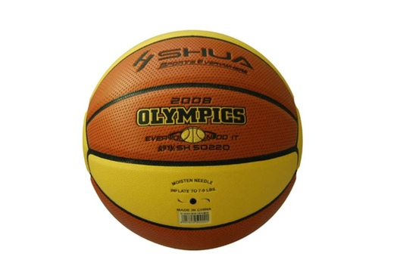 B.  C. 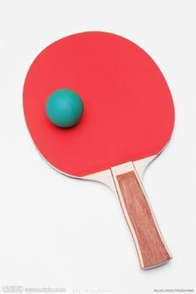
7. What hurt the boy?
A. 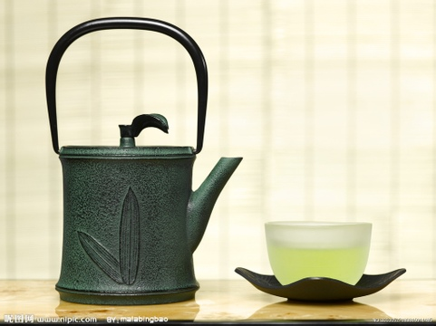 B. 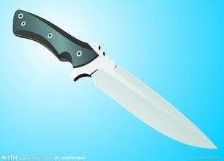 C. 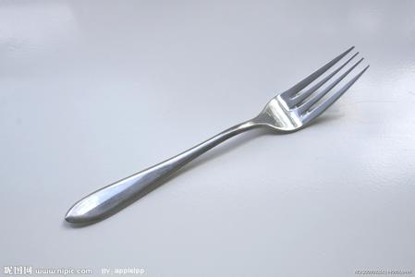
8.What’s the woman doing now?
A. 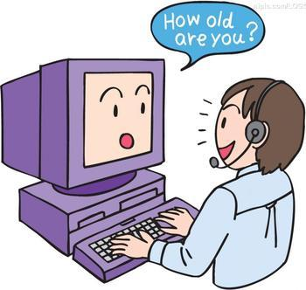 B. 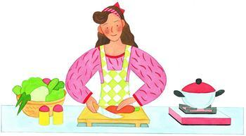 C. 
9.What does the man want to buy?
A. 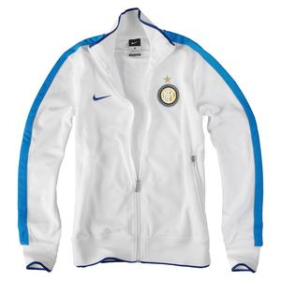 B. 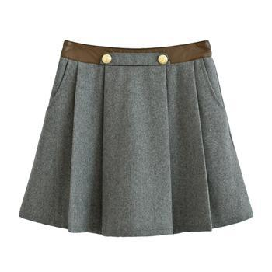 C. 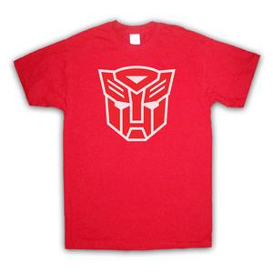
10.What can the boy eat for supper?
A. 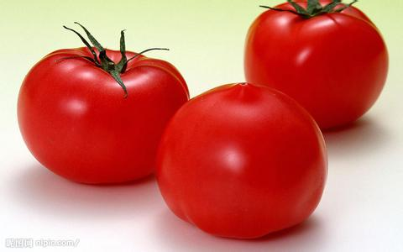 B. 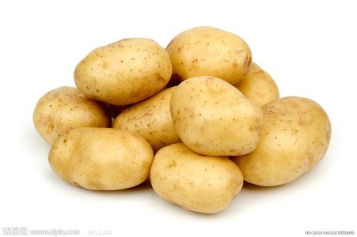 C. 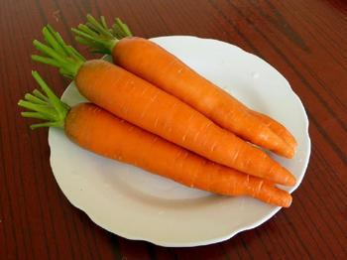
11. Why does Tom come here? _.
A. For holiday B. On business C. To study English
12. How much is a cup if you buy two?
A. Three yuan B. Five C. 2.5 yuan
13. What time is it now? It’s ___ now.
A. 7:00 B. 7:30 C. 6:30
14. What is Jim’s favourite? __.
A. Singing B. Playing football C. Dancing
15. __ would like to drink some orange juice.
A. Lucy B. Lily C. Mary
III. 2018年安徽合肥中考英语模拟试题长对话理解（共5小题；每小题1分，满分5分）
你将听到两段对话，每段对话后有几个小题．请在每小题所给的A、B、C三个选项
中选出一个最佳选项。每段对话读两遍。
听下面一段对话，回答第16至17小题。
16. When is Alice’s birthday?
A．tomorrow． B．The day after tomorrow C. The day they had the talk
17. What will the man and the woman buy for Alice?
A．A CD． B．Some flowers． C. A box of chocolate
听下面一段对话，回答第18至20小题。
18. What size does the man want?
A. Size L B. Size M C. Size S.
19. What color does the man like?
A. Brown. B. White. C. Black.
20. How much is the T-shirt?
A. ＄45 B. ＄46 C. ＄48
IV. 2018年安徽合肥中考英语模拟试题短文理解（共5小题；每小题1分，满分5分）
你将听到一篇短文，短文后有五个小题。请根据短文内容，在每小题所给的A、 B、C
三个选项中选出一个最佳选项。短文读两遍。
21. I read English for ___ in the morning.
A. twenty minutes B. half an hour C. ten minutes
22. I go back home _.
A. on foot B. by bike C. by bus
23. I have classes every day.
A. 4 B. 7 C. 3
24. I have lunch .
A. at home B. at school C. on my way to school
25．I take a bath ___.[来源:初三网]
A. at 9:30 B. after 9:30 C. before 9:30
V. 信息转化（共5小题；每小题1分，满分5分）
你将听到一篇短文。请根据短文内容，写出下面表格中所缺的单词，每空仅填一词。短文读两遍。
When | Last ___26__ I was on the way to school.
What | I found a CD27 on the ground.
Where | This happened on a(n)28_.
How | The songs were popular and 29.
Who | At last I handed it over to the ___30 of the bus station.

第二部分 英语知识运用（共三大题，满分55分）
VI．单项填空（共20小题；每小题1分，满分20分）
从每小题所给的A、B、C、D四个选项中选出一个可以填入空白处的最佳选项。
31. Today, we have many other_ to pay besides coins and paper money.
A. excuses B. ways C. chances D. plans
32. Many people think Peng Liyuan is the most beautiful First Lady. And _songs are also famous.
A. sheB. hersC. her D. herself
33. We are all told to take part in the Dish—eating up Campaign . So everyone should _
the dishes they ordered .
A. serve B. empty C. catch D. control
34. — What bad weather !It rained again .
— Yeah. _ when you walk to school .
A. Mind your head  B. Keep of the grass
C. Watch your step D. Be quiet
35. —Do you think Hefei is a city?
—Certainly. It has beautiful buildings, tidy streets and hard-working people.
A. likely B. lonely C. lively D. lately
36. —I will try my best in the English speech I may fail.
—Wonderful! I will support you all the time.
A. when B. untilC. unless D. though
37.Now many people_ posting articles and photos onto the WeChat(微信) to share with friends.
A. are used forB. are used to C. used to D. use to
38. —Why are you still here? They are ready to start?
—Sorry, but I _ when to leave.
A. don’t tell B. didn’t tell C. am not told D. wasn’t told
39. —What is mum cooking in the kitchen?
—Fish, I guess. How nice it _!
A. looks B. sounds C. tastes D. smells
40. —You have tried on several hats.
—Sorry to take up too much time of yours. But _ of them looks good on me.
A. neither B. any C. none D. both
41 —I’m so worried about the exam and I’m afraid I can’t pass it this time.
—_! I’m sure you can make it.
A. Don’t mention it B. That’s right C. No problem D. Cheer up
42. —You haven’t been to Hawaii, have you ? I went there last month.
—_. How I wish to go there!
A. Yes, I have B. Yes, I did C. No, I didn’t D. No, I haven’t
43. — Wow , the opening ceremony of Sochi Winter Olympics was fantastic last night !
— I missed it ! I _ for the next monthly exam .
A．am preparing B．have prepared C. was preparing D. will prepare
44. —Did you finish reading the article?
—Thanks _ your dictionary, I could have a good understanding of it.
A. for B. to C. with D. by
45. — Shall we go to the second floor to buy some new furniture?
—OK . Let’ s look for the sign _ together .
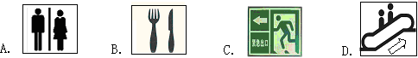
46. Mother’ s Day is coming . I’ m thinking about _ .
A. what present I gave her B. where we had a big meal
C. how I will give her a surprise D. if I planned a party for her
47. —Is the old man walking in the hallway our headmaster?
—It_ be him. He come to school to see us every morning.
A. can’tB. mustn’t C. needn’t D. must
48. —Have you finished writing the composition about Mo Yan_ will be handed in tomorrow?
—Not yet! I need to find more on the Ineternet.
A. who B. what C. whom D. which
49. —You should _ the shower when you are washing your hair.
—OK, I will. We need to save water.
A. give off B. put off C. turn off D. take off [来源:Z*xx*k.Com]
50. 一Hi, waitress. Is there a table for two, please?
一Is the one near the door OK？
A. Take your time. B. It's my pleasure. C. What a pity! D. This way, please.
VII. 2018年安徽合肥中考英语模拟试题完形填空（共20小题；每小题1.5分，满分30分）
阅读下列短文，从每小题所给的A.B.C.D四个选项中选出一个最佳选项。
A
A man was walking through a forest. He was holding an axe(斧子) in his hand. A little tree stopped him and said, “Please use your axe to___51___those tall trees, my friend. Because of them, the sunlight cannot fall on me, and I have no room at all to spread myself. 52___them. I’ll be the pride of this part of the forest these years.”
The man decided to help the little tree. He used his53 to cut down the trees. Then the little tree had enough room. The little tree felt happy and said54 to the man. When the sun came out, the little tree lost water and it became very55. Later when a storm came, the little tree56___ all its leaves and branches.
“Oh, poor little tree!” a bird said, “You shouldn’t have asked the man to cut down the57___. The tall trees protected you___58___ you didn’t worry about heat or wind and rain. Time went by and you have___59___. When you get tall and60___, you can have enough strength to fight against the sun and the storms. So I don’t think you should do that.”
After hearing the words of the bird, the little tree felt regretful(后悔).
51. A. put down B. cut down C. put off D. set off
52. A. WithB. Without C. Because of D. As for
53. A. knifeB. handC. axe D. rope
54. A. sorryB. thanks C. no D. hello
55. A. thirsty B. hungry C. happy D. sad
56. A. loved B. lost C. caught D. threw
57. A. grassB. plants C. trees D. forests
58. A. although B. whileC. if D. so that
59. A. grown up B. got upC. used upD. stayed up
60. A. weakB. low C. short D. strong
B
Whenever we see something new, we wish to write it down. We will be happier if we share our experience with others. Then 61 can we write better travel stories? Don't always believe your 62 . You may be clever, but is it possible for you to remember 63 ？You're seeing and hearing so much information 64 you're on a trip. When you return to write about your travel stories, you may 65 something. So you should make notes, take photos, and if 66 , take videos. In this way, you can describe your travel 67 missing anything. Photographs are very useful for you to remember what you have seen. As you see the photographs, you can describe your experience 68 When you are writing your travel stories, make sure that they are not too short as your readers may not get the full impression of them and make sure they're not 69 long that the readers may get bored. Make sure that your stories have many popular factors（因素）and the readers will find your travel stories not only pleasant to read, but useful as well: Popular factors are 70 to eat, places to stay and views to enjoy while travelling.
61. A. whatB. how C. when D. which
62. A. feeling B. hobbyC. memoryD. ability
63. A. anything B. something C. nothingD. everything
64. A. whileB. until C. before D. unless
65. A. provide B. designC. forget D. invent
66. A. possible B. important C. relaxingD. particular
67. A. through B. including C. except D. without
68. A. simply B. clearlyC. softly D. politely
69. A. so B. very C. too D. quite
70. A. wine B. menu C. food D. clothes

VIII.补全对话（共5小题；每小题1分，满分5分）
根据对话内容，从方框内的选项中选出能填入空白处的最佳选项，其中有两个为多余选项。
A: Long time no see, Liu Li. What’s your plan for the coming May Day?
B: I have no idea.71
A: I am going to Tunxi by train, a long history town.
B: 72
A: Because my grandparents live there. 73 I miss them very much.
B: Oh, I heard Tunxi Ancient Street is great. _74
A: I’m planning to visit not only Tunxi Ancient Street but also Xidi Village and Hong Village.
B: Tell me more, please.
A: Another great thing is to climb the Yellow Mountain.
B: That’s fantastic. _75
A: I will stay there for a week, taste traditional food. That’s really great.
B: You’re so lucky. Let me ask my mother if she allows me to go with you.
A. Where did you go there?
B. What about you?
C. Why are you going there?
D. What else are you going to do?
E. Could you tell me something about your plan?
F. I haven’t seen them for two years.
G. Who are you going with?
第三部分 2018年安徽合肥中考英语模拟试题阅读理解（共一大题，满分40分）
IX. 阅读理解（共20小题；每小题2分，满分40分）
阅读下列短文，从每小题所给的A、B、C、D四个选项中选出一个最佳选项。
A
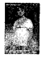
Jane Austen was one of the most well-known women writers of the world. She
was born in England in 1775. Jane loved reading and writing. She wrote a number of
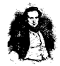
famous novels in her life. Among them, Pride and Prejudge written in 1799 was the most popular.
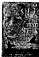
Victor Hugo, born in 1802 in France, was one of the best writers in the 19th century. The talent in writing and hard work brought great success to Hugo at an early age. His most popular novel, The Hunchback of Notre-Dame ,was written in 1831. The book was so successful that it was quickly translated into many other languages across Europe.
Ernest Hemingway, an outstanding American writer and reporter, was born in
1899. His life experience had a great influence on his writing style. Hemingway lived in Franceand Italy between the 1920s and the 1950s. Most of his books, like The Sun Also Rises, werewritten at that time. He won the Nobel Prize in 1954 mainly because of the novel The Old Man and the Sea. Chinese famous writer Mo Yan also won the Nobel Prize in 2012.
76. Jane Austen wrote Pride and Prejudice at the age of_.
A . 12 B.24 C.45 D.60
77. Victor Hugo was from_.
A. Asia B. America C. Europe D. Africa
78. The novel _brought the Nobel Prize to Hemingway.
A. Pride and Prejudice B. The Hunchback or Notre-Dame
C. The Sun Also Rises D. The Old Man and the Sea
79. Which of the following is NOT true?＿＿
A. Jane Austen was a famous woman writer in the 19th century from England.
B. Victor Hugo wrote his most popular and successful novels at the age of twenty-nine
C. Ernest Hemingway was born in 1899 and spent his early life in the USA.
D. Jane Austen, Victor Hugo and Hemingway all had great talent in writing.
80. _is the best title of this passage
A. Writers and their Books B. Writers and their Hard Lives
C. Success and TalentD. Books and their Influence

B
Lester was walking in the street with two huge and heavy suitcases . A stranger walked up to him and asked ,“Have you got the time ?”
Lester stopped , put down the suitcases and looked at his watch .“It’ s five fifteen ,”he said .“Hey , what a nice watch !”said the stranger .Lester smiled a little and said ,“Yes , it’ s not bad . Look at this .”Then he showed the stranger a time display for the 86 largest cities in the world .He hit a few buttons and a voice told the time in Chinese . Lester continued ,“Its voice can be set for different languages .”The stranger seemed very interested in the watch .“That’ s not all ,”said Lester . He then pushed a few more buttons and a small map appeared on the watch .“The map can show where we are ,”explained Lester .“I want to buy this watch !”said the stranger .“Oh , no , I’ m not selling it . I have spent nearly two years making it ,”said Lester .“I’ ll give you $ 1,000 for it !” “Oh , no , I’ ve already spent more than that .”“I’ ll give you $ 5,000 for it !”
Lester stopped to think . The stranger quickly gave him a check（支票）and said ,“$ 5,000 . Here it is .”Lester finally agreed to sell the watch . When the stranger was going to leave with the watch , Lester pointed to the two huge suitcases and said ,“Hey , wait a minute . Don’ t forget your batteries .”
81. Lester stopped in the street because _ .
A. the suitcases were very heavy B. he felt very tired
C. a stranger wanted to buy his watch D. someone asked him what the time was
82. The stranger paid _ for the watch .
A. nothing B. $ 1,000 C. $ 5,000 D. $ 4,000
83. What was in the suitcases that Lester was carrying ?
A. Money . B. Batteries . C. Watches . D. Paper .
84. Which of the following is NOT true about the watch ?
A. It can tell the time in different languages .
B. It can tell you where you are .
C. It is easy to wear and carry .
D. It can show a time display for many large cities around the world .
85. We can infer from the passage that Lester was a(n) _ .
A. engineer B. sportsman C. artist D. doctor
C
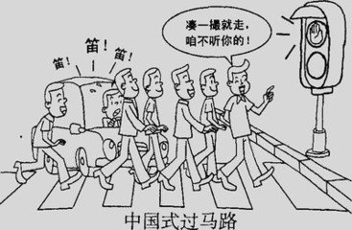
Even kids know that we should wait for the traffic light to turn green before crossing a road, but not everybody follows this basic rule. A CCTV news program showed that in only an hour, more than 600 people jumped red lights when crossing a road in Shijiazhuang, Hebei. “Chinese style road crossing” has become a hot expression recently. Chinese people “cross roads without thinking about traffic lights, so long as they are part of a crowd”, said a post on Sina Weibo.
Many people say that they jaywalk（乱穿马路）because the red light lasts too long. “People are likely to ignore(忽略) the light when the waiting time is longer than they can bear（忍受）,”said Zhang Ming , a member of the research team. However, a survey on Sina Weibo showed that nearly half of the respondents(调查对象)believe that people jaywalk mainly because they don’t respect rules.
Some Chinese cities have started taking some actions, too. For example, the first three people in a jaywalking group will be fined 50yuan in Shijiazhuang. But calling on people to obey rules is more important. To completely solve the problem, everyone should realize the importance of obeying the traffic rules.
86.Which of the following is the “Chinese style road crossing”?
A. To wait for the traffic light to turn green. B. To cross a road slowly.
C. To cross roads without looking at traffic lights. D. To follow the basic traffic rules.
87.Which is a reason for many Chinese people jaywalking?
A. The green light last too long. B. They won’t be punished in China.
C. They can’t bear the waiting time.D. They forget to follow the traffic rules.
88. In Shijiazhuang, who will be fined when a group of people jaywalk?
A. The first person. B. The first three people. C. All of them. D. No one.
89. In the first paragraph, the underlined word “hot” means.
A. new, popular B. warm, boiling C. spicy, peppery(辣的) D. sharp, smart
90. What’s the writer’s opinion?
A. It’s easy to solve the jaywalking problem completely.
B. All jaywalkers must be punished in China in future.
C. Respecting rules is more important than punishment.
D. Most Chinese people don’t respect the traffic rules at all.
D
Everyone has got two personalities (性格) -the one that is shown to the world and the other that is secret and real. You don't show your secret personality when you're awake because you can control yourself, but when you're asleep, your sleeping position shows the real you. In a normal night, of course, you often change your sleeping positions. The important position that best shows your secret personality is the one that you go to sleep.
If you go to sleep on your back, you're a very open person. You normally trust people and you are easily influenced by new ideas. You don't like to make people unhappy, so you never express your real feelings. You're quite shy and you aren't very confident.
If you sleep on your stomach, you are a person who likes to keep secrets. You worry a lot and you're always easily becoming sad. You never want to change your ideas, but you are satisfied with your life the way it is. You usually live for today not for tomorrow.
If you sleep on curled up (蜷缩), you are probably a very nervous person. You have a low opinion of yourself and often protect yourself from being hurt, so you are very defensive. You're shy and you don't usually like meeting people. You like to be on your own.
If you sleep on your side, you have usually got a well-balanced (平衡的) personality. You know your strengths and weaknesses. You're usually careful. You have a confident personality. You sometimes feel worried, but you don't often get unhappy. You always say what you think, even if it makes people angry.
91. You may find the passage in ___.
A. science magazine B. a guide bookC. a sports newspaper D. a story book
92. How many sleeping positions are mentioned in the passage?
A. two. B. five. C. three.D. four.
93. Tina hardly tells her secrets to her friends. She probably goes to sleep ___.
A. on curled up B. on her stomach C. on her back D. on her side
94. What does the underlined word "defensive" mean in the passage?
A. 易怒的 B. 攻击性的 C. 外向的 D. 有戒备心的
95. What does the passage tell us?
A. Sleeping on your side is the best way of sleeping.
B. Changing positions will cause sleeping problems.
C. Sleeping positions show people's secret personalities.
D. Enough sleep makes people look better and healthier.
第四部分 写（共两大题，满分25分）
X．单词拼写（共5小题；每小题1分，满分5分）
根据首字母及汉语提示，完成下列单词的拼写，使句意明确，语言通顺。
96. It is well known that the Diaoyu Islands b __（属于）to China .
97. Yang Mi has been m __（结婚）to Liu Kaiwei for nearly one year .
98. Tom is really b(聪明的) and he can always work out problems easily.
99. Don’t worry! It’s nothing serious. Just take some m____(药)and have a good rest.
100. On Tom’s t(十二) birthday, he got a new computer from his father.
XI． 2018年安徽合肥中考英语模拟试题书面表达（共1小题；满分20分）
你是一名初三的学生，三年的初中生活即将结束，你一定有很多话要对关心你的人说，请根据下列提示写一篇英文发言稿在下周一的升旗仪式上表达你的感谢之情。
感谢老师 一直在帮助你，亦师亦友。
感谢父母 照顾你，为你的学习操心。
感谢同学 相互帮助，一起学习，分享快乐。
感谢校工 创造美丽的校园环境，保护我们安全。
你的祝福 ……
注意：1.字数80左右； 2.请不要逐句翻译，可适当发挥； 3.开头和结尾已为你写好，不计入总词数。
Dear fellows,
How time flies! Three years has passed since I came here. I will leave school in about two months. Today I want to say thanks to all the people who care about me. First, ___
___
___
___
___
___
___
That’s all I want to say now. Thanks for listening.
安徽省合肥市29中2015—2016学年第一学期九年级期末考试英语试卷（听力稿）
I.关键词语选择
你将听到五个句子。请在每小题所给的A、B、C三个选项中选出一个你听到的单词或短语。每个句子读两遍。
1. The little dog is very lovely.
2. I won the first prize in the singing competition
3. The plane ticket is too expensive, I can’t afford it.
4. You look so tired, what’s wrong with you?
5. Can you please help me look after my dog while I am away?
II 短对话理解
你将听到十段对话，每段对话后有一个小题．请在每小题所给的A、B、C三个选项中选出一个最佳选项。每段对话读两遍。
6. W: I love table tennis. It’s very popular. What about you, Tony?
M: I prefer basketball. It’s more exciting than table tennis.
7. W: Bill, what’ the matter?
M: I was hurt by a kitchen knife.
8. M: Mum, may I watch programs on CCTV5?
W: Wait a minute, please. The TV play will be over soon.
9. W: Good morning. Can I help you?
M: Yes, please. I want to buy a T-shirt for my daughter.
10.M: I’d like some potatoes for supper, Mum.
W: I’ll cook them for you.
11. Girl: Hello, Tom , nice to meet you here. Are you here on holiday?
Boy: No, I’m not.
Girl: On business?
Boy: No. I’m learning English here.
12. Girl: Good morning, boy. What can I do for you?
Boy: I’d like to buy some cups. How much are these?
Girl: Three yuan for one and five yuan for two.
13. Boy: I hear the party will start at 7:30pm.
Girl: Good, we will have half an hour to get there.
14. Boy: Do you like singing, Mary?
Girl: Yes, I do. But my favourite is dancing. What about you, Jim?
Boy: Well, I like playing football best. And I like computer games, too.
15. Boy: What would you like to drink, Lucy?
Girl: A cup of tea with milk.
Boy: What about you, Lily?
Girl: A glass of orange juice, please.
Boy: And you, Mary?
Girl: Um, Coffee, please.
III长对话理解
你将听到两段对话，每段对话后有几个小题．请在每小题所给的A、B、C三个选项中选出一个最佳选项。每段对话读两遍。
听下面一段对话，回答第16至17小题。
M: Millie, I have something to tell you. Tomorrow is Alice’s birthday.
W: Are you sure? I think it should be the day after tomorrow.
M: Well, let me see. Oh, I’m sorry. You’re right. It is the day after tomorrow. Shall we buy her a present?
W: Yes, of course. Shall we give her some flowers?
M: Flowers are lovely. But I think it’s better to buy her a box of chocolates
W: Alice doesn’t like sweet things. Didn’t you know that?
M: Er… I know. We can give her a CD. She loves music.
W: That’s a good idea. Let’s go to the music shop and choose one for her.
听下面一段对话，回答第18-20小题。
W: Good morning! Can I help you?
M: Yes, please. I want to buy a T-shirt.
W: What size do you want?
M: Size M, please.
W: OK! What about this one?
M: Sorry! I don’t like black. Have you got any other colors?
W: Oh, yes. We’ve also got blue, brown and white ones.
M: Can I have a look at the brown ones?
W: Of course.
M: How much is it?
W: $48.
M: OK. I’ll take it.
IV短文理解，听短文
你将听到一篇短文，短文后有五个小题。请根据短文内容，在每小题所给的A、 B、C
三个选项中选出一个最佳选项。短文读两遍。
Every day, I get up early at six. After doing some morning exercises, I read English for twenty minutes. At seven o’clock, I have breakfast, usually just some bread, an egg and a cup of milk. After breakfast, I take my schoolbag and go to school. My home is a bit far from the school, so I have to take several buses to go to school. Our class begins at eight, and we have 4 classes in the morning. After lunch at 12 o’clock, I take a short rest in the classroom. We have three more classes in the afternoon. When school is over at five o’clock, I go back home. I often help my mother to prepare for supper. Sometimes I watch TV. After supper I begin to do my homework. I always try to finish it by nine and then I take a bath. I go to bed at nine thirty.
V．信息转化
你将听到一篇短文。请根据短文内容，写出下面表格中所缺的单词，每空仅填一词。短文读两遍。
Last Wednesday morning, I took a bus to school. Suddenly, I found a CD player on the ground near my seat. I picked it up and turned it on. There were some exciting pop songs in it. They were my favourite songs. I decided to keep it. And then, I told my friends about it. They said I should hand it over to the police of the bus station. I thought they were right and did so.
安徽省合肥市29中2015—2016学年第一学期九年级
期末考试英语参考答案
第一部分 听力
Ⅰ--Ⅳ. 1~5. BBACC 6~10. ABCCB 11~15. CCABB 16~20. BABAC 21~25. ACBBC
Ⅴ. 26. Wednesday27. player 28. bus 29. exciting 30. police
评分标准：1~30题每小题1分。

第二部分 英语知识应用
Ⅵ. 31~35.BCBCC 36~40 .DBDDC 41~45.DDCBD 46~50. CDDCD
评分标准：31~50题每小题1分。

Ⅶ. 51~55.BBCBA 56~60.BCDAD 61~65.BCDAC 66~70.ADBAC
评分标准：51~70题每小题1.5分。
Ⅷ. 71~75.BCFED
评分标准：71~75题每小题1分。
第三部分 阅读理解
Ⅸ. 76~80.BCDAA 81~85. DCBCA 86~90. CCBAC 91~95.ADBDC
评分标准: 76~95题每小题2分。

第四部分写
Ⅹ.96.belong 97.married 98.bright 99.medicine 100.twelfth
评分标准：96~100题每小题1分
ⅩⅠ.（略）评分原则：[来源:初三网]
本题总分为20分，按五个档次给分。
评分时，先根据文章的内容和语言初步确定其所属档次，然后以该档次的要求来衡量，结合内容和语言表达，综合给定分数。
考生可以根据要点适当发挥，加入自己的观点。
词数少于80的，从总分中减去1分。
拼写错误多，书写较差以致影响表达，在所确定档次的分数范围内，减去1分。
各档次的给分范围和要求：
第五档（很好）：（20~18分）
完全完成了试题规定的任务，涵盖了所有内容要点，或在发挥时内容有新意或亮点；语言基本无误，行文连贯,表达清楚。
第四档（好）：（17~14分）
完成试题规定的任务，涵盖了基本的内容要点；语言有少量错误，行文基本连贯，表达基本清楚。
第三档（一般）：（13~9分）
基本完成了试题规定的任务，写出了一些内容；语言有一些错误，行文不够连贯。
第二档（较差）：（8~5分）
未能恰当完成试题规定的任务，只能写出个别要点；语言错误较多，未能清楚传达信息。
第一档（差）：（4~0分）
未能完成试题规定的任务，只能写出与内容有关的一些单词；语言错误很多,未能清楚传达信息。
注：本卷总分不设小数，如遇小数，请进位。

