2017年鄂州中考英语试题
学校： 考生姓名： 准考证号：
2017年鄂州中考英语试题注意事项：
1．本试题卷共8页，满分120分，考试时间120分钟。
2．答题前，考生务必将自己的姓名、准考证号填写在试题卷和答题卡上，并将准考证号条形码粘贴在答题卡上的指定位置。
3．选择题每小题选出答案后，用2B铅笔把答题卡上对应题目的答案标号涂黑。如需改动，用橡皮擦干净后，再选涂其他答案标号。答在试题卷上无效。
4．非选择题用0.5毫米黑色墨水签字笔直接答在答题卡上对应的答题区域内。答在试题卷上无效。
5．考生必须保持答题卡的整洁。考试结束后，请将本试题卷和答题卡一并上交。
2017年鄂州中考英语试题第一部分 听力测试
Ⅰ. 2017年鄂州中考英语试题听力测试（共三节，20小题，满分25分）
第一节：听描述或对话,选图画。听下面2段描述和3段对话。听完以后，从A、B、C三幅图画中选出正确的一幅。每段描述和对话读一遍。（共5小题，每题1分，计5分）
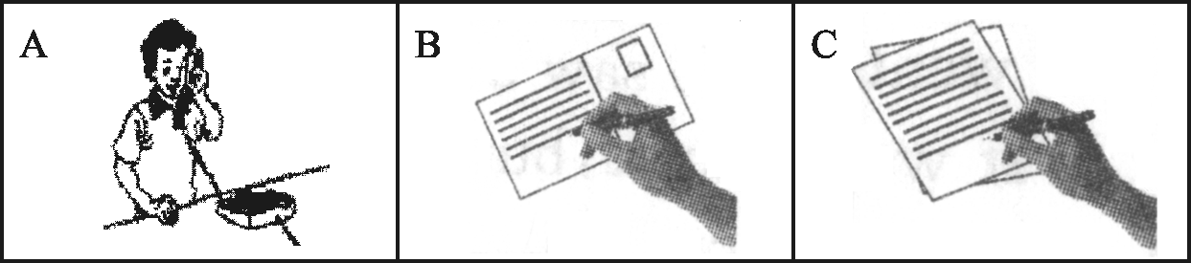

1.

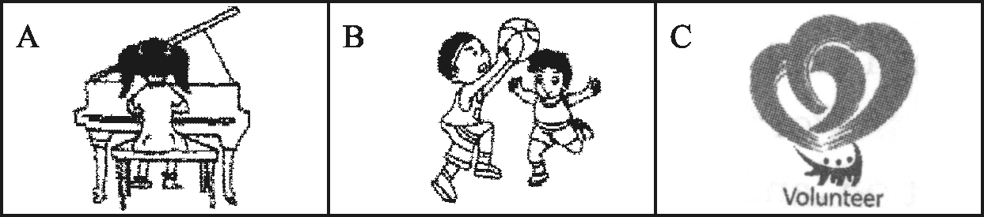

2.

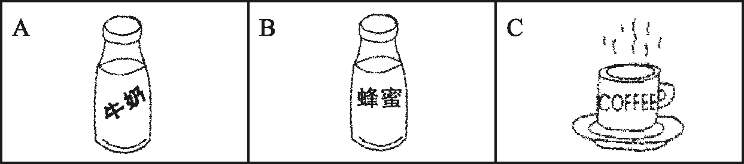

3.

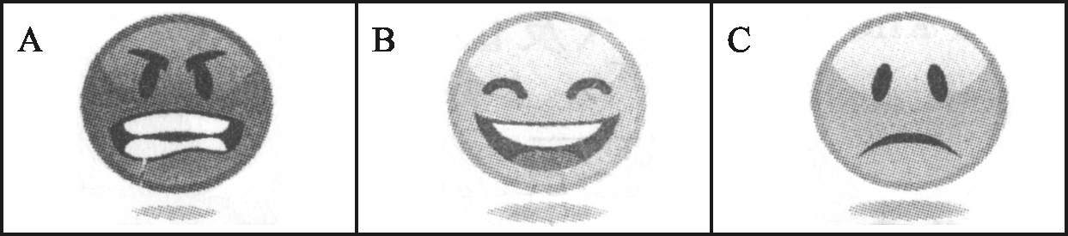

4.

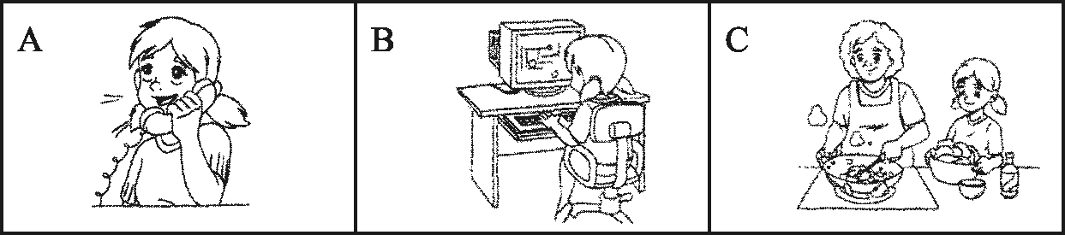

5.第二节：听对话，选答案。听下面4段对话。根据所提的问题，从A、B、C三个选项中选出最佳答案。每段对话读两遍。（共10小题，每题1分，计10分）
听第六段材料，完成第6、7小题。
6. What are the speakers talking about?
A. A match.B. A movie.C. A TV show.
7. Why didn’t Mary watch the match?
A. It started too late at night.
B. She had to do her homework.
C. She doesn’t like basketball matches.
听第七段材料，完成第8至10小题。
8. When did Ann go to her hometown?
A. Yesterday.B. Last week.C. Last month.
9. How was Ann’s trip?
A. Exciting.B. Wonderful.C. Unpleasant.
10. What has happened to Ann’s hometown?
A. People have polluted the river there. B. The water there has become clean.
C. People have planted many flowers and trees there.
听第八段材料，完成第11、12小题。
11. What is Mike going to do first?
A. Clean the room.B. Do his homework.C. Take out the rubbish.
12. What is Mom going to do?
A. Go to a meeting.B. See a movie.C. Go to a party.
听第九段材料，完成第13至15小题。
13. What is Jerry’s favorite music?
A. American country music.B. Classic music.C. Rock music.
14. What does the woman know about rock music?
A. The woman knows the Beatles. B. The woman knows Elvis.
C. The woman knows Michael Jackson.
15. What does the woman decide to do finally?
A. She decides to buy a CD of Elvis.
B. She decides to buy a CD of the Beatles.
C. She decides to find a good gift in CD shops.
第三节：听短文，选答案。听下面一段短文。根据短文内容选出最佳答案。短文读两遍。
（共5小题，每题2分，计10分）
16. Which of the following isn’t mentioned in the passage?
A. Gloves.B. Shorts.C. Sports suits.
17. How many pairs of sports shoes does each child need?
A. One.B. Two.C. Three.
18. How long is the lunchtime?
A. One hour.B. One and a half hours.C. Two hours.
19. Where do they buy snacks?
A. In a sports center.B. In a supermarket.C. In a shopping center.
20. What’s the passage mainly about?
A. Outdoor sports.B. Indoor activities.C. Sports camp plan.
2017年鄂州中考英语试题第二部分 语言知识
II . 2017年鄂州中考英语试题单项选择（共15小题，每题1分，满分15分）
从A、B、C、D四个选项中选出最佳选项。
21. —The dishes in this restaurant must be very expensive.
—Don’t worry. You can enjoy yourself. It’s my ___.
A. timeB. treatC. taskD. taste
22. —How old is your son?
—___. We had a special party for his ___ birthday yesterday.
A .Nine, nineB. Ninth, nineC. Nine, the ninthD. Nine, ninth
23. —The town of Huarong ___ a lot in the past five years.
—That’s true. It’s becoming more and more beautiful.
A. changedB. has changedC. had changedD. is changing
24. —He didn’t go to school late yesterday, did he?
—___, though it rained hard yesterday.
A. No, he didn’tB. Yes, he didn’tC. Yes, he didD. No, he did
25. —I had a pleasant trip last week.
—___.www.ccutu.com
A. Oh, that’s very kind of youB. It’s a pleasure
C. CongratulationsD. I’m glad to hear that
26. —If you do that, you will ___ with an egg on your face.
—But I won’t regret it.
A. take upB. end upC. keep upD. catch up
27. —Jack hasn’t taken his piano lessons for a long time.
—He is considering ___ his piano course and spending more time on his study.
A. to dropB. to throwC. droppingD. throwing
28. —What would you like to drink, tea or coffee?
—___ is OK, but I prefer coffee ___ milk.
A. Either, toB. Either, withC. Neither, toD. Neither, with
29. —The tall man with glasses over there looks like our math teacher.
—It ___ be him. He has gone abroad.
A. may notB. mustn’tC. can’tD. needn’t
30. —What an interesting story she told us!
—Yes, and her voice sounded __.
A. sweetB. smallC. clearly D. sadly
31. —I’ll be away for a long time.
—Don’t worry. She can look after your pet __.
A. careful enough B. enough careful
C. carefully enough D. enough carefully
32. —What do you often do __ classes to relax yourselves?
—We often do some running or listen to music.
A. inB. throughC. betweenD. among
33. —Time will __ whether I made the right choice or not.
—I believe you can succeed.
A. seeB. sayC. knowD. tell
34. —Do you know ___?
—Yes, she is very kind and outgoing.
A. what’s his mother like B. what his mother likes
C. what his mother is like D. how his mother is like
35. —Please tell me something about Yang Liwei.
—He is a great astronaut of __ all the Chinese are proud.
A. that B. whose C. who D. whom
III . 2017年鄂州中考英语试题完形填空（共10小题，每题1分，满分10分）
阅读下面短文，从A、B、C、D四个选项中选出最佳选项，使短文完整、通顺。
One evening, I went out for a walk on the path (小路) near my house with my husband. On my finger was a very special ring with a diamond (钻石) that my grandmother gave me for my 23rd birthday. At the end of the path, when I looked down at it again and found the diamond was 36 . I started back along the path hurriedly 37 the tiny stone. In my heart, I knew it seemed impossible for me to find it. The path was very long and 38 with leaves. As I searched the ground, crying and upset, I met an old lady. “What’s the matter, love ?” She asked kindly. I 39
about the missing diamond and showed her my ring. She said, “That’s going to be hard to find. Tell me what, love, I walk along this path every day, I’ll keep my eyes 40 for it.” I thanked her, 41 nothing, but still told her that we sometimes walked our dog along the path if she might find something.
A few days later, my husband and I met the old lady on the path. “Guess what?” She said, “I found your diamond!” To our 42 , she’d found the tiny stone and was willing to hand it back to me. “It was lucky that I found it.” When we 43 her with some money for her help, she 44
politely. I was deeply moved. She could have easily kept the diamond, or sold it, for it’s worth several thousand dollars, but she didn’t.
Every time I look at my ring and 45 myself that there’re kind and beautiful hearts in the world. I’ll spend the rest of my life trying to do something like that.
36. A. changingB. shining C. burningD. missing
37. A. looking for B. staring at C. running after D. taking away
38. A. fed B. filled C. covered D. taken
39. A. explained B. asked C. cared D. learned
40. A. opened B. closed C. close D. open
41. A. getting B. expecting C. wondering D. telling
42. A. attention B. sadness C. surprised D. surprise
43. A. gave B. offered C. provided D. showed
44. A. refused B. received C. accepted D. confused
45. A. ask B. remind C. warn D. promise
2017年鄂州中考英语试题第三部分 阅读理解
IV . 2017年鄂州中考英语试题阅读理解（共20小题，每题2分，满分40分）
阅读下面四篇材料，根据其内容，选择正确答案或完成阅读任务。
A
Wonderful Events
Horse Racing All Year Round  Races starting at 3 p.m. every Sunday  Racetrack only 20 miles away  Lots of free parking space  Free presents  No children allowed | 100 Years Of Pictures  Then & now (photo show)  See the history pictures (1917—2017)  February 1—April 30  City Art Museum 750 High Street  Tuesday to Sunday, 10 a.m.—5 p.m.
Weekend Sales  This Saturday 2—6 p.m.  Everything 20% — 40% off  Visit us at Block G. Grandview Mall  Realize your dreams, save time and money  Fall in love with prices we offer | Dance Party  Celebrate special date  Bringing your sweet heart  Sunday night, country club  Live band from 9 p.m.—1 a.m.  $25 a couple(夫妇); $15 a single person
46. Who can NOT go to the horse race?
A. A single person. B. A couple.
C. Children. D. The sweet heart.
47. People can see the photo show at ____.
A. Grandview Mall B. City Art Museum
C. Racetrack D. Country Club
48. What can you do if you only have time between 5 p.m. and 6 p.m. on Saturday?
A. Go shopping.
B. Go to see the photo show.
C. Go to the dance with your sweet heart.
D. Go to watch the horse race.
49. How much will Mr. and Mrs. Smith pay if they want to go to the dance party?
A. 15 dollars. B. 25 dollars.
C. 20% — 40% off. D. For free.
50. Where can you see the above advertisements?
A. In a book. B. In a magazine.
C. In a newspaper. D. On TV.

B
One of my best friends went abroad to enjoy her holidays, so the job of looking after her dog Missy has been given to me. A few months ago, Missy came to my friend’s house. She looked terrible. She has been abused for a long time.
When we first visited my friend and Missy, my friend had to gently pull her over on a lead (牵绳) to get her to come to us. She wanted to come but afraid to do so—the poor, beautiful thing. Clearly Missy came to the right home. My friend has given birth to a baby of his own and shows the love of a mother. This is just what Missy needs. Thanks to the love of my friend, she has changed into a new dog step by step. Sadly, she is still afraid of strange humans. I hate to imagine what the dog must have gone through.
Now, Missy trusts me completely, so I can touch her berry（肚皮）.While standing, she will jump up so gently to be closer to me, putting her paws（爪子）on my legs as she looks at me with those beautiful eyes.
Missy is really brave. She has the courage to try again, to open her hearts, and to know that not everyone is the same kind of people as before. Keep it in mind that tomorrow is another day.
51. The underlined word “abused” in the first paragraph means____.
A. 保护B. 喂养C. 虐待D. 挨饿
52. The writer felt ___ when she first saw Missy.
A. proud and relaxed B. sorry and caring
C. afraid and angry D. sad and disappointed
53. The writer thought it was good for Missy to stay with her friend ____.
A. because her friend could offer the love of a mother to Missy
B. because her friend had more free time to take care of Missy
C. because her friend stayed long at home and felt quite lonely
D. because her friend helped Missy to accept different people
54. The fourth paragraph mainly tells us ___.
A. the writer has learned the skills to communicate with Missy
B. the writer has made Missy understand and follow her orders
C. the writer has succeeded in winning the trust of Missy
D. the writer has come to realize that Missy is a beautiful dog
55. According to the passage, what is the writer’s suggestion?
A. No future in the past. B. Every dog has its day.
C. All efforts will pay off. D. Never too late to mend.

C
In 1901, an Austrian scientist discovered that there are four types of blood. He named them A、B、AB and O. People have one of these four types. Blood type O is the most common around the world. Blood type A is the second most common, and blood type AB is the least common.
In 1927, a Japanese doctor found that people with different blood types have different personalities (性格)，too. He said that people with type A blood are usually calm and serious;
people with type B blood are cheerful and outgoing; people with type O blood are generous and honest; while those with type AB blood are often caring and talented.
More recently, a doctor in the United States wrote a book that connects blood types with what people eat. The book suggests people with type O blood should eat more meat and less bread. A diet for people with type A blood includes more vegetables. His book, Eat Right for Your Type, has been a hit with people who want to lose weight. However, Dr. Peter D’ Adamo believes that eating food that matches a person’s blood type will make the person healthier in other ways, too.
（59题三词，其余各题均两词）
People with different 56 have different personalities.
Type A | 1. People are calm and serious.  2. People should eat 57 .
Type B | People are cheerful and outgoing.
58 | 1. It is the least common type.  2. People are caring and talented.
Type O | 1. People are 59 .  2. People should eat more meat and less bread.
If people eat food that matches a person’s blood type, they will 60 .

D
Bamboo is one of the nature’s most surprising plants. (61) 许多人称这种植物为树，但它是一种草。
Like other kinds of grass, a bamboo plant may be cut very low to the ground, but it will grow back very quickly. A Japanese scientist recorded one bamboo plant that grew almost 1.5 meters in 24 hours! Bamboo grows almost everywhere in the world except Europe. (62) There are more than 1,000 kinds of bamboo that grow around the world on both mountains and plains (平原).
Not all bamboo looks the same. Some bamboo plants are very thin. They may only grow to be a few centimeters wide while others may grow to more than 30 centimeters across. This plant also comes in different colors, from yellow to black to green.
Many Asian countries have been using bamboo for hundreds of years. They often use bamboo for building new buildings. As a matter of fact, the cables (绳索) that hold up the hanging bridge across the Min River in Sichuan are made of bamboo. The bridge has been in use for more than 1,000 years, and is still holding strong.
In Africa, (63) engineers are teaching poor farmers how to use bamboo to find water . These African countries need cheap ways to find water because (64) they have no money, and their fields often die from no rain and no water. It seems that bamboo is one of the best things they can use. Bamboo pipes and drills (钻) can help to make the poor thirsty fields be watered.
任务一：将61处翻译成英文。
任务二：将62处翻译成中文。
任务三：将63处改成复合句。
任务四：写出64处“they”指代的内容。
任务五：(65) 找出该文段的中心句。

2017年鄂州中考英语试题第四部分 语言综合运用及写作
V . 2017年鄂州中考英语试题完成句子（共9小题，每题1分，满分9分）
根据括号内的英语或汉语提示，完成句子。
66. John’s family came back to the USA last __ (九月).
67. Those __ (德国人) wanted to have fish for dinner.
68. The doctor did what he could __ (save) the patient’s life.
69. _ (luck), the man hurt badly in the accident.
70. Sandy’s grandparents __ (marry) for 50 years.
71. If you want to make yourself __ (understand), you’d better speak clearly and slowly.
72. —Tom has invented a tree-planting machine.
—I think no one is __ (create) than him. He’s a boy full of strange ideas.
73. Teenagers should __ (encourage) to solve their problems by themselves.
74. —Where did you find Miss Gao just now?
—In the office, she __ (talk) with other teachers at that time.
VI . 2017年鄂州中考英语试题补全对话（共3小题，每题2分，满分6分）
阅读对话，根据横线后所给标点符号的提示，在横线上填写适当的句子，使对话完整。
(It’s Friday afternoon. After school, Sun Mei meets Hu Fang on the way home.)
Sun Mei: Hello, Hu Fang!
Hu Fang: Hello, Sun Mei!
Sun Mei: Tomorrow is Saturday and the weather is fine. I want to climb the Ge Hill.
75_____?
Hu Fang: Sure, I’d love to. Oh, I hear there’s a strawberry garden near it. We can do
some picking in the garden after climbing.
Sun Mei: 76___! I like eating fresh strawberries. We can
also take beautiful photos there.
Hu Fang: Great! 77_____?
Sun Mei: Let’s meet at 8 o’clock in the morning at the gate of Yanglan Primary School.
Hu Fang: It’s a deal! See you tomorrow.
Sun Mei: See you.
VII . 2017年鄂州中考英语试题书面表达（满分15分）
为响应我市“创建国家卫生城市”的号召，6月3日，5000多名市民以绿色出行的方式参与了“生态鄂州——环洋澜湖健步走”活动。请以“共建绿色城市”为主题，根据以下文字提示，并适当发表自己的观点，写一篇英语短文。
主题 | Let’s build a green city together
具体  做法 | 方式 | 益处
具体  做法 | 1.骑车、徒步出行 | 避免交通拥堵，减少空气污染
具体  做法 | 2.不乱扔垃圾，不随地吐痰 | 让城市变得干净舒适
具体  做法 | 3.植树造林 | 美化城市，保护环境
你的  建议 | 联系自己的生活实际提出几条具体的合理的建议。（至少2条）
要求：1. 80－100词（开头的首句已给出，不计算在总词数内）。
2. 文中不能出现自己的姓名和所在学校的名称及其它相关信息，否则不予评分。
参考词汇：吐痰spit 垃圾箱dustbin 交通拥堵traffic jams 环境environment
As a middle school student of Ezhou, it’s our duty to help build a green city.__
__.
2017年鄂州中考英语试题参考答案
I. 听力测试（1—15题，每题1分，16—20题，每题2分，满分25分）
1—5 BCCBB 6—10 AACCA 11—15 BACBB 16—20 ABBCC
II. 单项选择（每题1分，满分15分）
21—25 BDBAD 26—30 BCBCA 31—35 CCDCD
III. 完形填空（每题1分，满分10分）
36—40 DACAD 41—45 BDCAB
IV. 阅读理解（每题2分，满分40分）
46—50 CBABC 51—55 CBACA
56. blood types 57. more vegetables 58. Type AB
59. generous and honest 60. be /get healthier
61. Many people call this plant a tree, but it is a kind of grass.
62. 有一千多种竹子生长在世界各地的山地和平原上。
63. engineers are teaching poor farmers how they can use bamboo to find water
64. (these) Afican countries
65. Bamboo is one of the nature’s most surprising plants..
V. 完成句子（每题1分，满分9分）
66. September 67. Germans 68. to save 69. Unluckily 70. have been married
71. understood 72. more creative 73. be encouraged 74. was talking
VI.补全对话（每题2分，满分6分）
75. Would you like to go (there)with me? / Would you like to climb the hill with me? / Do you want to go (there)with me? / Do you want to climb the hill with me?……
76. Good idea!./ That’s a good idea! / That sounds good! / Sounds good! / Sounds nice! /
Sounds great! /.……
77. When and where shall we meet?/When and where are we going to meet?/……
VII.书面表达（满分15分）
One possible version:
As a middle school student of Ezhou, it’s our duty to help build a green city. We can avoid
the traffic jams and reduce the air pollution by riding bikes or walking. We mustn’t throw rubbish or spit anywhere. In this way, we can keep our city clean and tidy so that we can live a comfortable life. And we’d better plant more trees to protect the environment and make our city beautiful.
In my daily life, I can pick up rubbish and put it into the dustbin wherever I go. I can also
save the energy by turning off the lights when leaving the room. In a word, everyone can play a part in building our city.

