各位同学在查看时请点击全屏查看
2017年福建省中考英语试题
I.2017年福建省中考英语试题听力（共三节，20小题;每小题1.5分，满分30分）
2017年福建省中考英语试题第一节听句子听下面五个句子，从每小题所给的三幅图中选出与句子内容相符的选项。（每个句子读两遍）
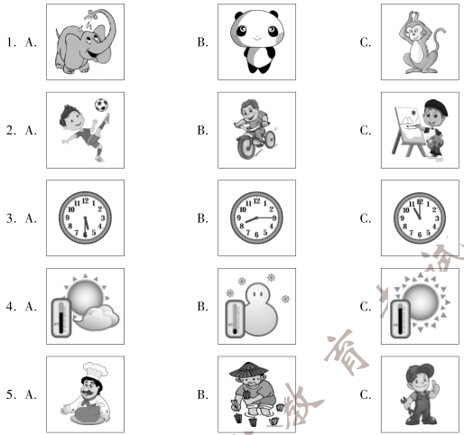
2017年福建中考英语试题第二节听对话听下面七段对话，从每小题所给的A、B、C三个选项中选出正确答案。（每段对话读两遍）
听第1段对话，回答第6小题。
6. What does Helen think of Shanghai?
A. Modem. B. Noisy. C. Crowded.
听第2段对话，回答第7小题。
7. When did Jane take part in the activity?
A. Last Friday. B. Last Saturday. C. Last Sunday.
听第3段对话,回答第8小题。
8. Whose watch is it?
A. David’s. B. Lily’s. C. Sally’s.
听第4段对话，回答第9小题。
9. What kind of fruit does Maria like best?
A. Bananas. B. Apples. C. Oranges.
听第5段对话，回答第10~11小题。
10. What does the woman want to buy?
A. A skirt. B. A blouse. C. A T-shirt.
11. What size does the woman wear?
A. Size S. B. Size M. C. Size L.
听第6段对话,回答第12~13小题。
12. Where are the two speakers?
A. In a gym. B. In a hospital. C. In a musuem.
13. What was wrong with Lucy yesterday?
A. She had a cold. B. She had a cough. C. She had a toothache.
听第7段对话,回答第14~15小题。
14. What will Nancy do?
A. Wash the dishes. B. Tidy the living room. C. Clean the windows.
15. What’s the relationship between the two speakers?
A. Brother and sister. B. Father and daughter. C. Mother and son.
2017年福建中考英语试题第三节听短文根据你所听到的短文内容,完成下面表格，每空填一词。（短文读三遍）
Ways to Protect Your Body
Protect your teeth | Brush your teeth 16 a day.  Avoid too much 17 and soft drinks.
Protect your ears | Don’t listen to 18 music.
Protect your eyes | Take a rest every 19 minutes when using the computer.  Make sure you always 20 in good light.
Ⅱ.选择填空（共15小题;每小题1分，满分15分）
从每小题所给的A、B、C三个选项中,选出可以填入空白处的正确答案。
21. Jack is such__________friendly boy. He gets along well with his classmates.
A. a B. an C. the
22. China successfully hosted the Belt and Road Forum_________May, 2017.
A. on B. in C. by
23. — Our English teacher will work for 2017 BRICS Summit (金砖峰会）this September.
—Great! I am so proud of_____.
A. she B. her C. hers
24. —Joan has made great progress in speaking Chinese.
—She_________works hard at it, you know.
A. never B. seldom C. always
25. The scientist has failed in the test many times, ______he never gives up.
A. but B. so C. or
26. — Do you know the Color Run, a five-kilometer race?
—Yes. So far it______into quite a few cities in our country.
A. comes B. came C. has come
27. TFBOYS has a lot of fans. It____________thousands of young people.
A. is popular with B. is satisfied with C. is strict with
28. — Mum, may I go swimming now?
—Yes, dear, but remember that you___________go with your dad.
A. may B. can C. must
29. — Nowadays more and more foreigners are becoming interested in Beijing Opera.
—That’s true. It’s an important part of Chinese____________.
A. culture B. invention C. custom
30. —_____________ has Hong Kong been back to our motherland?
—For 20 years. How time flies!
A. How soon B. How long C. How often
31. Eleven Chinese films ___________ during the 7th Chinese Film Festival in France last month.
A. showed B. are shown C. were shown
32. The students were singing happily_________ I passed the school hall.
A. when B. unless C. though
33. — Don’t__________the waste paper. We can collect and recycle it.
—You' re right. Everyone should be a greener person.
A. blow away B. put away C. throw away
34. — Do you like the weekly talk show, The Reader，on CCTV?
—Sure. It' s a great TV programme__________brings the habit of reading back into the public
A. who B. that C. what
35. — Michael, could you tell me_______________?
—I' d like to join the dancing club.
A. why you like the dancing club
B. which club you are going to join
C. whether there are any clubs in your school
III.2017年福建中考英语试题完形填空（共10小题;每小题1.5分，满分15分）
从每小题所给的A、B、C三个选项中，选出可以填入空白处的最佳答案。
Jadav Payeng is a forestry worker from Jorhat, India. Over the past 38 years, he has planted trees on a sandbar (沙洲）of the Brahmaputra River and has 36 it into a forest.
One day in 1979，16-year-old Payeng was walking 37 the bank of the Brahmaputra River. He saw many snakes on the sandbars. These snakes died in a few days’ time 38 the heat and the absence of trees. Payeng felt very 39 when he saw this. He decided to plant some trees. Single-handedly, he started planting bamboo trees, as only bamboo trees could survive (存活）in the sandbars.www.chusan.com
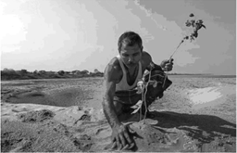
To water the trees was a difficult 40 for one man. With his hard work and great effort, day by day the 41 bamboo trees grew into a forest. His tree planting has changed the soil (土壤).Now the sandbar is a thick forest and 42 to thousands of plants and animals. A large group of around 100 elephants visit the forest every year and 43 there for a few months.
Payeng is now in 44 fifties. He has planted close to 1,400 acres (英亩)of forests and is 45 as the Forest Man of India. In 2015，he was honored with Padma Shri, one of the top awards in India.
36. A. divided B. put C. turned
37. A. along B. through C. across
38. A. according to B. because of C. as for
39. A. lonely B. sad C. tired
40. A. task B. journey C. condition
41. A. wild B. tall C. young
42. A. way B. guide C. home
43. A. stay B. lie C. sit
44. A. her B. his C. its
45. A. invited B. served C. known
IV.2017年福建中考英语试题阅读理解（共两节，25小题;满分45分）
- 阅读下面A、B、C、D四篇短文，根据短文内容，从题中所给的A、B、C、D四个选项中，选出最佳答案。 (共20小题;每小题2分，满分40分）
A.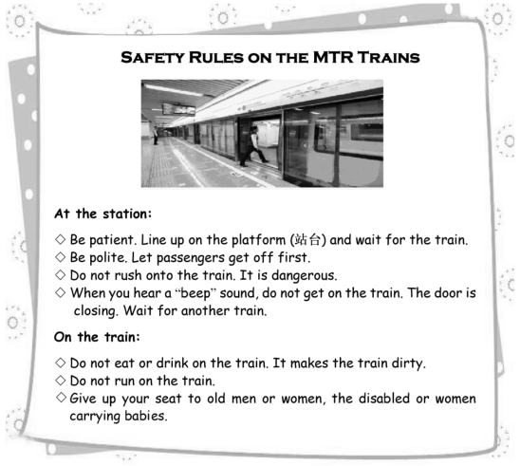
46. The text is mainly about how to____________.
A. be a careful driver B. buy MTR tickets
C. be a good passenger D. keep safe at home
47. People who will get on the train should___________.
A. wait in line B. open the door C. ask for help D. leave the seats
48. When you hear a “beep” sound, ______________ .
A. close the door B. rush onto the train
C. get off the train at once D. stop and wait for the next train
49. Which picture shows the good behavior on the train according to the text?
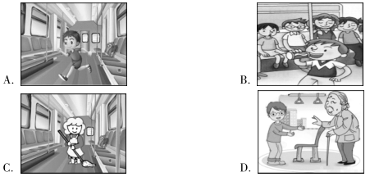
50. The text is probably a________________.
A. report B. notice C. diary D. poem
B
I was traveling alone through the UK. To reach places that were off the public transportation map，I bought an old car, which cost most of my money. I couldn’t afford to stay in the hotel, so I had to camp in my car for the rest of the trip.
One morning I awoke in my old car on a country road in Ireland and saw a single house. The water in my thermos (保温瓶）had gone cold, so I knocked on the door of the house. A woman opened it. I asked her for some hot water. But she wouldn’t let me get away with just that! I was invited indoors. She asked me to sit at the table and have breakfast with her family. They filled my thermos before I left.
I was greatly moved. And I decided to pass the kindness on. The other day I met a young man who had been driving around to look for a parking lot. He looked increasingly upset. I was glad that I was able to point one out to him. His thankful smile was the hugest reward (奖赏）for me.
51. The writer bought the car in order to______________.
A. serve the public B. travel more easily
C. take the trip alone D. save more money
52. Why did the writer camp in his car?
A. He was short of money. B. It was his habit.
C. He could have a better rest. D. It would be warmer.
53. The writer asked the woman for______________.
A. a map B. a thermos C. some hot water D. a light breakfast
54. How did the young man feel at last?
A. Funny. B. Upset. C. Disappointed. D.ThankfuL
55. What’s the main idea of the text?
A. Traveling alone is interesting. B. Sharing food is a pleasure.
C. Kindness is the sunshine in life. D. Smile is important to everybody.
C
No one knows when the first kite was made. The first record of a kite was more than 2,000 years ago in China. Han Xin, the leader of an army, wanted to bring down a king. He decided to dig a tunnel (隊道）into the king’s palace. He flew a kite over the wall of the palace to make sure the length (长度）of its string (线).In this way, he could determine how long the tunnel should be.His men in the tunnel took the kite string with them. When they reached the end of the string, they knew to dig up.
Kites have been flown in Japan for hundreds of years. In the 1700s, kites were flown in autumn to give thanks for a good harvest. They were also flown to send good wishes to couples who had their first son. Today in Japan, kites are often flown as part of a celebration, such as the beginning of a new year. And kite festivals are held each year in many parts of the country.
Kites have been used for scientific purposes in the western world. In 1752，Benjamin Franklin tied a key to a kite and flew it in a storm to find out that lightening was a form of electricity. In the 1890s，Lawrence Hargrave invented the box kite to test ideas about flight. From 1898 until 1933，the United States Weather Bureau (气象局） used box kites to collect weather data. The Wright brothers also experimented (试验）with kites. What they learnt helped them make the first airplane flight in 1903.
56. Why did Han Xin want to dig a tunnel?
A. To pull down the palace. B. To fight against the king.
C. To search for the king’s treasure. D. To find out the length of the kite string.
57. What does the underlined word “determine” in Paragraph 1 probably mean in Chinese?
A.测定 B.选择 C. 了解 D.考察
58. One of the purposes of flying kites in Japan is_.
A. to give thanks for a good harvest in summer
B. to express good wishes to the first-born daughter
C. to celebrate the beginning of a new year
D. to hold kite festivals all over the country
59. When did the United States Weather Bureau begin to use box kites?
A. In 1752. B. In 1898. C. In 1903. D. In 1933.
60. What would be the best title for the text?
A. The History of Kites B. The Experiments of Kites
C. The Invention of a Kite D. The First Record of a Kite
D
On May 5，2017, China’s home-made passenger aircraft (飞机）G919 completed its 90-minute first flight and landed safely back at Pudong Airport in Shanghai.
G919 is developed by COMAC, a Chinese aircraft company. It is designed to compete with Boeing 737 and Airbus A320. The first C919 aircraft can carry 168 passengers and is able to fly a distance between 4,075 and 5，555 kilometers. It，s reported that a C919 costs around 50 million dollars，less than half of a Boeing 737 or an Airbus A320. Up to now, more than 570 aircrafts have been ordered from 23 customers，mostly Chinese，but also American and Thai companies or airlines. COMAG aims to take one fifth of the world’s narrow-body aircraft market and one third of the Chinese market by 2035.
The name G919 has its special meanings. The letter C stands for both “COMAC"“China”. The number 9 is pronounced as jiu in Chinese, which means “forever”. And the number 19 refers to its capacity (容量）of 190 passengers.
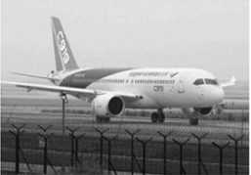
The large passenger aircraft is praised as “ the flower of modern industry ”. It is a symbol of the nation’s industrial and technological standards as well as the comprehensive (综合的）power. In order to realize the century dream of flying in the sky and the strategy (战略）of the nation, COMAC bears the nation’s dream and people’s trust. China considers it as a national pride.
61. G919 is produced by________.
A. Boeing B. a Thai aircraft company
G. Airbus D. a Chinese aircraft company
62. Which of the following is TRUE about the first C919 aircraft?
A. It can carry 190 passengers at most. B. It can only fly a distance of 4,075 km.
G. It costs less than half of a Boeing 737. D. It costs more than half of an Airbus A320.
63. Which picture shows COMACs aim to take the narrow-body aircraft market by 2035?
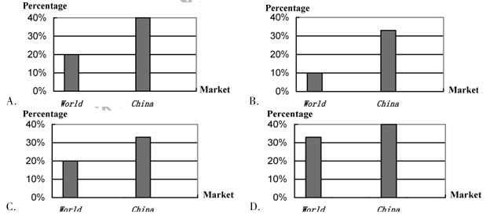
64. The letter C in C919 stands for______.
A. “company” B. both “COMAC” and “China”
C. “customer” D. both “cost” and “capacity”
65. The news report is written mainly to ___________.
A. introduce the design of C919
B. describe the first flight of C919
C. explain “the flower of modern industry”
D. show China’s achievements in aircraft industry
2017年福建省中考英语试题第二节阅读下面短文，从短文后所给的五个选项中选出能填入短文空白处的最佳选项，使短文通顺、连贯， 意思完整。（共5小题;每小题1分，满分5分）
E
Teenage life — better now，or in the past?
Does this situation sound familiar (熟悉)？
You are complaining (抱怨)to your parents about something. Maybe your computer isn't powerful enough to play the latest games. 66 Then you hear...
When I was your age, there weren’t any computers or video games. And I didn’t get a bike until I was sixteen. And it was second-hand. 67 ”
So, is it really true that life is better for teenagers now? It is certainly true that many teenagers have got more things nowadays. 68 So parents have got more money to spend on each child. And many things are cheaper than they were when our parents were children.
69 Forty years ago, no one could imagine a world with tiny computers and amazing smartphones. And now these things are necessary — we can’t imagine living without them!
However, technology often means we spend more time at home. And often it，s just us, with our computer or television. Teenagers don’t do enough exercise. 70 And, although young people still get on well with their friends，some people think teenagers today don’t have so many social activities as they did in the past.
What do you think? How is teenage life better these days?
A. And it was too big for me.
B. A typical family is smaller now.
G. Or your friends’ bikes are better than your!
D. So they aren’t as healthy as they were in the past.
E. Technology is probably the greatest change in our life.
V.情景交际（共5小题;每小题2分，满分10分）
根据情景提示，完成下列各题。
71.别人祝你新年快乐，你可以这样应答：
____________________________________________________________
72.你想和同学一起回家，可以这样对他说:
_____________________________________________________together.
73.你想借用同桌的尺子，可以这样问：
Excuse me, ____________________________________________________
74.你想知道这只杯子的价格，可以这问：
_________________________________________________________
75.朋友告诉你他的钱包丢了,你可以这样对他说：
______________________________________________________
VI.2017年福建省中考英语试题看图写话（共5小题;每小题2分，满分10分）
根据每小题所提供的图画情景和提示词，写出一个与图画情景相符的句子。
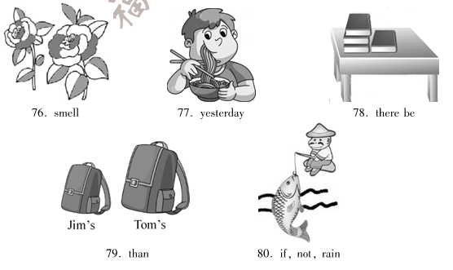
VII 2017年福建省中考英语试题短文填空（共10小题;每小题1分，满分10分）
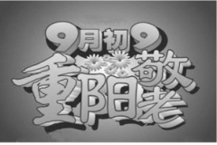
阅读下面短文，根据语境、音标或所给单词的提示，在每个空格内填入一个恰当的词，要求所填的词意义 准确、形式正确，使短文意思完整、行文连贯。
The Chongyang Festival is a Chinese traditional festival. It is celebrated on the ninth day of the ninth lunar month. It’s also 81 (call) the Double Ninth Festival.
The festival started as 82 /ˈɜ:li/ as the Warring States Period (475—221 BC) . It has a history of more than 1,700 years. Among the numbers from zero to nine, nine is the 83 (high) odd number (奇数). People believe that two “nines” meeting together stand for a long life. So it is a special holiday 84 Chinese people to show love and respect for their elders. They hold many 85 (kind) of activities in honor of old people, wishing them good 86 /helθ/ and a long life.
The festival comes during the golden time of 87 /fɔ:l/. On the day, people traditionally drink chrysanthemum (菊花）wine, eat Double-Ninth Cakes 88 climb mountains. They also carry a kind of plant named dogwood. People in ancient times believed that 89 plant could drive away evil (邪恶的）spirits and prevent them from 90 (catch) an illness in winter.
VIII.2017年福建省中考英语试题书面表达（满分15分）
91.你的美国朋友John计划暑假来中国旅游。请你根据以下图示，用英语在QQ中给他留言，介绍并推荐你的家乡福建，词数80左右。
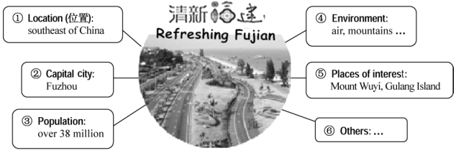
要求：
1.必须包含所有提示信息，开头与结尾已给出，不计入总词数;
2.意思清楚，表达通顺，行文连贯，书写规范；
3.请勿在文中使用真实的姓校名及提示信息以外的地名。
Hi，John, I’m glad to hear that you're planning to travel around China during the summer vacation. I'd like to invite you to my hometown Fujian for a visit.
Fujian lies __________________________________________________________________
_______________________________________________________________________________
_______________________________________________________________________________
_______________________________________________________________________________
_______________________________________________________________________________
_______________________________________________________________________________
_______________________________________________________________________________
_______________________________________________________________________________
__________________________________________________________________________
_______________________________________________________________________________
I'm looking forward to meeting you!
2017年福建省中考英语试题参考答案
I.听力（共三节,每小题1.5分,共30分）
第一节 1. B 2.C 3.C 4.B 5. A
第二节 6. A 7. C 8. B 9. A 10. C 11. B 12. A 13. C 14. A 15. B
第三节 16. twice 17. candy 18. loud 19. twenty/20 20. read
Ⅱ.选择填空（每小题l分，共15分）
21. A 22. B 23. B 24. C 25. A 26. C 27. A 28. C 29. A 30. B
31. C 32. A 33. C 34. B 35. B
III.完形填空（每小题1.5分，共15分）
36. C 37. A 38. B 39. B 40. A 41. C 42. C 43. A 44. B 45. C
IV.阅读理解（共二节，共45分}
第一节（每小题2分，共如分）
46. C 47. A 48. D 49. D 50. B 51. B 52. A 53. C 54. D 55. C
56. B 57. A 58. C 59. B 60. A 61. D 62. C 63. C 64.B 65. D
第二节（每小题1分，共5分）
66. C 67. A 68. B 69. E 70. D
V.情景交际（每小题2分，共10分）
71. The same to you.
72. Let’s go home together.
73. Excuse me, may I borrow your ruler?
74. How much is the cup?
75. I'm sorry to hear that.
说明:71-75每小题仅提供一种答案作为参考。
VI.看图写话（每小题2分，共10分）
76. The (two) flowers smell sweet/nice.
77. The boy had noodles (for dinner) yesterday.
78. There are four books on the desk/table.
79. Jim's bag is smaller than Tom’s.
80. The man will go fishing if it doesn’t rain.
说明:76-80每小题仅提供2种答案作为参考。
Ⅶ.短文填空（每小题1分,共1o分）
81. called 82. early 83. highest 84. for 85. kinds
86. health 87. fall 88. and 89. the 90. catching
说明：81-87小题及90小题均为唯一答案;88-89仅提供一种答案作为参考。
Ⅷ.书面表达（共15分）
91.参考范文：
Hi，John, I'm glad to hear that you’re planning to travel around China during the summer vacation. I，d like to invite you to my hometown Fujian for a visit,
Fujian lies in the southeast of China with Fuzhou as its capital city. It has a population of over 38 million. Because of the nice environment, it’s known as Refreshing Fujian, which attracts millions of tourists from home and abroad. If you come, you can enjoy fresh air, blue sky as well as beautiful mountains and clear rivers. Many famous places of interest like Mount Wuyi and Gulang Island are well worth visiting. Besides，you can taste various kinds of delicious food.
I'm looking forward to meeting you！

