2017年广东省中考英语试题word版（含答案）
一、听力理解（本大题为A、B、C、D四部分，共25小题，每题1分，共25分）
A. 听单句话（本题有5小题，每小题1分，共5分）
根据所听句子的内容和所提问题，选择符合题意的图画回答问题，并将答题卡上对应题目所选的选项涂黑，每小题听一遍。
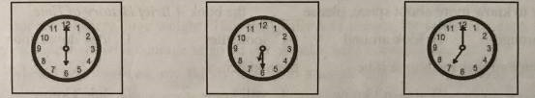
1. What time did jenny have breakfast this morning?
A B C
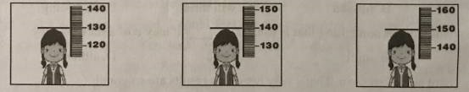
2. How tall is Amy?
A B C
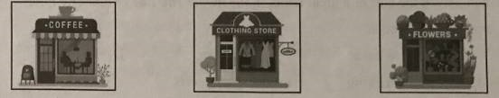
3. Where is Jane going to meet her friend?
A B C
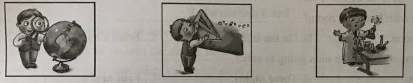
4. Which is Mark’s favorite subject？
A B C
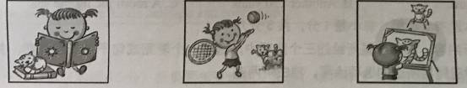
5. What is Sarah doing?
A B C

B. 听对话（本题有10小题，每小题1分，共10分）
根据所听内容，回答每段对话后面的问题，在每小题所给出的三个选项中选出一个最佳答案，并将答题卡上对应题目所选的选项涂黑。每段对话听两遍。
听第一段对话，回答第6小题。
6. What’s the problem with George’s homework?
A. Spelling mistakes. B. Grammar mistakes. C. Awful handwriting.
听第二段对话，回答第7小题。
7. What is the boy going to do tomorrow afternoon?
A. Play basketball B. play football. C. Play volleyball.
听第三段对话，回答第8小题。
8. How much is one tea set with eight cups?
A. 40 yuan. B. 160 yuan. C. 200 yuan.
听第四段对话，回答第9小题。
9. How does the woman like the city?
A. She is not used to the weather there. B. She thinks the traffic there is very good.
C. She likes the shopping environment there.
听第五段对话，回答第10小题。
10. Why is the girl going to the bookstore tomorrow?
A. She wants to spend time there reading. B. Some of the books there will be cheaper.
C. Her father will be free and drive her there.
听第六段对话，回答第11-12小题。
11. Where does the conversation take place?
A. At a dining hall B. At a restaurant. C. At a noodle factory
12. What place does the woman prefer?
A. A table by the window. B. A table in the smoking area.
C. A table near the non-smoking area.
听第七段对话，回答第13-15小题。
13. How did the man book the room?
A. On the phone B. On the Internet C. From a tourist office.
14. For how many nights is the man going to stay?
A. One night B. Three nights. C. Four nights.
15. What does the man ask for?
A. His ID card. B. Another 150 yuan. C. A room facing the sea.

C. 听独白（本题有5小题，每小题1分，共5分）
请根据所听内容，在每小题所给的三个选项中，选出一个能完成句子的最佳答案，并将答题卡上对应题目所选的选项涂黑，独白听两遍。
16. ____________ was the first to arrive at the camp.
A. Tony B. David C. the leader
17. The weather was ______________ on that day.
A. cool B. warm C. hot
18. The campers went to the beach _____________.
A. in the morning B. in the afternoon C.in the evening
19. The skill Tony liked most was how to _____________.
A. get away from snakes B. deal with wild dogs C. tell the time
20. Tony didn’t take the drumming lesson because _______________.
A. he was sleepy B. he didn’t C. he had to make his bed

D. 听填信息（本小题有5小题，每小题1分，共5分）
你将听到的是一篇关于将熊猫运送到荷兰（the Netherlands）的短文。请根据所听内容填写下面的信息卡，并将答案写在答题卡相应题目的答题位置上。短文听两遍。

The Netherlands, a New Home for Xing Ya and Wu Wen
The date of leaving from Chengdu: On the twelfth of 21__________, 2017
The way of sending the pandas: By 22__________.
The purpose of sending the pandas to the Netherlands: To keep the good 23 ____________ between China and the Netherlands
The ages of the pandas: Three years old and 24___________ years old
The first activity during the welcoming party: Three officers made short 25____________.

二、单项填空（本大题有20小题，每小题1分，共20分）
在每小题所给的四个选项中，选出可以填入空白处的最佳答案，并将答题卡上对应题目所选的选项涂黑。
26. I went to __________ supermarket to buy ___________ birthday gift for my aunt yesterday.
A. an, a B. a, a C. the, / D. /, the
27. Jessica used to be a manager in a company, but she gave up ___________ job when she became a mother.
A. she B. hers C. her D. herself
28. Two months ago, China tested its ___________ aircraft carrier (航空母舰) built completely on its own.
A. one B. first C. the one D. the first
29. Daniel has tried to lose ___________ by eating less recently, but two kilos has been put on instead.
A. weight B. weights C. height D. heights
30. It’s believed that playing computer games too much does ___________ harm than good.
A. many B. much C. more D. most
31. — Is there any outdoor learning in your school?
— ___________. We learn outdoors once or twice every month.
A. Yes, there is B. No, there isn’t C. Yes, it is D. No, it isn’t
32. We can collect rainwater when it rains ___________, and use it to water plants.
A. softly B. heavily C. noisily D. quietly
33. For more than once, our head teacher asks us ___________ the habit of keeping a diary.
A. develop B. develops C. developing D. to develop
34. To keep children safe, we ___________ put the things like knives and medicine away in our house.
A. may B. should C. can D. might
35. It’s very kind ___________ you to lend me your reusable shopping bags.
A. of B. for C. to D. with
36. If you want to know more about space, please ___________ the book A Brief History of Time.
A. look through B. look around C. look after D. look down upon
37. Johnson won’t answer the phone if he ___________ the number.
A. knew B. doesn’t know C. will know D. didn’t know
38. Sue wasn’t happy because she ___________ the concert given by her favorite singer.
A. misses B. missed C. will miss D. is missing
39. “A white elephant” means something that is useless, ___________ it may cost a lot of money.
A. unless B. until C. since D. although
40. Betty ___________ hard since last term. That’s why her exam results are so good!
A. has worked B. will work C. worked D. was working
41. — Aamir Khan played the part of a great father in the movie The Tale of Fatherly Love.
— ___________ excellent actor he is!
A. What B. What a C. What an D. How
42. The waiter told me that free parking ___________ for the hotel guests.
A. provides B. provided C. will be provided D. was provided
43. — Do you know ___________ yesterday?
—Yes. He went for the boat race.
A. why didn’t Peter go to school B. why doesn’t Peter go to school
C. why peter didn’t go to school D. why peter doesn’t go to school
44. According to a survey, people ___________ are able to speak two languages can manage two things at the same time more easily.
A. which B. whom C. whose D. who
45. — Would you please come to the dancing party with me tonight?
—___________. I suppose we shall have a wonderful night!
A. Never mind B. Have a good time C. Not exactly D. With pleasure

三、完形填空（本大题有10小题，每小题1分，共10分）
请读下面短文，掌握其大意。然后在每小题所给的四个选项中，选出一个最佳答案，并将答题卡上对应题目所选的选项涂黑。
Jack’s love for birds started when he made his first birdfeeder about six years ago. He filled the feeder with seeds (种子), put it in his backyard and then __46__ started coming. He got really __47__ in birds as more came. Then be joined a local society. As he realized that more and more birds were dying very __48__, he wanted to try his best to help them.
Besides what he has done, he has his own group called Protecting Out Birds. He does __49__ about birds, run a website to teach people about birds and how to help them, and __50__ boxes for birds. Not long ago, he found that the bluebirds were nesting（做窝）in the dead trees which were often cut down, __51__ he began to make bluebird boxes for the birds in order to save them. Now he wants to use these boxes to __52__ the dead trees. He hangs these boxes up in trees and takes __53__ down every week to see if the birds are nesting in them. He also writes articles, hoping that more people will __54__ protecting natural ecosystems(生态系统). “Researching birds is __55__ to protecting birds,”jack says, “In order to protect birds, we have to learn and really know about the birds. ”
46. A. bees B. birds C. people D. scientists
47. A. nervous B. weak C. bored D. interested
48. A. peacefully B. safely C. quickly D. sadly
49. A. practice B. business C. instruction D. research
50. A. builds B. breaks C. lifts D. pushes
51. A. so B. but C. though D. because
52. A. take good care of B. take the place of C. catch up with D. come up with
53. A. it B. this C. these D. them
54. A. wait for B. send for C. join in D. hand in
55. A. simple B. crazy C. important D. fresh

四、阅读理解（本大题有15小题，每小题2分，共30分）
阅读A、B两篇短文，从每小题所给的四个选项中，选出能回答所提问题或 完成所给句子的最佳答案，并将答题卡上对应题目所选的选项涂黑。
A

International Poetry Competition
World Poetry Day is celebrated on 21 March. Its purpose is to improve people’s ability to read, write, and teach poems all over the world.
This year, the International Poetry Centre is holding a poetry competition to celebrate the festival! The competition is open to all the poets(诗人)aged 18 and over from all over the world, and they will be divided into two groups:
Open Group (open to all the poets aged 18 and over)
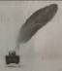
ESL Group (open to all the poets aged 18 and over who can write in English as a Second Language)
The winners of each group will receive￡1000.
RULES:
All the poems must be unpublished (未出版的) works.
Poems will not be returned, so please keep a copy.
The poem(s) must be in English and created by the poet himself/herself.
Poems can be written on any proper subject. No subject on violence(暴力) or drugs.
The competition begins on 3 March, 2017 and ends on 28 August, 2017.
To enter the competition, please visit the Centre Shop to pay ￡5 for each poem. Once the payment is made, please email the poem(s) to poetrycomp@center.uk. Remember to mark Open or ESL in the top right-hand corner of the document(文档) to show which group to enter before emailing your poem(s).
Questions about the competition can be emailed to poetrycomp@center.uk.

56. The World Poetry Day is on_____.
A. March 28th B. March 3rd C. March 21st D. August 28th
57. The purpose of the World Poetry Day is_____.
A. to encourage the British to write poems
B. to teach children how to read and write poems
C. to raise money for the poets from all over the world
D. to help people to read, write and teach poems better
58. The rules for the competition include the following EXCEPT_____.
A. that poets can write poems in any language
B. that poets must use their unpublished poems
C. that poems can’t be taken back after the competition
D. that poems can’t be written on the subject of violence or drugs.
59. Poets can get ￡1000 if_____.
A. they win in the group B. their poems are published
C. they enter the competition D. their poems are written by themselves
60. Which is the correct order for poets to enter the competition?
①Pay￡5 for each poem.
②Visit the Centre Shop.
③Email their poem(s) to poetrycomp@center.uk.
④Mark Open or ESL in the top right –hand corner of their document.
A. ①②③④ B. ②①③④ C. ②①④③ D. ③④②①

B
People often think of the North Pole(北极) and the South Pole as similar frozen(冰冻的)
wastelands. They are both places with very cold temperatures and few people live there. However, the North and South Poles are not much alike as people may imagine.
The North Pole has no land, only thick ice. Temperatures seldom go above 32°F, at which water turns into ice. Most of the time, it stays below zero. In winter temperatures are usually as low as -30°F.
Although conditions were very poor, people tried for many centuries to reach the North Pole. About 100 years ago, two men, Robert Peary and Mathew Henson, were able to get to this environment full of troubles and difficulties. They reached the North Pole on March 8th, 1909. It was really a hard trip for them.
There are few things more dangerous than crossing the Arctic(北极圈) on foot. People who stayed there may face many problems: very cold temperatures, sudden storms, and even hunger. Most of the area is uninhabited. Few people can live in such a difficult place.
People might think that with such low temperatures for most of the year, the ice would be thick and hard. However, this is not true in the Arctic. The movement of the ocean water under the ice may often cause many different changes on the surface. Sometimes the ice breaks into two opening lanes of water(水道) called “leads”. Anyone who falls into a lead can be frozen to death in a few minutes.
61. This passage is probably from ___________.
A. a book review B. a science book
C. a school report D. a computer magazine
62. According to the passage, what happened about 100 years ago ?
A. Two men succeeded in getting to the North Pole.
B. Temperatures in the North Pole went above 32°F.
C. The environment in the North Pole suddenly became worse.
D. The North Pole changed into thick ice because of the temperatures.
63. What does the underlined word “uninhabited” probably mean in Chinese?
A. 气候恶劣的 B. 充满危险的 C. 困难重重的 D. 无人居住的
64. The reason for the ice to break into two opening lanes of water is _____________.
A. that the temperature suddenly drops B. that the water under the ice is frozen
C. that the ocean water under the ice moves D. that the surface is covered with lots of ice
65. What does this passage mainly talk about?
A. The thick ice in the North Pole.
B. A difficult trip to the North Pole.
C. The real situation in the North Pole.
D. The differences between the North Pole and the South Pole.

C
配对阅读 左框是五位旅行者的需求，右框是丝绸之路的旅游路线信息。请根据这些旅游者的需求，选出最适合他们的旅游线路，并将答题卡上对应题目所选的选项涂黑。[来源:Zxxk.Com]
66．Kitty will have two weeks off and she’d like a tour at a cost of about $2500. She feels like visiting China’s historic capitals.  67. Lucas dreams of travelling along the ancient route(路线)in China during his summer vacation to find out what it used to be.  68. Sam likes to meet challenges（挑战）. He is going to spend no more than $2000 travelling across Xinjiang.  69. Elsa is taking her parents to visit china. They plan to travel along the Silk Road. They also want to take a cruise on the Yangtze River.[来源:Z#xx#k.Com]  70. Janet wants to learn about China. She is looking forward to visiting the great wonders in China. | A. 22 Days from $3629 Travel on the ancient route, you may wonder why it was chosen then and later given up. The remains of the old cities help to record their past.  B. 13 Days from $2700 This is a journey deep into Xinjiang area. Driving most part of this journey is surely an exciting experience, and most areas we pass are still undeveloped.  C. 6 Days from $1899 We’ll take you across Xinjiang area. This Silk Road route is a challenging journey, for most part of the journey will be made by bus.  D. 13 Days from $2449 You can experience going through China’s past to its present. The world-famous historic capitals along the Silk Road and the colorful culture are really fantastic.  E.5 Days from $2069 The Great Wall and the Terracotta Warriors(兵马俑)are great winders in the world. These places of interest are valuable treasures across the beautiful area.  F.12 Days from $2199 This journey heads all the way to Kirgizstan, a friendly neighbor from the beginning. Business along this historic trading road is still going on though it is not as busy as before.  G.16 Days from $3799 Traditional Silk Road includes excellent Yangtze Cruise（乘船游览）.This tour From the capital to Dunhuang, Chongqing, and then to shanghai shows you a big part of the basic sightseeing of China.

五、短文填空 （本大题有10小题，每小题1.5分，共15分）
请用适当的词完成下面短文，并将所缺单词填在答题卡指定位置上，每个空只能填一个形式正确、意义相符的单词。
What will happen if a family without the Internet for a month? One American family decides to find out. They have sent invitation to a leading US television station, expecting that it will send a film group to record their day-to -day life __71__ technology for a month.
When the film group meet __72__ Smiths, they find that Mr. Smith, Mrs. Smith and their two sons are so crazy about technology that __73__ hardly do things together. At mealtimes, no one __74__ at the dining table for their food. “Everyone just runs into the kitchen, takes their food and then goes back to their screen,” Mrs. Smith explains. “__75__ we don’t make a change, our family will become strangers to each other!”
Getting back to the normal life without the Internet is not __76__, especially when the Smiths lose themselves in it. They have to make many __77__. For example, the two brothers have to go to the school __78__ to borrow books for their scientific projects, and Mr. and Mrs. Smith need to go out shopping because they cannot buy things __79__. As the family have picked up the new lifestyle, they find that they can spend more time taking over meals, playing sports and doing all __80__ of activities together.
Would they be able to go for long without using the Internet after the challenge?

六、读写综合（本大题分为A、B两部分，共20分）
A. 信息归纳（共5小题，每小题1分，共5分）
请阅读Jason在他的个人主页上写的一篇文章，根据所提供的信息，完成信息卡，把答案写在答题卡指定的位置上。[来源:学&科&网Z&X&X&K]
Our words carry huge weight. They may influence people for years, and even for a lifetime. They provide them with courage to go on or one more reason to give up.
When I was fourteen, my family moved to another city. Junior high was always a difficult time for me, and the move made my ninth-grade year even harder. I remember walking into the dining hall for the first time. The other kids had good friends with them, but I didn’t know anyone. I felt lonely and went to the nearest seat after getting some food. The kids beside me looked at me up and down and then laughed. I could feel my face turning red at that moment. Then one of the Kids broke the ice. “Man! You have one BIG nose!” I felt hurt and didn’t know what to say. I wanted to cry. But I managed a little smile---as if it didn’t hurt me at all. But it did. From then on, I would often look at myself in the mirror. I studied the big nose closely. It seemed that I was just living for my nose. Thankfully, I grew out of this influence finally. But it really took me twenty years
There is another thing that is kept deep in my mind. I remember going through a terrible business failure. I lost everything. I called my dad for help and he told me a lot about how to deal with the failure. What he said gave me a lot of courage and confidence（信心）to go on with my business.

Information Card
The thing that may influence people for a long time | 81.
Jason’s feeling when he entered the dining hall | 82.
The part of Jason’s body that other kids laughed at | 83.
The number of years that Jason spent growing out of the influence | 84.
The person who gave Jason courage and confidence | 85.

B. 书面表达（本题15分）根据要求完成短文写作，请将作文写在答题卡指定位置上。
常言道“良言一句三冬暖，恶语伤人六月寒”。假设你是李雷，你将要参加学校举办的英语演讲比赛，主题是“语言的力量”，请你写一篇英文演讲稿，内容包括：
你的一次受老师或同学言语激励的经历（事情的经过以及对你的影响）；
呼吁同学们要注意自身言语对他人的影响。

作文要求：
1. 不能照抄原文；不得在作文中出现学校的真实名称、老师和同学的真实姓名。
2. 语句连贯，字数80个左右。作文的开头已经给出，不计入总词数。

Ladies and gentlemen,
How will words influence others? Let me tell you one of my experiences. _______________
______________________________________________________________________________________________________________________________________________________________________________________________________________________________________________________________________________________________________________________________________________________________________________________________________________________________
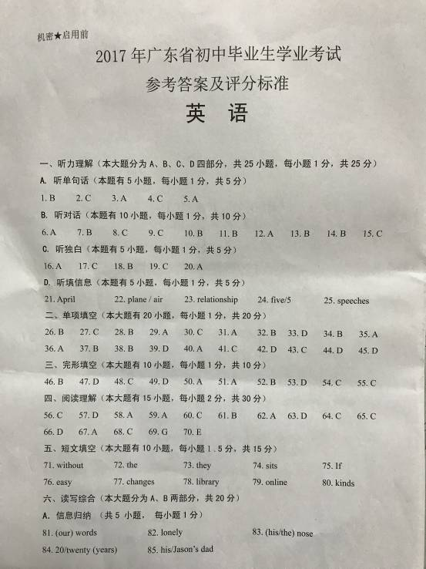

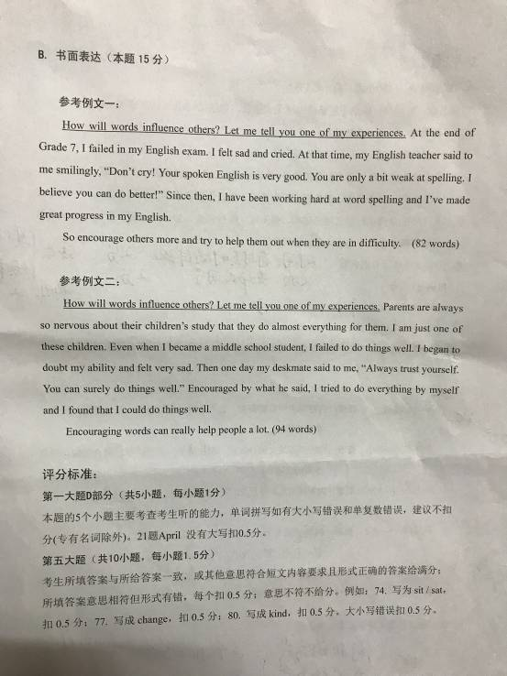

听力理解
首先，播放一分钟音乐信号，请监考老师调试好录音机的音量。音乐结束后，听力考试正式开始。
A. 听单句话。根据句子的内容和所提问题，选择符合题意的图画回答问题。每小题听一遍。
听每小题之前，你有5秒钟的时间阅读题目，听完后，你有5秒钟的答题时间。
停顿5秒钟
1. Jenny had breakfast at half past six this morning. 停顿10秒钟
2. Amy is my younger sister and she is 1.5 meters tall.停顿10秒
3.Jane is going to meet her friend at the coffee shop after work.停顿10秒钟
4.Chemistry is Mark’s favorite subject because he likes doing experiment.停顿10秒钟
5. Sarah is reading a story book while his pet cat is sleeping near her.停顿5秒

B. 听对话. 回答每段对话后的问题，在各题所给的选项中选出一个最佳答案。每段对话听两遍。听每小题之前，你有5秒钟的时间阅读题目，听完后，你有5秒钟的答题时间。
停顿5秒钟[来源:学科网ZXXK]
听第一段对话，回答第6小题。
W: George, pay attention to your spelling. There are too many mistakes in your homework.
M: Sorry, Ms. Miller. I’ll be more careful next time.
停顿2秒钟 (Listen again) 停顿10秒钟
听第二段对话，回答第7小题。
M: Mum, I feel like playing football with my classmates tomorrow afternoon after school.
W: No problem, but you must be back by 6:00 pm.
停顿2秒钟 (Listen again) 停顿10秒钟
听第三段对话，回答第8小题。
W: How much is one tea set with four cups?
M: One hundred and sixty yuan. But if you like to pay forty yuan more, you can have the set with eight cups.
W: Ok, I’ll take the tea set with eight cups.
停顿2秒钟(Listen again) 停顿10秒钟
听第四段对话，回答第9小题。
M: You’ve been in the city for half a year. What do you think of it?
W: It’s a lovely city with nice weather and good shopping environment.
M: I agree with you. But I think the traffic condition should be improved.
停顿2秒钟(Listen again) 停顿10秒钟
听第五段对话，回答第10小题。
W: Dad, could you drive me to Sunshine Bookstore tomorrow morning?
M: Sorry, dear, but I have a meeting to attend. What about the day after tomorrow?
W: Tomorrow is members’ day and some of the books there will be 50% off.
M: Why not ask your mum to drive you there? She may be free tomorrow.
停顿2秒钟 (Listen again) 停顿15秒钟
听第六段对话，回答第11－12小题。
M: Hello, welcome to Ranch Noodle House.
W: We like the table for three, please.
M: All right. Would you prefer a smoking area or a non-smoking area?
W: Non-smoking, please. And we like a table by the window if possible.
M: Ok, let me see. ..Yes, we do have a table by the window right now. This way, please.
W: Great. Thank you so much.
停顿2秒钟 (Listen again) 停顿25秒钟
听第七段对话，回答第13－15小题。
M: I’d like to check in, please. I’ve booked the room on the Internet. My name is Jam Hall.
W: Let me check…. Err…Here it is. Could you please show me your ID card?
M: Here you are. I need a room for three nights. Do you have a room facing the sea?
W: Sure, but you have to pay another 150 yuan for one night. Is that OK with you?
M: No problem.
W:Good. Should I ask someone to carry your bags to your room?
M: No, thank you.
停顿2秒钟 (Listen again) 停顿15秒钟

C. 听独白。根据所听内容，在每小题所给的三个选项中，选出一个能完成所给句子的最佳选项。本题听两遍。听独白之前，你有25秒钟的时间阅读题目，听完后，你有25秒钟的答题时间。 停顿25秒钟
I’m Tony. Let me tell you about my summer camp. Last Friday night, I was so excited about going camping but I didn’t sleep well. I arrived at the camp earlier than anyone else the next morning. Then I learned how to put up a tent from David. It was very hard work in a hot sun. At noon, everyone was glad to have a picnic lunch. At 2:00 pm, on the way to the beach, our leader told us some skills we may need for our lives outdoors, such as how to deal with snakes and wild dogs. My favorite skill was how to tell the time by looking at the sun. In the evening, we had dinner followed by a drumming lesson. I didn’t take it because I had to sleep earlier to make up for the night before. I think it was a great experience and I learned a lot.
停顿2秒钟 (Listen again) 停顿15秒钟

D. 听填信息. 你将听到的是一篇关于将熊猫运送到荷兰的( the Netherlands)的短文，请你根据所听内容填写下面的信息卡并将答案写在答题卡相应题目的答题位置上。短文听两遍。听短文之前，你有25秒钟的时间阅读题目，听完后，你有25秒钟的答题时间。 （停顿25秒钟）
On the 12th of April, 2017, an airline in the Netherlands sent two pandas from Chengdu in China to the Netherlands. This is the first time for the airline to fly pandas from China to the Netherlands. The two pandas are called Xing Ya and Wu Wen. Sending the two pandas to the Netherlands helps to keep the good relationship between the two countries. The pandas would live in one of the zoos where a special area was built for them. The 3-year-old and 5-year-old pandas would stay there for a long time. During the welcome coming party, three government officers made short speeches. After that, people watched these two cute animals with great interest. And people also enjoyed a short video on the Internet about how the pandas were sent from China to the Netherlands

停顿2秒钟 (Listen again)

全部题目均朗读完毕，请接着做笔试部分。

