各位同学在查看时请点击全屏查看
2017年忻州中考英语试题
英语试题第I卷（共75分）
I.情景反应（每小题1分，共5分）
本题共5个小题，每小题你将听到一组对话。请你从每小题所给的A、B、C三幅图片中，选出与你所听到的信息相关联的一项，并在答题卡上将该项涂黑。
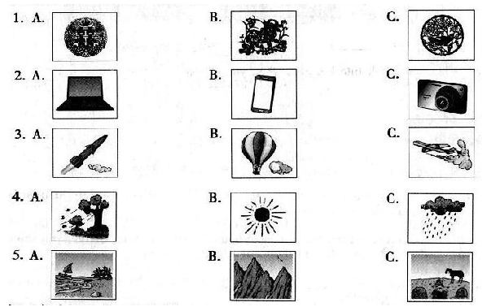
答案：1.A 2.B 3.C 4.B 5.C
II.对话理解(每小题1分，共5分)
本题共5个小题，每小题你将听到一组对话和一个问题。请你从每小题所给的A、B、C三个选项中，选出一个最佳选项，并在答题卡上将该选项涂黑。
()6.A.Thursday B.Friday C.Saturday
()7.A.Thelibrary B.Thelab C.Theplayground
()8.A.Apolicewoman B.Anactress C.Adoctor
()9.A.Aparentandateacher B.Afatherandadaughter
C.Abossandacustomer
()10.A.Shewillkeepabirdasapet
B.Shewillgetabirdandsetitfree
C.Shewillbuyabirdforherfather
答案：6.B 7.C 8.A 9.A 10.B
III.语篇理解(每小题1分，共5分)
本题你将听到一篇短文。请你根据短文内容和所提出的5个问题，从每小题所给的A、B、C三个选项中，选出一个最佳选项，并在答题卡上将该项涂黑。
（）11.WhichcountrywasMarkbornin？
A.America. B.China. C.England.
（）12.Whendidhismomaskhimtobuyfish?
A.OnChristmasEve. B.OnNewYear’sDay. C.OnSpringFestivalEve.
（）13.Whatdidhemeanbysaying“XianShengYu”?
A.Thefisherman’sname. B.Freshfish. C.Thenameofadish.
（）14.Whydidthepeopleatthefishstorelaughathim?
A.BecausehetoldaChinesejoke.
B.BecausehespokefunnyChinese.
C.Becausethefishermanmadefunofhim.
（）15.WhatdoesMarkwanttotellusbysharinghisstory?
A.Weneedn’tcareaboutwhatothersthinkofus.
B.Itisimportanttospeakmorethanonelanguage.
C.Nobodyissupposedtoforgethisowntraditionalculture.
IV.听力填空（每小题1分，共5分）
本题你将听到一篇短文。请你根据所听内容，完成下面的表格，并将获取的信息填写到答题卡相应的位置上。每空一词。
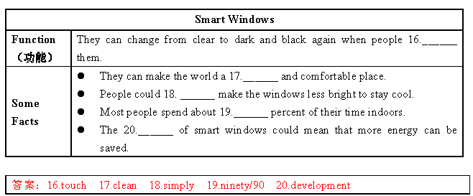
IV.单项选择（每小题1分，满分10分）
请你从每小题所给的A、B、C三个选项中，选出可以填入空白处的最佳选项，并在答题卡上将该项涂黑。
()21.Believein___isaveryimportantruleforyoutogetalongwellwithothers.
A.myself B.himself C.yourself
答案：C
()22.Youshouldlookintohiseyeswhenyoutalktosomebody.Itshowsyour___.
A.shyness B.politeness C.quietness
答案：B。
()23.Skimmingisakindofreadingstrategy.Itmeansreadinganarticle___tofindthemainideawithoutreading everyword.
A.quickly B.carefully C.clearly
答案：A。
()24.Ourteachershavebeenwithusfornearlythreeyears___wecametojuniorhighschool.Weshouldthankthem forwhattheyhavedoneforus.
A.until B.before C.since
答案：C。
()25.Ifyourbestfriendtellsyouhissecret,it’s___foryoutokeepthemforhim.Bydoingthis,youcanwinothers’ trust.
A.special B.necessary C.possible
答案：B。
()26.Whenyou’reinvitedtohavedinnerathomebyanAmericanfriend,youshouldbe___oralittlelater.It’s differentfromourChinesecustom.
A.ontime B.onbusiness C.onshow
答案：A。
()27.Nomatterwhatproblemswemeet,weshouldtrytosolvethem,andeventhoughwefail,teachersandparents
___us.
A.arestrictwith B.areworriedabout C.areproudof
答案：C。
()28.Whengoingupstairsordownstairs,weneedtowalkontheright,leavingtheleftspaceforthepeoplewho___.
A.hurryup B.lookaround C.runaway
答案：A。
()29.MissLi,___,isactiveallthetime.Althoughshehasnotbeenwellthesedays,herclassisstillfulloflaughter.
A.asyouknow B.allinall C.tostartwith[来源:.Com]
答案：A。
()30.—Afterweenterthehighschool,wewillhavethecoursesaboutlifemanagement.Wecanchoosewhatwe like.Iwonder___.
—Physics.Iwanttostudyscienceinthefuture.
A.whatchoosingcoursesisfor
B.whatcoursesyouwanttotake
C.whatyouthinkofchoosingcoursed.
答案：B。
VI.补全对话（每小题1分，共5分）
根据对话内容，从对话后方框内的选项中选出能填入空白处的最佳选项，使对话意思完整，并在答题卡上将该
项涂黑。选项中有两项为多余项。
（Atbreak,AmymeetsKeninthehallway）
Amy:Hi,Ken.Jane’sbirthdayiscoming.Haveyoureceivedherinvitation?
Ken:Yes.___31___
Amy:Metoo.I’mjustthinkingaboutthegift.___32___
Ken:Well,shelikeswriting.Whynotgetherpensandbooks?
Amy:___33___Ithinkshe’llbehappytogetthem.
Ken:Yeah.Bytheway,howwillyoubuythegift?Willyouaskyourparentsformoney?
Amy:___34___I’vealreadysavedmypocketmoney.
Ken:You’reright.Ithinkweshouldlearntomanagepocketmoney.IjustspenditonthethingsIreallyneed.
Amy:That’strue.___35___
Ken:Whatakindgirl!Learningtosaveandusemoneyarebothimportanttous.
31._______32._______33._______34._______35._______
A.Yes,please.
B.Soundsgood.
C.Ofcoursenot.
D.Howaboutyou?
E.Canyoucometomyparty?
F.Haveyougotanygoodideas?
G.Ialsouseittohelpothersinneed.
答案：
31.D 32.F 33.B 34.C 35.G
VII.完形填空（每小题1分，共10分）
阅读下列短文，掌握其大意，然后从每小题所给的A、B、C三个选项中，选出一个最佳选项，并在答题卡上将
该项涂黑。
MaximeandLiseareayoungFrenchcouple.TheyarereadytotravelacrossChinafromBeijingtoYunnanProvince onatandembicycle(双人自行车).Theyhavetwomainpurposesandoneofthemisthattheywanttoencouragegreen ___36___throughit.
Maxime,26,workshelpingfarmersraisetheircows,___37___hiswifeLise,26,isateacher.Thetwoalsolikesharing theirtravelstoriesonFacebook.
“Wechooseatandembicyclebecauseitmakesit___38___tocommunicatewitheachotheraboutinterestingpeople andthingswecomeacrossduringthejourney.___39___,bicyclingishealthier.Andit’sacheaperandmore environment-friendlywayoftravelingthan___40___cars,motorsandsoon,”thecouplesaid.
Asfortheother___41___oftheirjourney,thetwosaidtheywantedtogetpeople’sgoodideasontopicssuchashealth,economy(经济)andpolitics.Whentheywereasked___42___theychosetovisitChina,theysaiditwasbecausetheyoften talkedaboutitslonghistoryandbeautyandhowmuchofthecountryiscompetitive(有竞争力的)intheworld.
“WeknowChinaisacountrywithalargepopulationandwillbethe___43___oftheeconomyaroundtheworldinthe future.Wewanttogetabetterunderstandingofthecountryanditspeople.We___44___thecountry,”theysaid.
ThecouplewillbeontheirjourneytoChinasoon.Wehopetheycanmakemorepeoplefurther___45___Chinaby sharingwhattheyseeandhearontheway.Meanwhile,wehopetheyenjoytheirtravelinChina.
()36.A.food B.farming C.travel
()37.A.while B.though C.because
()38.A.busier B.easier C.earlier
()39.A.Besides B.Instead C.However
()40.A.buying B.using C.making
()41.A.order B.result C.purpose
()42.A.how B.why C.when
()43.A.leader B.player C.learner
()44.A.need B.miss C.love[来源:学科网]
()45.A.dreamabout B.hearabout C.knowabout
答案：
36.C 37.A 38.B 39.A 40.B
41.C 42.B 43.A 44.C 45.C
VIII.阅读理解（一）（每小题2分，共30分）
（A）
请阅读下列五个故事简介，将其与上面书橱中陈列的书籍相匹配，并在答题卡上将对应的选项涂黑。其中有一项为多余选项。
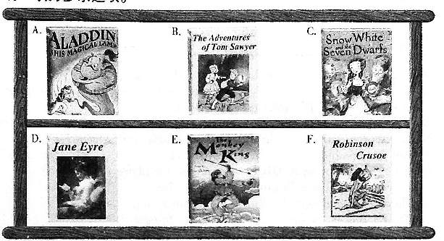
46.EverydaythebadQueenaskshermirror:“Mirror,Mirror,onthewall,who’sthemostbeautifulofusall?”Andevery daythemirrorreplies,“Youare!”…untilonedayitsays,“ThePrincess!”SotheQueenissoangrythatshedecidesto killthePrincesswhohasskinaswhiteassnow.Shedoesn’texpectthegirltofindnotonebutseventinymen.
47.Finally,themangetstoalonelyisland.Luckily,hegetssometools,foodanddrinks,knivesandgunsfromthebroken shiphetook.Later,hefindsacave(山洞)tolivein.Butoneday,hefindssomelargefootprintsinthesand.Isthere anyoneelseontheland?Whoisrunningtowardshiscave?
48.Withoutparents,thegirlistakentoaboardingschool.Thoughshehasahardtimethere,shegetseducationandlater becomesateacher.However,shegetssoboredwithherlifethatsheisthirstyfortheoutsideworld.Soshesendsanad forajob.Willshegetareply?Willshegeteverythingshefightsfor—freedom,fairnessandtruelove?
49.Whentheyoungmanmeetshislong-lostuncle,hefindsamagiclampthatchangeshislife.Insideisagenie(精灵)with thepowertomakewishescometrue.Butcaneventhegeniehelptheyoungmanwinthebeautifulyounggirl?Andis hislong-lostuncleallheseems…?
50.Hereistheboywhoislikeyouinsomeways.Hethinksschoollifeisboringandlooksforwardtosomethingexciting. Oneday,heentersacavewithhisfriend.Theywalkdeeperanddeeperintothecave.Unluckily,theircandleisputou andtheygetlostinthedark.Cantheygetoutofthecave?Withotherexcitingthingswilltheyexperience?

答案：
（B）
请阅读下面短文，从每小题所给的A、B、C三个选项中，选出一个最佳选项，并在答题卡上将该项涂黑。
High-speedtrains,Alipay（支付宝）,sharedbikesandonlinepaymentareseenasthenewFourGreatAchievementsof Chinabyyoungforeigners,accordingtoavideosurveybytheSilkRoadResearchInstituteofBeijingForeignStudies University.Inthevideo,youngpeoplefrom20countriesalongBeltandRoadRoutes（一带一路）wereaskedtonamegreat inventionsthathadinfluencedtheirlivesinChina.Thefollowingiswhattheysaidfrom4youngpeopleofthem.
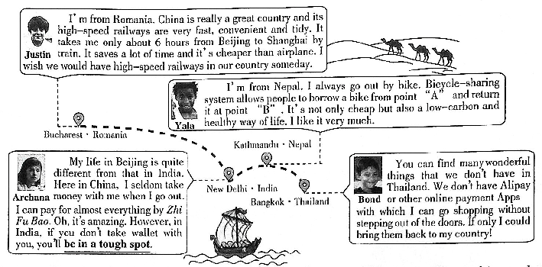
()51.WhatdoesJustinthinkofthehigh-speedrailwaysinChinaaccordingtohiswords?
A.Fastandtidy.
B.Convenientandwonderful.
C.Cheapandamazing.
()52.Whatdo“A”and“B”referto(指)inYala’swords?
A.Twobikes.B.Tworiders.C.Twoplaces.
()53.Whatdoestheunderlinedphrase“beinatoughspot”mean?
A.Getintotrouble.B.Loseyourway.C.Stayinsilence.
()54.WhichofthefollowingisTRUEaccordingtotheaboveinformation?
A.Bicycle-sharingsystemprovidesbikesforfree.
B.There’renohigh-speedrailwaysinRomanianow.
C.ZhiFuBaoistheonlywayofpayingforthings.
()55.Whatconclusion（结论）canwedrawaboutthenewfourgreatachievements?
A.Theywerecreatedbyyoungforeignpeople.[来源:.Com]
B.TheyarethesignsthatChinaisimprovingrapidly.
C.TheywerebroughttothecountriesalongBeltandRoadRoutes.
答案：
51.A 52.C 53.A 54.B 55.B
（C）
阅读下面短文，根据短文内容，从方框内所给的选项中选出能填入空白处的最佳选项，使短文意思通顺，并在
答题卡上将选项涂黑。选项中有一项为多余项。
Whatislife’sgreatestgift?Itischoice.Choiceistheabilitytochoosesomeactionsfromasetofthingstoachievea goal.___56___Thereasonisthatitturnsusfromdumbanimalsintoartists.Choicebecomesthetoolweusetosculpt（雕刻） ourlife.Thetooldoesn’tcomefree,however,forthepriceofchoiceisresponsibility.___57___itisenjoyment.
Choiceispower.Choiceisattheheartoflife.It’sthecreativepoweroflife.Lifeisalwayschangingandwehaveto makelotsofchoices.___58___Weoftenneedtocheckwhereweareonourjourney.Weneedtoaskquestions:AmI movingclosertomygoals?Ifnot,whatactionwillItakenowtomakemyselfrealizemygoals?
___59___Andourlifebecomesmoreconvenientorcomfortablebecauseofthem.Forexample,youdecidewhich storestoshopatandwhichbusstationtogoon.Butthedecisionsthatwemaketosculptourlivesaremuchmoreimportant thandecidingwheretoshop.Themoreweunderstandthedifferencebetweensmallandbigdecisions,themorepleasurewe willget.
Lifeislikeachessgame.___60___Allchessloversrealizethatitisn’tnecessarytowintoenjoythegame.Makethe
bestmovesyoucanundertheconditions.Thenyoucanenjoyyourlife.
A.Whyischoicesogreat?
B.Thepleasureisintheplaying.
C.Infact,wehavetomakechoiceseveryday.
D.Butwhenweacceptandcarryitout,wegetagreatreturn.
E.Becausemakingrightchoicesismoreimportantthanworkinghard.
F.Everychoicewemakeleadsusclosertoorfartherfromourgoals.
答案：
第II卷（共45分）
IX.阅读理解（二）（每小题2分，共20分）
(A)
请阅读下面短文，根据短文内容，在下面的表格中填入与文章意思最符合的单词，并将答案写在答题卡相应的位置上。每空一词。
Doyoueverfeellikeyouarejustrushingfromonesubjecttoanother?Whenthingshappensofast,maybeyoucan’t understandclearlywhatyouaredoingorlearning,soitisimportanttostopyourselftothinkaboutwhatyouhavebeen doingorlearning.
Self-reflection（反省）meansslowingdownandcalming（使平静）yourself,includingcalmingyourmind.Bycalming downandgoingslowly,yougiveyourbrainachancetothinkaboutwhatithasalreadyreceived.Somepeopleprefertodo self-reflectiononlyintheirmind.Otherskeepadiary.What’smore,takingnotesisalsoOK.Eachmethodworks, dependingonyourownpersonallearning.Youcanfollowthestepstodosoself-reflection.
First,choosethepropertimetodoit.Schooltextbooksaredividedintounitsofstudy.Thismakesiteasiertobegin self-reflection.Lookfortimewhenyoucompleteaunitofstudy.Sometimesyouknowtheunitisoverbecausethereis somekindoftest.Usethesenaturalbreakstostopanddoself-reflection.
Then,findaquietplaceandtakeoutyourreflectiondiary.Writedownsomenotesonthenewthingsthatyoulearned intheunit.Letyourmindthinkaboutthenotesyouhavewrittenandmakesomeconnections.
Finally,thinkaboutthingsthatyouarenotsureof.Maybeyoulearnedanewwaytoworkoutamathproblem,but you’renotsurewhentouseit.Writingdownyourquestionswillhelpyouremembertolookforanswersthenexttimeyou areworkingwiththesametopic.
Successfulstudentsalwaysknowself-reflectionisimportant.Ifyouhavenevertakenthetimetodoself-reflection,try itnow.
Self-reflectionMakesYouaBetterLearner
Introduction |  Itmeansslowingdownandmakingyourselfclam.   Youcanthinkaboutwhatyouhavelearnedbycalmingdownandgoing___61___.   Youcandoitonlyinyourmind,andyoucanalsokeepadiaryor___62___notestodoit.
Howtodoit |  It’sapropertimetostartit___63___aunitisover.   Writedownandthinkaboutwhatyouhavelearnedintheunitandmakesomeconnections.   Writedownyourquestionsaboutsomethingyou’renotsureof.It’s___64___toworkwiththe  sametopicthenexttime.
Conclusion | Successfulstudentsalwaysknowthe___65___ofself-reflection.Tryitnow!

答案：
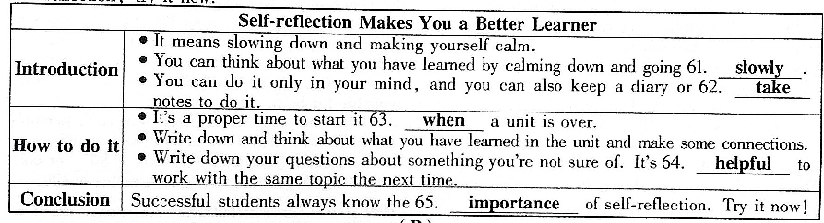
（B）
阅读下面图文，简要回答所给问题，并将答案写在答题卡相应的位置上。
Livingintheageof“Internet”,moreandmoreelectronicproductsandAppshavechangedpeople’slifestylesinmany ways,suchasreadinghabitsandsportsevents.
ElectronicReading
Insteadofreadingpaperbooks,morepeopleliketouseelectronicdevices(设备)toreadinChinanow.Thereading timespentonthemisgettinglonger.ChartⅠshowsdifferentreadingtimefromasurvey.However,eventhoughpeople spendmuchtimeone-books,thetraditionalpaperbooksarestillpopularamongreaders.Researchhasshownthatreaders remembermoreinformationfrompaperbooksthane-books.Toourgreatjoy,thenumberofbooksthateachpersonreadin
2016inChinareached7.86,whichincreasedalotmorethanbefore.
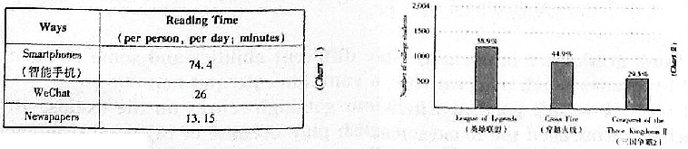
ElectronicSports
Justlikesoccer,basketballandbaseball,e-sportshasbecomeverypopulararoundtheworld.E-sportsisshortfor electronicsports.Itismorethanjustchildrenplayinggamesintheirbedrooms.Ine-sports,teamsofgamersplayelectronic gamesinfrontofmanypeopleandcompete.Andtheyneedtoputinalotofhardworkandtraining.ChartⅡshowsthetop threemostfollowede-sportsamongChinesecollegestudentsfromasurveylastyear.
Actually,e-productsplayanimportantroleinourdailylife.Theyhavenotonlychangedourlifebutalsomadethe worldcolorful.Onecoinhasitstwosides.Asteenagers,ifweputthee-productsintogooduse,theycanaddmorefunto ourlifeandbecomegoodhelperstoourstudy.
66.Accordingtothepassage,whyarethepaperbooksstillpopularamongreaders?
____________________________________________________________________________
67.ChartⅠshowsthereadingtimeonWeChatismorethanthatonnewspapers.Howmuchmoretime?
____________________________________________________________________________
68.Doyoulikereadingpaperbooksorelectronicbooks?Why?
____________________________________________________________________________
69.WecandrawaconclusionthatmanyyoungpeoplewanttobeaherointheirmindfromChartⅡ.Howcanyouknowit?
____________________________________________________________________________
70.Intheageof“Internet”,whatinfluencedoyouthinkthee-productshaveonus?
____________________________________________________________________________
解析：
66.Becausereadersremembermoreinformationfrompaperbooksthane-books根据文章第二段倒数两句可得答案。
67.(It’s)12.85minutes.从表1可看出答案。
68.Paperbooks.Becausetheyarebetterformyeyesthane-books./E-books.Becausetheyareconvenient./...结合文章 合理作答。
69.Thechartshowsthetopthreee-sportsamongcollegestudentsareallaboutheroes./Because58.9%ofcollege studentsplaytheLeagueofLegends./...从表二可看出答案。
70.Theyhavenotonlychangedourlifebutalsomadetheworldcolorful./Theyhaveprovidedmorewaystoget information./...结合自身实际合理作答即可。
X.词语运用（每小题1分，共10分）
根据语篇内容，用方框中所给词的正确形式填空，使短文通顺、正确、连贯，并将答案填写到答题卡相应的位置上。方框中有两个词为多余项。
bywholifetakethatserious oronetheysendhappyinfluence
oncehadanunforgettableexperiencethathasaffectedanddirectedthewayIthinkandactnow.
WhenIwasaboutsevenyearsold,mygrandfather71._______metoafishpondonafarmandtoldmetothrowa stoneintothewater.Hetoldmetowatchthecirclescreated72.______thestone.Thenheaskedtothinkofmyselfatthat stone.“Youmaycreatelotsofcirclesinyourlife,butthewaves73.______comefromthosecircleswilldisturb(干扰)the peaceofallthepeoplearoundyou,”hesaid74.______.“Rememberthatyourcirclemayspreadtomanyothercircles, meaningthatyourthoughtsoractionsmaydisturbothers’75.______.Youareresponsibleforwhatputinyourcircle.Ifyou want,thegoodorpeacethatcomesfromyourcircle76.______toothers.Atthesametime,theangerorjealousy(嫉妒) comingfromyourcirclewillalsospreadtoothercircles.Youshouldallowthegoodfeelings77._______others,notthebad ones,becauseyouareresponsibleforboth.”
Thatwasthe78.______timeIheardmygrandfathertellmethese.Ihadrealizedthateachperson’s79.______or angercanmoveoutintotheworld.Ifwearefilledwithdoubtoranger,wecannotcreateworldpeace.Wespreadthe feelingsandthoughtsthatweholdinside,whetherwespeak80.______ornot.Thesecirclesarespreadingintotheworld, creatingbeautyormakingtroublestoothercirclesoflife.
答案：
XI.书面表达（共15分）请将短文写在答题卡相应的位置上。
在我们成长的过程中，有过各种各样的经历，其中，“考试”也是一种经历，“成绩”更是一直“伴随”着我们。为使同学们学会客观、理性地看待问题，九年级三班以“考试成绩重要吗，它是否等同于实际能力？”为题展开了辩论。
假设你是正方或反方的一员（只需选择一方），请围绕你的观点，结合亲身经历来说服同学们。
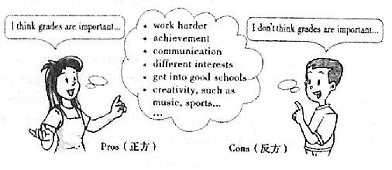
要求：1.词数不少于80词；
2.提示词正、反方均可使用，仅供参考；
3.文中不得出现真实的人名、校名。
Pros（正方）Cons（反方）
__________________________________________________________________________________
__________________________________________________________________________________
____________________________________________________________________________________________________________________________________________________________________
__________________________________________________________________________________
__________________________________________________________
Apossibleversion:
Idon’tthinkgradesareimportant.Studentshavedifferentabilitiesandsomeofthemcan’tbemeasured bygrades,suchascreativity,abilitiestocommunicateandact.
Tostartwith,Iwasn’tgoodatEnglishandseldomgothighscoresontheexams.Butoneday,myteacher encouragedmetoperforminanEnglishplaybecauseofmygoodpronunciationandlivelyexpressions.To performwell,Istudiedmylinesmanytimesandevendresseduplikethecharacter.Whilewewere performing,Icouldhearmyclassmatescheering.Howexcited!Later,myteacherpraisedmeformy wonderfulactingandthismadememoreconfidentandinterestedinEnglish.
Allinall,gradescanbeawaytomeasurestudents’achievementsinschoolwork.However,different interestsandabilitiescanmakeastudentafullman.

