秘密★启用前
各位同学在查看时请点击全屏查看
2017年贵阳市中考英语试题
同学你好！答题前请认真阅读以下内容：
1. 本试卷共8页，共8个大题，满分1 50分，答题时间120分钟，考试形式为闭卷。
2. 一律在答题卡相应位置作答，在试卷上答题视为无效。
3. 选择题均为单项选择，多选不得分。
英语试题第I卷(选择题，共100分)
I. 听力测试(本大题共30分，每小题1分)
A. 听对话，选择与对话内容相符的图，并将答题卡上该选项涂黑。(读一遍)
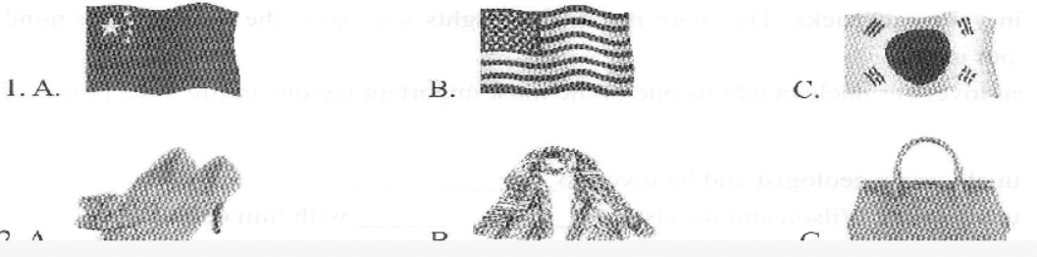
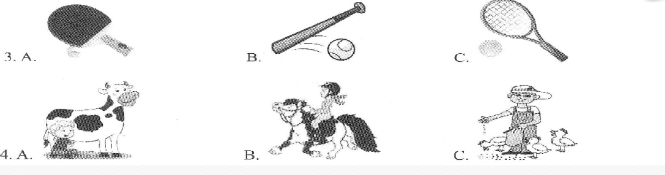
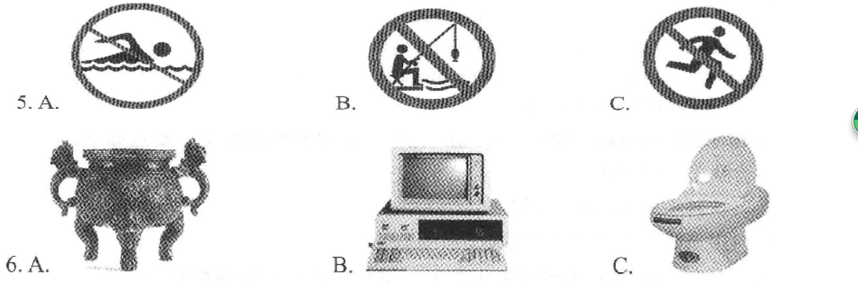
B. 听句子，根据所听句子，选择最佳应答，并将答题卡上该选项涂黑。(读一遍)
7.A. By bus. 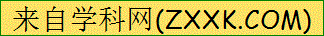 B.It’s fine. C.Thanks.
8.A. It’s Okay. B.It’s an orange. C.It’s sunny today.
9.A. See you. B.Sounds good. C.You’re welcome.
10.A.English. B.Koalas. C.Carrots.
11.A.Sure, I’d love to. B.It’s a nice day. C.Here you are.
12.A.Mooncakes. B.Dumplings. C.Zongzi.
C. 听对话，根据对话内容，选择最佳选项完成句子，并将答题卡上该选项涂黑。(读两遍)
13. Scott loves____music.
A. pop B. rock C. country
14. Jack likes____because they are healthy.
A. apples B.noodles C.vegetables
15. Jane’s telephone number is
A. 543-4721 B.876-3721 C.635-2721
16. Bill used to be___.
A. shy and friendly B.kind and quiet C.shy and quiet
17. Mary thinks a good friend should____.
A. make her laugh B.be a good listener C.care about her
18. Mr. Green is going to next year.
A. take guitar lessons B.get lots of exercise C.get good grades
D. 听对话及问题，根据对话内容，选择最佳答案，并将答题卡上该选项涂黑。(读两遍)
19.A.At 6:30. B.At 7:30. C.At 8:30.
20.A.Glass. B.Wood. C.Paper.
21.A.He has a cough. B.He has a fever. C.He has a cold.
22.A.Tom Sawyer. B. Treasure Island. C.Sleeping Beauty.
23.A.Recycle books and paper. B.Walk to school. C.Use cloth shopping bags.
24.A.He was taking a shower. B.He was sleeping. C.He was reading.
E. 听短文及问题，根据短文内容，选择最佳答案，并将答题卡上该选项涂黑。(读三遍)
25.A.Beijing. B.London. C.New York.
26.A.Her parents. B.Her friends. C.Her classmates.
27.A.On July 10th. B.On June 10th. C.On May 10th.
28.A.For three days. B.For four days. C.For five days.
29.A.Tian’anmen Square, B.The Summer Palace. C.The Great Wall.
30.A.Chinese culture. B.Chinese history. C.Chinese people. [来源:学§科§网Z§X§X§K]
II.单项选择(本大题共15分，每小题1分)
根据语境或句意，选择可填入句子的最佳选项，并将答题卡上该选项涂黑。
31. There is a______in my neighborhood and I often go there to see tigers.
A. zoo B. bank C. school
32. “Look! An old man is lying on the road.” “His leg is badly hurt. Let’s call_____.”
A. 118 B. 119 C. 120
33. “Do you know when the Belt and Road International Day is?”
“Yes, it is____December 16th.”
A. at B. on C. iri
34. When l was on my way home, it suddenly started to rain_____.
A. heavily B.quickly C.hardly
35. My hometown is the place______holds all my sweet memories.
A. who B. which C. what
36. Grace often gets nervous before she gives a speech .
A. in pubic B. in total C. in common
37. Xiao Ming, you’ll be late for school______you hurry up.
A. after B. though C. unless
38. We should not trees in order to make our environment more beautiful.
A. write down B. cut down C. turn down
39. “Cindy, how far is it from your home to school?” “About 20 walk.”
A. minutes B. minute’s C. minutes’
40. We all know that one ofthe world’s most popular sports football.
A. am B. is C. are
41. Huangguoshu Waterfall is beautiful that I want to come here again next year.
A. so B. too C. such
42. “I’ve never been to Disneyland, Judy.” “ ”
A. So have I. B. Neither am I. C. Neither have I.
43. Annie decides to work harder and get better grades next year.
A.many B.much C.very
44. It’s best not to run away from our problems. We should always try to them.
A. solve B. take C. get
45. The Chinese government has made______possible for people to live happy lives.
A. that B. this C. it
III. 情景交际(本大题共1 0分，每小题1分)
A. 从右栏选项中找出左栏各旬的最佳应答，并将答题卡上该选项涂黑。
46. How do you learn English? A. Let’s go.
47. What does your friend look like? B. Sure, Mom.
48.I am flying to Sanya to take a holiday. C.I agree with you.
49.I think the air will be cleaner in the future. D. Have a nice trip!
50. Bob, could you please take out the rubbish? E.By reading aloud.
F. She’s of medium height.
B. 补全对话根据对话内容，选择方框内最佳选项完成对话，并将答题卡上该选项涂黑。
A: Dad, how much do you know about China?
B: 51 China is a big country that has about 5,000 years of history. It attracts
many tourists from all over the world every year.
A: Is that so? 52
B: Yes. And many of them are famous, such as Mount Tai, Mount Huang and Mount Emei.[来源:学科网]
A: 53
B: There are many rivers in China. Among them the Yangtze River is the longest one and the
second longest one is the Yellow River. 54
A: Anything else?
B: Sorry. That’s alll know. If you want to learn more, you can read Guide to China. 55
A: Thanks. I’ll read it.
A. Just a little.
B. What about rivers?
C. I don’t know it at all.
D. Are there any beautiful mountains?
E. They’re the birthplaces of Chinese culture.
F. It’s a book which introduces China in detail.
IV. 完形填空(本大题共15分，每小题1分)
通读全文，理解大意，从各题所给选项中选择可填入短文的最佳选项，并将答题卡
上该选项涂黑。
(A)
When I’m in trouble,I always take out a book and read quietly.I put my heart into it so that
I can forget all the 56 things. I have developed a habit ofreading in this way.
When I was a little boy, I was interested in comic books and storybooks. When I grew older and went to a middle school,I began to read novels, plays, essays and so on.I found I could get 57 from them. Little by little,I took a great interest in literature and last term I 58 the first prize in the composition contest among high school students in our city.
Reading The Emperor i New Clotk,es makes me 59 a lot because of the emperor’s silly and funny behavior. The Little Match G/d makes me feel 60 because she lives a hard life.Robison Crusoe takes me into a strange world full of danger. My favorite book is The Story of
My Life because I’m deeply. 61 by Helen Keller’s spirit of being strong and never giving up. Besides these, books also tell me other things-how to be a brave man and how to tell the difFerence between right and wrong.In a word, good books can let me know 62 I didn’t know before. So I think good books are iust like mv best friends.
56. A. unhappy B. wonderful C. interesting
57.A. any B. much C. many
58. A. lost B. did C. won
59.A.believe B.laugh C.cry
60.A.sad B.sleepy C.tired
61.A.expected B.moved C.loved
62. A. that B. which C. what
(B)
Mario Green and Mary Brown are from Hope High School. These two students volunteer
their time to help 63 people. This volunteer work takes them several hours a week.
Mario loves 64 and wants to be an animal doctor. He volunteers at an animal hospital every Saturday morning, Mario believes it can help him to 65 his future dream job. “It’s hard work,” he says, “but I want to learn more about how to 66 animals. I get such a strong feeling of satisfaction when I see the animals get better and the look ofjoy on their owners’
67 .”
Mary is good with old people. Last year, she worked as a volunteer in an old people’s home. She helped out with things like 68 the newspaper to the old people, or just talking to them. They told 69 stories about the past and how things used to be. She still works there once a week to help the old people there. “A lot of old people are lonely. We should listen to them and care for them. We’re all going to be 70 one day, too.”
Volunteering is a dream come true for both Mario and Mary. They can do what they love to do and help others at the same time.
63. A. other B. others C. another
64. A. subjects B. sports C. animals
65.A.buy B.get C.lose
66. A. look after B. look for C. look at
67. A. heads B. faces C. noses
68. A. seeing B. watching C. reading
69.A.her B. him C.it
70. A. young B. strong C. old
V.阅读理解 (本大题共30分，每小题2分)
A. 阅读下列材料，根据其内容选择最佳答案，并将答题卡上该选项涂黑。
(A)
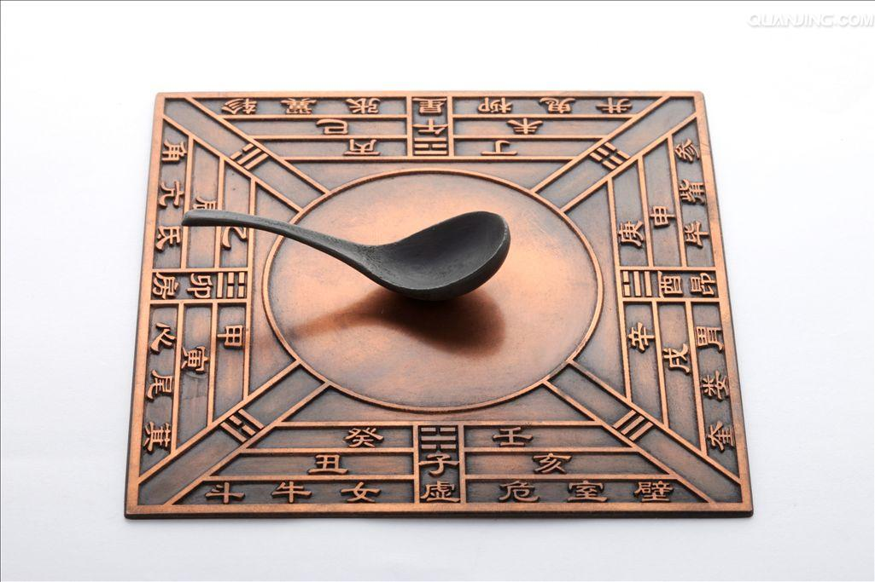Compass | It was a great gift to the world from ancient China. Before it was invented, sailors had to depend on the stars to find direction. After it was invented, the oceans were open to travel. And many new discoveries were made with the help of it.
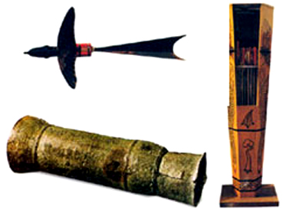  Gunpower | It was one of the greatest inventions. It is said that in the 3rd century a Chinese man wrote about how to make it. At lirst, it was used for making fireworks. At the end of the Tang Dynasty, people began to use it in wars. The method of making it was brought to the Arab world and Europe in the 13th and 14th centuries.
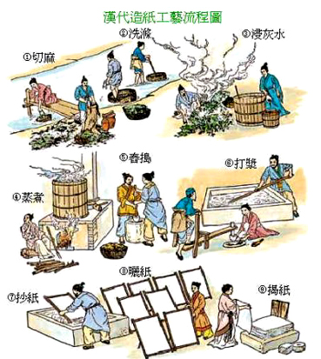Paper-making | China was the first country in the world to make paper. During the Western Han Dynasty (202B.C.~9A.D.), paper was made in some places in China. It was developed in the Eastern Han Dynasty (25A.D.~ 220A.D.) by Cai Lun. He made paper with bark, ropes, rags and so on. Before it was invented, the ancient Chinese carved characters on animal bones and stones. They also wrote them on bamboo and wooden sticks.
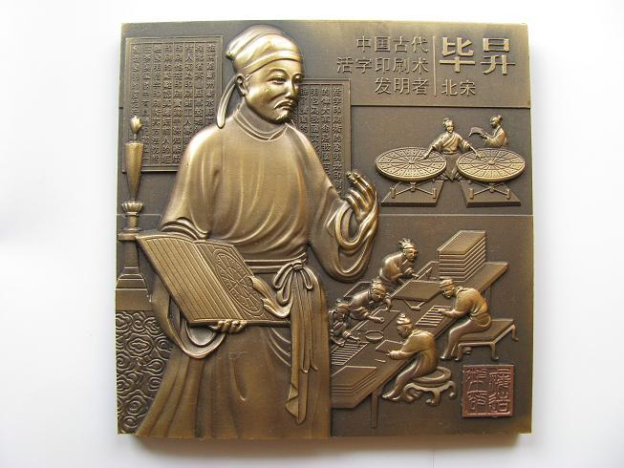Printing | It was developed in 1041-1048 in the Song Dynasty. A man named Bi Sheng carved characters on pieces of clay and wood. Then he put ink on them. After the characters were printed on paper, the pieces of clay or wood could be used again.This technology then spread to Korea, Japan and Europe. It was the basic method atthat time.
71. After the was invented, the oceans were open to travel.
A. compass B. printing C. gunpowder
72. At first, gunpowder was used for_______.
A. finding direction B. making fireworks C. carving characters
73. developed paper-making in the Eastern Han Dynasty.
A. Some sailors B. Bi Sheng C. Cai Lun
74. Printing was developed in the
A. Tang Dynasty B. Song Dynasty C. Han Dynasty
75. The best title for the reading material is_____________.
A. The Four Dynasties ofAncient China
B. The Four Great Inventors ofAncient China
C. The Four Great Inventions ofAncient China
(B)
In different countries around the world, most children must start schooling at early ages.
And they become "adults" at different ages. Being an adult means having the right to do certain
things, such as getting a part-time job, voting(投票), getting married, or getting a driving license
It also means accepting the responsibilities that go along with these rights.
In many countries, sixteen or eighteen is the age when a person becomes an adult. Young
men and women at this age can get a part-time job, and begin to receive an income of their own.
They no longer have to depend on their parents for money all the time. In Canada and America,
sixteen is the age when one can get a driving license; in England, it is seventeen.
There are responsibilities that go along with both of these rights. Getting a part-time job
means that you have to pay income tax. Driving a car demands that you follow certain rules like
buying car insurance.
Voting is another right that young people enjoy when they become adults. In the United
States, Canada and Britain, young people have the right to vote at the age of eighteen. With this
right also comes responsibility. For young people to use their right to vote wisely, they must
have an understanding of the needs of society, and they must also learn how politics work.
76. The underlined word "right" in Paragraph One means in Chinese.
A.正确 B.右边 C.权利
77. In America and Canada, young people who are can get their driving licenses.
A. at the age of 16 B. at the age of 15 C. at the age of 14
78. If you drive a car, you have to .
A. get a part-time job B. follow certain rules C. understand society
79. Tom is a 17-year-old English boy and he has the rights to_______.
A. drive and learn B. vote and marry C. drive and vote
80. From the passage, we can know that ____________.
A. sixteen-year-olds have all kinds of rights
B. responsibilities need to go along with rights
C. the rules are the same in the UK and the USA
B. 句子还原阅读短文，根据短文内容，从方框中选择五个选项分别填入空白处，使其
文理通顺，并将答题卡上该选项涂黑。
In the city of Guiyang, China, lives a girl named Li Fang. When she was a teenager, she
dreamed of going to the United States. 81 “I had a picture of the daddy sitting in the living room, the mommy doing some cooHng and their kids playing games on the floor.”
Li Fang decided to go to college in California. When she arrived, however, it was not the
dream world she had imagined. "People were struggling with problems and often seemed
unhappy and too busy," she said.“ 82 ”
One of her most difficult classes was P.E. When the class played volleyball, the other
students were good at it.but she wasn’t. One afternoon, the P.E. teacher had Li Fang hit the ball
to her teammates so that they could knock it over the net. It was not a big deal for most people,
but it made Li Fang scared. 83
A young man on her team seemed to understand what she was going through. He walked up
to her and whispered(小声说)，“ 84 ”
Li Fang said, e’You will never understand how those words of encouragement made me feel.
Four words: You can do that.I felt like crying with happiness." Perhaps she thanked the young
man; she can’t remember it.
Six years has passed. Li Fang is back in China, working as a salesclerk. “I have never
forgotten the words. 85 ” She said,“I am sure the young man had no idea how much his
kindness meant to me. He probably doesn’t even remember it.From this experience,I have
learned a lesson. Whenever you say something to a person-cruel or kind-you have no idea
how long the words will stay with them.” She is back in China. But still she hears those four
simple words: You can do that.
A. I felt very lonely.
B. Come on. You can do that.
C. Don’t worry, I can help you.
D. When things are not going well, I think of them.
E. She wa.s afraid of failing and being laughed at by others.
F. Most ofwhat she knew about ~nerican life was from textbooks.
第II卷(非选择题，共50分)
VI. 基础知识与运用(本大题共10分，每小题1分)
A. 根据语境或句意，用所给词的适当形式填空，并将答案填写在答题卡上指定的位置。
86. Thanksgiving is always on the Thursday in November. (four)
87. Erquan Yngyue is the most piece ofmusic that I’ve ever heard. (move)
88. Chinese are supposed to shake when they meet for the first time. (hand)
89. Jack is talented in sports. He can play basketball as as his brother. (good)
90. To protect elephants, we must save the trees and not buy things ofivory. (make)
B. 根据语境或句意，从方框中选择恰当的短语完成下列各句，并将答案填写在答题卡上
指定的位置。
kind of belongs to team leader on weekends be good at be thankful to
91. I don’t like this movie because it’s boring.
92. We should never fail to the people around us.
93. I think Qianlingshan Park is the best place to have fun_____.
94. A good helps everyone to work together in a group.[来源:学+科+网]
95. This book Mary because J, K, Rowling is her favorite writer.
VII.任务型阅读(本大题共20分，每小题2分)
A. 阅读短文，捕捉信息，根据短文内容完成表格，并将答案填写在答题卡上指定的位置。
The Silk Road is the name of different roads that long ago linked Europe, Africa and Asia.
People reached these different places along these roads. Scientists and archaeologists believe people began to travel the Silk Road about 3,000 years ago. By the time the Chinese silk trade became nnportant in the world, the Silk Road had covered almost 6,500 kilometers. It stretched
from Rome to China, which is from the West to the Far East.
Merchants(商人)travelling along the Silk Road carried silk, of course. They also carried
and traded spices, cloth, rare jewels, slaves and gold.
During its busiest period, the Silk Road allowed people from many different cultures and countries to meet each other and mix. The Silk Road allowed the sharing of precious goods and
new ideas. These included people and trading goods from the Mediterranean, Persian, Magyar,
Armenian, Bactrian, Indian and Chinese areas. All these peoples travelled the Silk Road, and
they shared goods, stories, languages and cultures.
In modern times, the old Silk Road routes are still used, but now they are crossed by trains
instead of camels and horses. There is even a Silk Route Museum in Jiuquan in China. It has
over 35,000 0bjects from all along the Silk Road. In this way, China protects the history of many countries and peoples.
The Silk Road
In the past | When | People began to travel the Silk Road about 96 ago.
In the past | What | ▲ Along the Silk Road, merchants 97 silk, spices, cloth and so on.  ▲ People from 98 met each other and mixed.  ▲ People shared precious goods, new ideas, stories, languages and coulture.
In the past | How | People used to 99 to cross the Silk Road routes.
At present | China protects the history of many countries and people by 100 in Jiuquan.
B. 阅读短文，捕捉信息，根据短文内容完成文后的句子，并将答案填写在答题卡上指定的位置。
I am Wilson. My sister and I spent our summer holidays with our uncle this year. He was a
geologist and loved to collect stones.
One day, he bought us two backpacks and asked us to go to the mountain with him. We walked the whole day. Every now and then he put stones in our backpacks. To our surprise, he also took some stones out from them. But we thought he had just found better stones.
When we returned to the house, we were very tired. The backpacks were so heavy that we felt great relief when we took them off. Yet our uncle’s backpack was half empty.
“Why did you give us so many stones?” we asked.
“ didn’t. You did,” he said. “You didn’t know it, but I gave you a little attitude test today. I
listened to every word you said. Whenever you were complaining (抱怨), I added a stone to your
backpacks. Whenever you talked about something with positive thinking, I took out a stone. And
now look at your backpacks.”
Our backpacks were full ofstones.[来源:学科网]
“Your negative (消极的) thoughts are just like stones. You carry them in your mind just like those stones in your backpacks. The more negative thoughts you have, the heavier your mind will be.” said our uncle.
With great love, our uncle taught us one of the most important lessons in life-the power of the attitude.
101. Wilson’s uncle was a geologist and he loved to_______________.
102. Wilson’s uncle asked Wilson and his sister to with him one day.
103. Wilson and his sister asked their uncle why_________________.
104. The underlined word “them” in Paragraph 7 refers to “_________”.
105. The story mainly tells us that we should have__________________.
VIII.书面表达(本大题共20分，A、B部分各1 0分)
百善孝为先。孝顺父母是中国传统文化美德的精髓。在我们成长的过程中，父母任劳任怨地为我们付出。我们的每一次生日，父母都为我们精心准备，尤其是妈妈不辞辛劳地为我们做丰盛的生日大餐。作为子女，你打算怎样为你妈妈过生日？
请根据下列写作要求，完成A、B两部分的写作任务。
A. 请分别用一个完整的句子回答下列五个问题：
106. When is your mother’s birthday?[来源:学科网]
107. Where will you celebrate your mother’s birthday?
108. Who will you celebrate your mother’s birthday with?
109. What will you do to celebrate your mother’s birthday?
110. How will your mother feel on that day?
B. 请以“My Mother’s Birthday”为题，写一篇不少于80词的英语短文，要点如下：
1、短文应包含A部分所有信息；
2、你为什么以这种方式为你妈妈过生日；
3、文中不得出现考生的真实个人信息。
注意：照抄试卷上的材料蚁及文中出现考生姓名、学校等真实信息将被扣分。
秘密★启用前
2017年贵阳市中考英语试题参考答案
I. 听力测试(本大题共30分，每小题1分)
1-5 ABCBA; 6-10 CABCB; 11-15 ACCAB; 16-20 CBAAB
21-25 CBACB; 26-30 CACAB;
II. 单项选择(本大题共1 5分，每小题1分)
31-35 ACBAB; 36-40 ACBCB: 41-45 ACBAC;
III. 情景交际(本大题共10分，每小题1分)
46-50 EFDCB; 51-55 ADBEF
IV. 完形填空
56-60 ABCBA;
V. 阅读理解
71-75 ABCBC：
(本大题共15分，
61-65 BCACB:
(本大题共30分，
76-80 CABAB:
每小题1分)
66-70 ABCAC;
每小题2分)
81-85 FAEBD
Ⅵ，基础知识与运用(本大题共1 0分，每小题1分)
86. fourth 87. moving 88. hands 89. well 90. made
91. kind of 92. be thankful t0 93. on weekends 94. team leader 95. belongs to
Ⅶ. 任务型阅读(本大题共20分，每小题2分)
96. 3,000 years
97. carried and traded
98, many different cultures and countries
99. ride camels and horses
100. setting up，building/ establishing a Silk Route Museum
101. Wilson’s uncle was a geologist and he loved to collect stones.
102. Wilson’s uncle asked Wilson and his sister to go to the mountain with him one day.
103. Wilson and his sister asked their uncle why he had given/ gave them so many stones.
104. The underlined word ~ithem" in Paragraph 7 refers to "(your/the)negative thoughts" .
105. The story mainly tells us that we should have a positive attitude towards life.

