此试题可能存在乱码情况，在查看时请点击右上角全屏查看
2018年株洲中考英语复习题
时量:90分钟 总分120分
Ⅰ.听力技能（三部分，共20小题，计25分）
A）反应 根据你所听到的内容，选择正确答语完成对话。（共5小题，每小题1分）
（ ）1. A. Yes, please. B. Here you are. C. In the library.
（ ）2. A. It doesn’t matter. B. It’s cold. C. Good idea.
（ ）3. A. Yes. I do. B. Basketball. C. No, I don’t.
（ ）4. A. Sounds boring. B. I don’t like it. C. I agree.
（ ）5. A. She is my aunt. B. She is quiet. C. She is tall. [来源:学
B）理解 根据你所听到的对话，选择最佳答案回答问题。（共10小题，每小题1分）
听下面的对话，回答第6至7小题。
（ ）6. How’s the weather in Harbin?
A. Raining. B. Sunny. C. Snowing.
（ ）7. What are people wearing?
A. Hats and sweaters. B. Coats and jeans. C. Ties and suits.
听下面的对话，回答第8至10小题。
（ ）8. How many people are going to Qingdao?
A. Three. B. Four. C. Five.
（ ）9. How will they go there?
A. By train. B. By plane. C. By bus.
（ ）10. How long are they staying there?
A. About five days. B. About a week. C. About two weeks.
听下面的对话，回答第11至13小题。
（ ）11. When did Kate get the model plane?
A. In 2006. B. In 2008. C. In 2010.
（ ）12. Why is Kate selling the model plane?
A. Because it’s old. B. Because it’s broken. C. Because she doesn’t play it anymore.
（ ）13. How much is the model plane?
A. 20 cents. B. 45 cents. C. 65 cents.
听下面的对话，回答第14至15小题。
（ ）14. Where’s the bank?
A. Behind the park. B. Across from the park. C. Next to the park.
（ ）15. Is Center Street far from here?
A. No, it isn’t. B. Yes, it is. C. I don’t know.
C）笔录要点 根据你所听到的内容，填写下面的表格。（每空不超过3个单词，共5小题，每小题2分）
STUDY ENGLISH IN AMERICA
Country | Tina comes from 16 .
Weekend Activity | Tina visits many 17 places on Sundays.
Location | Tina’s host family is in a 18 area.
TV Program | Tina always watches 19 in the evening
Study Time | Stay for 20 months and study English like Tina does!
Ⅱ. 知识运用（两部分，共20小题，计20分）
A）语法填空 从A、B、C三个选项中选择最佳答案填空。（共10小题，每小题1分）
（ ）21. —Could you ______ the computer for me, dear? I want to check my e-mails.
—Certainly, I’ll do it right away.
A. turn on B. turn down C. turn off
（ ）22. —______ exciting the movie is!
—Sure, I have seen it three times.
A. What B. What an C. How
（ ）23. —Look! Here comes your mom’s car.
— It ______ be hers. She sold her car yesterday.
A. must B. can’t C. needn’t
（ ）24. The little girl wrote a ______ diary last night.
A. two-hundreds-word B. two-hundreds-words C. two-hundred-word
（ ）25. —Dad, where is Mom?
— She ______ the supermarket.
A. has gone to B. has been to C. is going to
（ ）26. World Reading Day is ______ April 23.
A. on B. in C. at
（ ）27. Though he often made his little sister ______, today he was made ______ by his little sister.
A. cry, to cry B. crying, crying C. cry, cry
（ ）28. I hate people ______ laugh at others when they are in trouble.
A. who B. where C. which
（ ）29. —It’s too cold today．Would you mind ______ the window?
—Certainly not．Go ahead．
A. to close B. closing C. close
（ ）30. —Mum, ______ shall we have lunch?
—We will have it when your dad ______ .
A. when, returns B. where, will return C. when, will return
B）词语填空 阅读下面的短文，掌握其大意，然后从各题所给的三个选项中选出一个最佳答案。（共10小题，每小题1分）
Many kids want to help keep the environment clean but don’t know where to start. 31 , even the simplest everyday activities can make a real difference to the environment. Here is how:[来源:Z*xx*k.Com]
- Don’t litter. Litter can 32 our water and that could do harm to us and to wildlife.
- Recycle bottles, paper and plastic. This is a good 33 to develop and can really make a difference.
- 34 turn off lights and electronic devices（设备）when they are not being used.
- Use your 35 or walk to nearby locations rather than riding in a car. Encourage your friends and family to 36 the same.
- Don’t throw your old clothes or toys away. Give 37 to a local charity or a friend that may need them.
- 38 wasting plastic bags by bringing your own reusable cloth bags to stores.
- If you see litter, 39 .
- By following these tips and using them in your everyday life, you will make the world a 40 place. It’s never too late to start, and what better time is there than right now?
（ ）31. A. At first B. In the end C. In fact
（ ）32. A. pollute B. use C. waste
（ ）33. A. interest B. plan C. habit
（ ）34. A. Never B. Even C. Always
（ ）35. A. train B. bike C. car
（ ）36. A. do B. look C. say
（ ）37. A. it B. them C. this
（ ）38. A. Keep B. Avoid C. Enjoy
（ ）39.A. look it up B. pick it up C. put it up
（ ）40. A. bigger B. greener C. more peaceful
Ⅲ. 阅读技能（五部分，共25小题，每小题2分，计50分）
A
阅读短文，根据短文内容判断所给句子正（T）误（F）。（共5小题，每小题2分）
There is quite a beautiful city in the southwest of Hunan Province. It is called Shaoyang. Here are two main rivers, Zijiang and Shaoshui, passing through the city. People once called it Baoqing in history.The earliest city was established here 2,500 years ago.
In the history of Shaoyang, we will never forget two persons —Wei Yuan and Cai E. Wei Yuan, the first person to know the west world, was a famous thinker in the Qing Dynasty. His book---World Geography Records was the first book to introduce the geography and history of western countries in China. Cai E was a general(将军) in China. He took part in the Xinhai Revolution in 1911.
If you come to Shaoyang. of course, don’t miss Mount Lang. It’s also a very beautiful place, which lies in Xinning County. Then the well-known traditional foods such as Zhuxie Wanzi, Lutofu and so on are very delicious. You can't miss them, either. Besides, people in Shaoyang are nice and friendly. If you need help, they will try to help you. Welcome to Shaoyang whenever you like!
（ ）41.Shaoyang lies in the southwest of Hunan Province.
（ ）42.In history , Shaoyang was called Baoqing.
（ ）43. The underlined phrase “World Geography Records” means《海国图志》in Chinese.
（ ）44. Wei Yuan and Cai E took part in the Xinhai Revolution in 1911.
（ ）45. Mount Lang belongs to Wugang.
B
阅读短文，从各题所给的三个答案中选择最佳答案回答问题或完成句子。（共5小题，每小题2分）
Are you a good helper in the kitchen? Flynn McGarry, from the US, does more than that. The 15-year-old boy began cooking at the age of ten. And now he has his own restaurant.
McGarry practiced his cookery skills after school. He taught himself from books and the internet. The boy really loves cooking. In his room, there are no video games but cooking tools. He turned his room into an experimental kitchen called Club Eureka.
Today, many famous people pay around $ 160 per person to eat in McGarry’s Club Eureka. The New York Times magazine described his food as “creative”.
As for the future, McGarry wants to open a Michelin-Starred restaurant. He hopes to make it one of the world’s 50 Best and “maybe top 5”.
（ ）46. When did McGarry begin to learn cooking?
A. When he was five. B. When he was ten. C. When he was fifteen.
（ ）47. Who taught McGarry cookery skills?
A. His parents. B. His teachers. C. He himself.
（ ）48. Why did McGarry learn cooking?
A. Because he loves cooking. B. Because he wanted to make money. C. Because his parents asked him to learn cooking.
（ ）49. Which of the following is NOT true about Club Eureka?
A. McGarry is the owner. B. McGarry is the cook. C. The food is free.
（ ）50. What does McGarry want to do in the future?
A. To have an experimental kitchen. B. To have a world’s top restaurant.
C. To cook for famous people.
C
阅读图表,从每题所给的A、B、C选项中，选择最佳答案回答问题或完成句子。（共5小题，每小题2分）
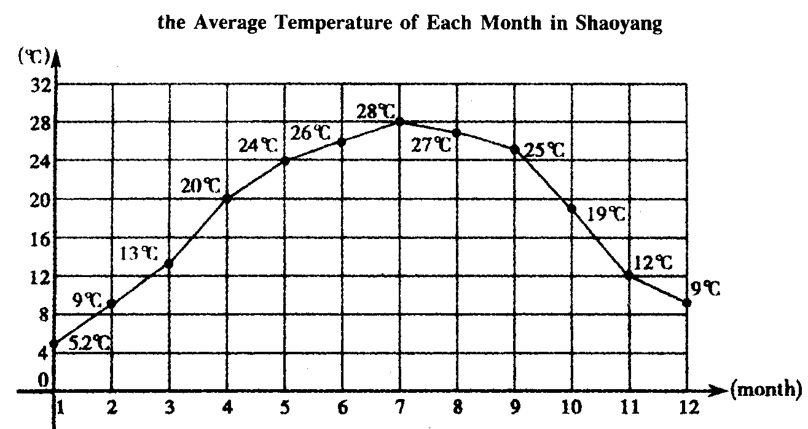
（ ）51. The average temperature in _______ is 9°C. .
A. February B. December C. February and December
（ ）52. The average temperature in _______ is the highest. .
A. January B. July C. August
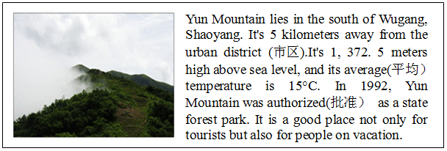
（ ）53. Yun Mountain lies in _______.
A. the east of Wugang B. the west of Wugang C. the south of Wugang
（ ）54. Yun Mountain has been authorized as a state forest park for _______.
A. over 10 years B. over 20 years C. over 30 years
（ ）55. Which sentence is TRUE according to the ads?
A. Yun Mountain is 5 kilometers away from the urban ditrict.
B. Yun Mountain is not a good place for people on vacation.
C. Yun Mountain is 1,372.5 kilometers high above sea level.
D
阅读短文，根据短文内容回答问题。（共5小题，每小题2分）
Ma Yun became one of the richest men in China when his company Alibaba went on the stock（股票)market in 2014 with a value of around 140 billion-the largest public offering in history. Here are some stories about him on the way to success.
Ma made his first trip to the a US in 1995 and used the Internet for the first time. After searching for “beer”, he saw that no results came up about China. Then he searched for “China” and still saw no results. He decided to set up a Chinese website--the seed for Alibaba was sown(播种).
Ma said he was refused many times in his life. He failed the College Entrance Examination in China three times and few companies offered him jobs, including one at KFC. And he was refused by the famous Harvard University 10 times.
It was difficult to learn English when Ma was a teenager because of limited resources. However, he found that he could learn English well by giving tourists free guides around his hometown Hangzhou. And he kept it for nine years. Ma said that tourists opened up a new world for him because everything they said and did was so different from what he had been taught at school and by his parents.
Ma’s hero is Forest Gump who never gives up. When he made a speech about his success at Davos(达沃斯论坛)in 2015,Ma said, “Life is like a box of chocolates because you never know what you are going to get.”
- When did Ma Yun make his first trip to the US.
____________________________________________________________________
- How many times was Ma Yun refused by Harvard University?
____________________________________________________________________
- How did Ma Yun learn English well when he was a teenager?
____________________________________________________________________
- Did Ma Yun make a speech at Davos in 2015?
_____________________________________________________________________
- Why does Ma Yun consider Forest Gump as his hero?
____________________________________________________________________
E
阅读短文，根据短文内容，在表格中填入相应信息。（每空不超过3个单词，共5小题，每小题2分）
The pupils and teachers at Fairfield School think it's worth protecting the environment! This is what they’ve been doing.
Growing vegetables
Fairfield School pupils started their own vegetable garden. Both children and teachers grow vegetables, then they pick them. In this way, school dinners are more delicious than ever before.
Recycling
The Fairfield pupils don’t just bring their books to school — they bring their rubbish too! There are recycling bins(回收箱) in the playground for cans, plastic bottles and paper. The teachers give a prize every month to the pupil who’s tried the hardest to recycle.
Finding cleaner ways to get around
Everyone walks or rides a bike to Fairfield School! “It’s faster to ride bikes than to drive anyway, even the teachers don’t use their cars.” says one pupil.
ways | How to 61. the environment
Growing  vegetables | The Pupils can enjoy delicious food by 62. and picking vegetables from their own garden.
Recycling | The pupils bring both their 63. to school.  The pupil who works hardest at recycling will get a prize from the teachers 64. .
Finding cleaner ways to get around | The teachers and pupils at Fairfield School usually go to school on foot or 65. .

Ⅳ.写作技能（三部分，共11小题，计25分）
A）完成对话 通读对话，根据上下文补全对话内容。（共5小题，每小题1分）
A: Hello, Tom. I called you yesterday afternoon, but there was no reply.
B: Sorry, I wasn’t at home yesterday afternoon.
A: 66._______________________________?
B: I went to a bookstore.
A: 67. _______________________________?
B: Because I wanted to buy some science fiction books.
A: Science fiction books? I like them very much .68. __________________________________?
B: I bought five science fiction books.
A: 69. ________________________________?
B: Yes. You can borrow one or two from me. But why not buy some for yourself? I can go with you to the bookstore.
A: Good idea. Thank you very much.
B: 70.________________________________.
B）英汉互译 阅读短文，将文中画线部分译成汉语或英语。（共5小题，每小题2分）
Hey, boys and girls, do you know something about TFBOYS ? Well, 71.TFBOYS means the fighting boys. Sometimes we call them TF family. Many of you may know that there are three boys in this TF family, and they are Wang Junkai,Wang Yuan and Yiyang Qianxi.
Wang Junkai is the captain(队长) of the family. 72.他是三个男孩中年龄最大的。 His English name is Karry. His birthday is on September 21st. Jay Zhou is his favorite singer, and he sings some of Jay Zhou’s songs, like Qi Li Xiang. Roy is Wang Yuan’s English name. His birthday is on November 8th . He comes from Chongqing. Yiyang Qianxi’s English name is Jackson. His birthday is on November 28th. 73.He often practices Latin dance and he can dance very well.
74.这三个男孩喜欢唱歌而且他们能唱得很好。 So a lot of fans like them and their songs a lot. They are also good at their lessons. 75.They debuted their first album（专辑） “Ten Years” on August 13th, 2013.
71.
72.
73.
74.
75.
C）作文（计10分）
学会自我保护是青少年需要具备的一种意识和能力。请根据以下提示，并结合自己的观点，以“How Can We Protect Ourselves?”为题，写一篇不少于80词的短文，谈谈在生活中青少年应该怎样自我保护(self-protection)。
提示：never swim alone, be careful to make friends, call the police when you are in danger, eat healthy food, don’t crowd(go upstairs and downstairs)
要求：句子结构准确，要点齐全，内容合理，篇章结构连贯；文中不能出现真实姓名、校名、地名。

2018年株洲中考英语复习题听力材料及参考答案
听力材料
A）反应
1. Can I help you?
2. Let’s take a walk after supper.
3. Do you like basketball or volleyball.
4. I think it is important for us to learn English well.
5. Who is the woman with sunglasses?
B）理解
听下面的对话，回答第6至7小题。
M: How’s the weather in Harbin?
W: It’s snowing right now.
M: What are people doing?]
W: Some boys are skating and some girls are making a snowman. They are all wearing hats and
sweaters.
听下面的对话，回答第8至10小题。
M: Summer vacation is coming. I’m going to Qingdao.
W: Wow, are you going there with your friends?
M: No, I’m going there with my parents.
W: How will you go there?
M: By plane.
W: Well, how long are you staying there?
M: About a week.
W: Have a good time!
M: Thank you.
听下面的对话，回答第11至13小题。
W: I have too many great things at this yard sale, Jeff.
M: Great! Kate, this is your old model plane, isn’t it?
W: Yes, I got it from my aunt in 2006.
M: It looks nice. Why are you selling it?
W: Because I don’t play it anymore.
M: How much is it?
W: You can have it for at least 20 cents.
M: OK. I’ll get it.
W: Thank you.
听下面的对话，回答第14至15小题。
M: Hi! Excuse me.
W: Yes？How can I help you?
M: Well, I’m new in town. Is there a bank near here?
W: Yes, it’s on Center Street and it’s across from the park.
M: Oh, Is Center Street far from here? how can I get there?
W: No. It’s not far from here. You can walk there.
M: Thank you very much.
W: You are welcome.
C）笔录要点
I’m Tina from China. English is one of my favorite subjects, so I went to an English language school in America. My class is quite small. There is one student from India, two from Thailand, one from Japan. We study English every morning, Monday through Friday. On Sundays we visit many famous places.
I’m very lucky because my host family is in quiet area outside the city. I like playing sports, and always watch sports shows in the evening.
Life is a journey. Come to America for two months and have fun learning English like I do.

参考答案
1-5. ACBCA 6-10. CA ABB 11-15. ACABA
16. China 17. famous 18. quiet 19. sports shows 20. two/2
21-25. ACBCA 26-30. AAABA
31-35. CACCB 36-40. ABBBB
41-45. TTTFF
46-50. BCACB
51-55. CBCBA
56.In 1995. 57. 10/Ten times 58. By giving tourists free guides around his hometown Hangzhou. 59.Yes, he did. 60. Because he never gives up.
61. protect 62. growing 63. books and rubbish 64. every month 65. by bike
66. Where did you go 67. Why did you go there/to the bookstore 68. How many (science fiction) books did you buy 69. Can/Could I borrow some from you/Can you lend some to me 70. You’re welcome/That’s all right/No problem.
71.略 72. He is the oldest of the three boys. 73略 74. The three boys like singing and they can sing very well. 75略
作文
How Can We Protect Ourselves
Self-protection is one of the most important skills for teenagers．But how can we protect ourselves? Here are some suggestions．First, we should be careful when we make friends, especially on line．Second, if we are in danger, we must call the police for help in time so that we can keep ourselves safe．Also, we should eat healthily and safely．Besides, we shouldn’t crowd each other when we go upstairs or downstairs at school．Last, summer is coming, we must remember it’s dangerous to swim alone．In short, everyone needs to learn how to protect ourselves and stay away from danger．(102 words)

