2017年安徽阜阳中考英语模拟试题（word版）
英 语
（考试时间：90分钟 试卷满分：120分）
注意事项：
1. 本试卷共三部分，六大题，满分120分，考试时间90分钟。
2. 请务必在答题卡上答题，在试卷上答题无效。
3. 考试结束后，请将试卷和答题卡一并交回。
第一部分 英语知识运用（共两大题，满分45分）
I. 单项填空（共15小题；每小题1分，满分15分）
从每小题所给的A、B、C、D四个选项中选出一个可以填入空白处的最佳选项。
1. —Li Ming, it’s said that many famous singers will come to Yangzhou in June. How about watching the evening show there?
—___! Let’s ask Wang Gang to go with us.
A. Best wishes B. Sounds great C. Good luck D. That’s all right
2. —What good ___ you’ve given me! Thanks a lot. I will take them.
—My pleasure.
A. information B. news C. suggestions D. advice
3. —Have you found your lost pen?
—No, I haven’t found ___, but I bought a new ___ this morning.
A. one; that B. that; one C. it; one D. one; it
4. It’s common for us to have smartphones today. They ___ in our daily life.
A. used widely B. were widely used C. use widely D. are widely used
5. Summer is coming, and the weather is getting ___.
A. hot and hot B. hoter and hoter C. hotter and hotter D. more and more hot
6. Tom didn’t work hard at his lessons. ___, he failed in his exams．
A. By the way B. Such as C. For example D. As a result
7. —Let’s put away Johnny’s test paper to give Father a big surprise.
—You ___ do that. He told Father about his test result this morning.
A. can’t B. needn’t C. shouldn’t D. mustn’t
8. ___ you ___ Tina can join us. We just need one of you.
A. Both; and B. Not only; but also C. Neither; nor D. Either; or
9. Tom, you mustn’t swim in the river. It’s too ___.
A. safe B. dangerous C. careful D. easy
10. I like the red scarf. It ___ very soft.
A. tastes B. feels C. sounds D. smells
11. —Have you ever heard of Tu Youyou?
—Yes, she ___ the Nobel Prize in medicine in 2015.
A. won B. winned C. wins D. has won
12. We shouldn’t ___ the trees anymore. Instead, we should plant more trees.
A. cut off B. cut up C. cut down D. close down
13. The teacher raised his voice so that we could hear him ___.
A. clearly B. quietly C. slowly D. quickly
14. —Look! Some people are running the red lights!
—We should wait ___ others are breaking the rule.
A. because B. if C. unless D. although
15. —Jieyang Chaoshan Airport, please. I have to get there before 7.
—___, sir, but I’ll try my best.
A. Sorry, I can’t B. I can’t promise C. Yes D. No problem
II. 完形填空（共20小题；每小题1.5分，满分30分）
阅读下列短文，从每小题所给的A、B、C、D四个选项中选出一个最佳选项。
A
The Power of Story
When my dog Gracie disappeared six years ago, I really learned what I believe. Gracie escaped from our backyard around 2:00 p.m. We searched the neighborhood for hours but had no 16 . We put up advertisements, and by dark, we returned home, exhausted(精疲力竭).
On the second day, I called my animal doctor, the SPCA, and the animal shelter(收容所). Nothing. I felt lost.
If I knew Gracie had been 17 , I would have been heartbroken. If I knew she was caught somewhere, I would save her. If I knew she had found a better home, I would be 18 yet relieved(放心的). But how do I deal with the unknown? Wait patiently? Search endlessly? Give up?
The third day, while I was searching in the woods with my friend Rhea, I told her losing Gracie was like losing faith(信任) in everything. Rhea smiled and said, ＂You know, maybe Gracie’s on a great adventure.＂ It seems 19 , but I felt better then. Rhea’s words 20 me what, as a writer, I surely have faith in: the power of story.
As one writer said, all we have is stories. It’s what holds our life together. We call stories science, some stories myth(神话), but imagine hearing for the first time that the world may be round. Such stories only become real when we 21 them. And some stories are never supported with scientific facts, but they still seem to hold true.
For example, ten years earlier, I’d dreamt that I should get a 22 , and by that evening, Gracie came into my life. When people would ask what kind of dog she was, I would say Muppet wolf terrier(小猎狗). It was something I 23 because I believed Gracie was half dog, half wolf.
So why not imagine now that she was off on an adventure exploring her wolf side?
The fourth day started with me finding a 24 on the sidewalk, I’d always thought of finding money as a good sign. And I was sure Gracie would come home on the fifth day. I guess it was another story to hold on to.
On Day Five, I was at a friend’s house when her phone rang. I knew immediately it was news about Gracie. And I was right. When I finally saw her in my hallway, I cried. ＂My wolf days are 25 .＂ Gracie seemed to say. ＂I’m back to being a dog＂.
Or so is the story I choose to believe.
16. A. luck B. reason C. good D. problem
17. A. kept B. sold C. stolen D. killed
18. A. mad B. worried C. sad D. moved
19. A. right B. strange C. reasonableD. real
20. A. ordered B. warned C. reminded D. suggested
21. A. hear B. know C. believeD. read
22. A. dog B. prize C. story D. house
23. A. looked up B. built up C. set up D. made up
24. A. card B. coin C. phone D. book
25. A. lasting B. exciting C. short D. over
B
Mike and his father hadn’t talked for ten years. Ten years ago, Mike’s mother 26 . He thought it was his father who caused his mother’s death. He hated his father.
Now they were sitting in a nice 27 . Suddenly his father asked the waiter to put some salt in his coffee. Mike was 28 . His father smiled and said, ＂Before you were born, your mother and I often had fun 29 in the sea. We could taste the sea, just like the taste of the salty coffee. Every time I have salty coffee, I always 30 your mother. I miss her so much.＂
Mike was deeply moved. He never knew his father had such 31 love for his mother. One month later, he moved to live with his father. Whenever he made coffee for his father, he would put some 32 in it.
Ten years later, his father died. Mike 33 a letter saying ＂Dear Mike, please forgive me for my 34 — the salty coffee. Now let me tell you the truth. I don’t like salty coffee actually, but I drank salty coffee for 10 years! Being with you was the biggest 35 of my whole life.＂
26. A. hurt B. disappeared C. died D. missed
27. A. mall B. restaurant C. house D. garden
28. A. surprised B. upset C. strange D. disappointed
29. A. drinking B. eating C. working D. playing
30. A. think up B. think over C. think of D. think about
31. A. wide B. deep C. high D. big
32. A. sugar B. milk C. honey D. salt
33. A. wrote B. received C. accepted D. refused
34. A. lie B. secret C. regret D. mistake
35. A. shyness B. kindness C. happiness D. sadness
第二部分 阅读理解（共两大题，满分45分）
III. 补全对话（共5小题；每小题1分，满分5分）
根据对话内容，从方框内的选项中选出能填入空白处的最佳选项，其中有两个为多余选项。
A: Hi, Bill! You’re reading the novel again.
B: Yes, Tom. I’ll never be tired of it.
A: 36
B: Three times. Every time I read it, I can learn something new.
A: Really? 37
B: Charles Dickens. I think he is a great English writer. What about you?
A: 38 He is also my favorite foreign writer. Please let me have a look at it.
B: OK, here you are! What do you think of this novel?
A: 39 I haven’t seen a better one for long. Where did you buy it?
B: In the Rose Bookshop.
A: I don’t know where it is. 40
B: No. Only 10 minutes’ walk from here, next to the People’s Cinema.
A: Oh, I see. I’m going there to get one, too. Thank you!
B: You’re welcome.
A. When did it come out?
B. How many times have you read it?
C. Is it far from here?
D. Who is your favorite author?
E. It is wonderful.
F. So do I.
G. How far is it?
IV. 阅读理解（共20小题；每小题2分，满分40分）
阅读下列短文，从每小题所给的A、B、C、D四个选项中选出一个最佳选项。
A
When I was about 12, I had an enemy, a girl who liked to point out my shortcomings. Sometimes she said I was thin. Sometimes she said I was lazy. Sometimes she said I wasn’t a good student. Sometimes she said I talked too much, and so on. I tried to stand her as long as I could. At last, I became very angry. I ran to my father with tears in my eyes.
He listened to me quietly, and then he asked, ＂Are the things she said true or not? Mary, didn’t you ever wonder what you’re really like? Go and make a list of everything she said and mark(标记) the points(点) that are true. Pay no attention to the other things she said.＂
I did as he told me and to my surprise, I discovered that about half the things were true.
I brought the list back to my dad. He refused to take it. ＂That’s just for you,＂ he said. ＂You know better than anyone else the truth about yourself. When something said about you is true, you’ll find it will be helpful to you. Don’t shut your ears. Listen to them all, but hear the truth and do what you think is right.＂
Many years has passed. The situation often appears(出现) in my mind. In our life we often meet with some trouble and we often go to someone and ask for advice. For some advice you will treasure(珍惜) all your life!
41. The word ＂shortcomings＂ in the first paragraph means __.
A. 克服 B. 缺点 C. 生气 D. 敌人
42. What did the writer’s father do after he heard her words?
A. He agreed with her ＂enemy＂.
B. He let her continue to stand her ＂enemy＂.
C. He told her to write down all her ＂enemy＂ had said about her.
D. He told her not to pay attention to what her ＂enemy＂ had said.
43. The writer felt __ when she did the things as her father had told her.
A. surprised B. angry C. disappointed D. sad
44. Which of the following can be the best title of the passage?
A. My Parents
B. A Serious Criticism(批评)
C. What People Say About You Is Always Right
D. The Best Advice I Ever Had
B
Do you still find it hard to choose a cool and useful present for your friend? Do you still find it difficult to surprise whom you love? Welcome to Guardian Reader Offers site. Within our online shopping mall you will find hundreds of products that you may be interested in. Here are some cool choices for you.
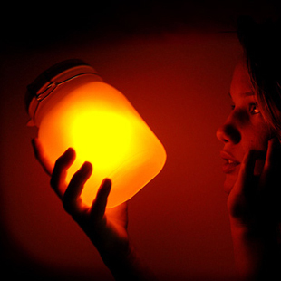  Sun Bottle | Is it cool if the sun still shines at night? This special bottle can collect the warm sunshine. Place it in direct sunlight for a few hours and it will be ready to provide you with warm sun-like light for over five hours. The soft light works great as a night light in a child’s bedroom or on a dinner table.
  Solar(太阳能) Book Light | Does he or she like reading? This might be what he or she really wants. Just place it in the sun, and you will have light wherever you go. Take it when you go camping or are on flights. You can even keep it at your bedside. It can be put on your books when you are reading. It has two lights and a pen.
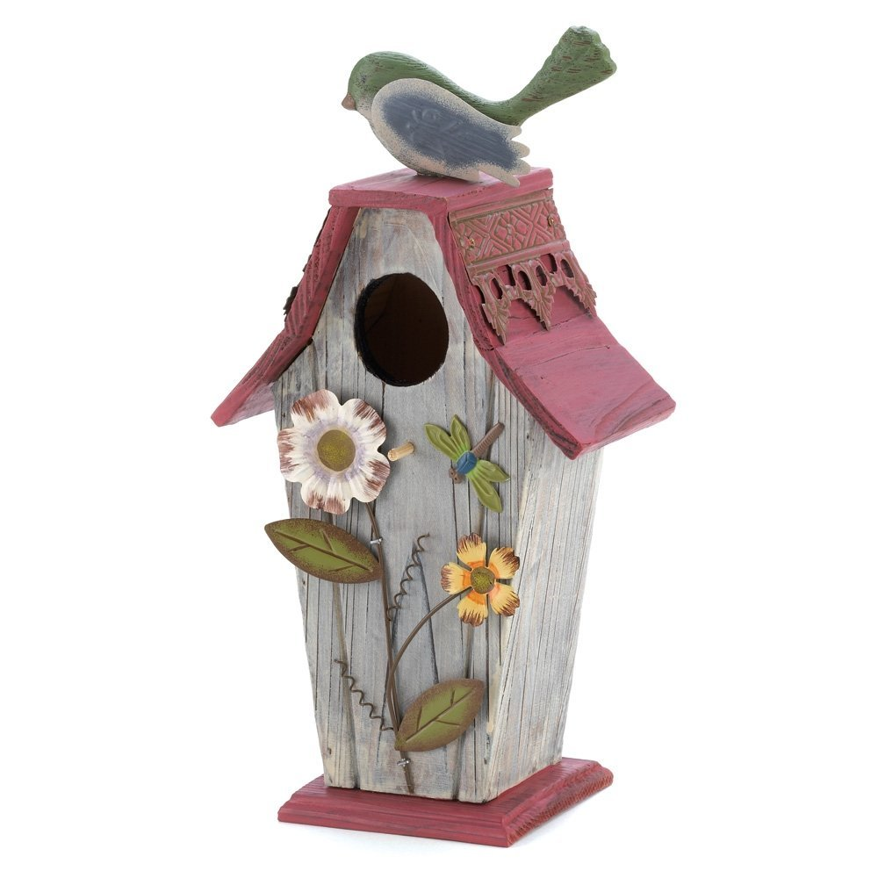  Modern Bird House | Any bird friend would like a cool house like this! It has wooden walls with a green roof. The roof can be taken off for easy feeding and cleaning. The entrance is just like a bird, which is so attractive that it’s sure to fill your garden with happy birds.
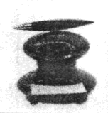  Cool Stationery Set(文具) | This cool stationery set has a ball pen, a clock and a memo pad(便签簿). The pen sits on the top and rotates(旋转) around. Press down on the top, and you will have a piece of memo paper and get your pen off the top. It’s fashionable and useful. It’s a perfect gift!
45. __ would be the best choice if you want to give a present to your friend who loves reading.
A. A sun bottle B. A solar book light
C. A modem bird house D. A cool stationery set
46. Which is not true about the modern bird house?
A. It has wooden walls.
B. Its roof can be moved away.
C. Its door has a bird shape.
D. It makes the sound of bird singing.
47. The author wrote this passage to __.
A. talk about the latest cool inventions
B. ask people to use cool things in daily life
C. introduce several cool and useful presents
D. talk about the gifts he used to surprise his friends
48. Where can we buy the cool things according to the passage?
A. Online. B. At school.
C. In the supermarket. D. In the drugstore.
C
Are you happy most of the time? Or do you easily get angry sometimes? Everyone has a different temperament(脾气). It is usually believed that both genes(基因) and environment may affect people’s temperaments in different ways. Scientists have found that the season of the birth also plays a role.
Scientists from Budapest, Hungary, studied 400 university students. In the study, the students need to finish a questionnaire(问卷). The purpose of it was to find out which of four kinds of temperaments they most had. From the questionnaire, scientists found that the students always answered something like ＂My mood often changes for no reason.＂ and ＂I love to deal with new projects, even if it is risky.＂ These answers were then matched with their birthdays.
They discovered that people born in summer easily change between sad and happy moods compared to people born in winter. Those who always feel positive are mostly born in spring and summer.
The study also found that those born in autumn less probably had a mood of depression which may easily drive them to cry, while those in winter were not easier to be angry.
Scientists said that this was probably because the seasons had an influence on certain chemicals in the human body. And the chemicals are important to control people’s moods even in adult life.
＂It seems that when you are born may increase or decrease your chance of developing certain mood disorders(紊乱) ,＂ lead scientist Xenia Gonda told the Telegraph.
49. What probably can’t affect people’s temperaments according to Paragraph 1?
A. Genes. B. Ages. C. Seasons. D. Environment.
50. What does the underlined word ＂depression＂ most probably mean?
A. Sadness. B. Happiness. C. Surprise. D. Excitement.
51. Which of the following sentences is NOT true from the passage?
A. People born in summer change their moods more easily.
B. The season of birth has an influence on human’s moods.
C. There were 400 middle school students taking part in the study.
D. The answers to the questionnaire were matched with their birthdays.
52. What will the writer most probably write about on ＂__＂?
A. How many kinds of moods there are.
B. What can we change the human body most.
C. How the certain chemicals affect the moods.
D. Whether the students will continue their study.
D
Hip-pop Dancing
Hip-pop dancing is popular with many young people today. They like it because they can invent their own moves. They use this dance to show their love for life. It also shows that they feel good about life, that they just want to be themselves and enjoy life, and that they are not afraid of problems.
Hip-hop dancing has a history of more than 30 years. It first began in the 1980s in the US. In early times, it was seen in New York and Los Angeles. At that time, many young black people often danced to music in the streets. They used their legs, arms, heads and even shoulders to dance. Many young people still use most of these moves today.
Hip-pop dancing became popular all over the world because of the 1983 movie Flash Dance. Some people performed Hip-hop dancing in the movie. People enjoyed their performances. They began to dance like them. Then it became popular. There are two kinds of Hip-pop dancing: the new school and the old school. More and more young people are learning Hip-pop dancing. People believe that it is a good way to exercise their bodies, and that it is good for their health.
53. Young people like Hip-pop dancing because ____.
A. it has a history of more than 30 years B. it first began in the US
C. they can invent their own moves D. many young black people often dance it
54. At first Hip-pop dancing was seen ____.
A. in the movies B. in the streetsC. in the old schools D. in the new schools
55. The young black people used their ____ to dance at that time.
A. legs B. heads C. arms and shoulders D. A, B and C
56. Hip-pop dancing became popular all over the world ____.
A. in the 1980s B. in 1983 C. 20 years ago D. in early times
57. Which of the following is TRUE about Hip-pop dancing?
A. It’s not a good way to exercise.
B. It shows that young people feel bad about life.
C. Young people use this dance to show their love for life.
D. It shows that young people are afraid of problems.
阅读下面短文，并用英语回答问题（请注意每小题后面的词数要求）。
E
One evening, I found an electric(电动的) model car on my 6-year-old son’s desk. We hadn’t bought one like that for him. At dinner, I asked my son about it.
＂I exchanged my paper model plane from a little girl in the neighborhood.＂ he said.
We were surprised. The paper model plane really cost nothing. But the electric model car might cost 15 dollars at least. We thought our son might tell a lie. But we said nothing.
The next day, I took my son to the little girl’s home with the electric model car. I was going to make sure whether my son told us a lie, and to return the model car to the girl.
But the little girl’s mother told me that it was true.
＂The electric model car belongs to my daughter. It is up to her. I respect her decision.＂ She said. ＂Since your son likes the electric model car, it belongs to him.＂
Then I took the girl with us to a toy store. I bought an electric model plane to her. And I wanted the girl to understand whether it was worth exchanging an electric model car for a paper plane.
Since then, they have been good friends all their lives.
Education is really an art. It was lucky that we didn’t scold(训斥) our son before we learned about the fact.
58. What did the boy exchange his paper model plane for with the little girl? （不超过5个单词）
____
59. What’s the mother’s opinion on her daughter’s exchange? （不超过5个单词）
____
60. What does the writer want to tell us? （不超过15个词）
____
第三部分 写（共两大题，满分30分）
V. 单词拼写（共5小题；每小题1分，满分5分）
根据首字母及汉语提示，完成下列单词的拼写，使句意明确，语言通顺。
61. When we met, we s____ (握住) hands with each other.
62. Michael is always t____ (渴望) for knowledge.
63. The girl feels scared every time she c____ (过) the river.
64. The scientist always dresses himself s____ (朴素地) and cleanly.
65. Your tiny help may bring much w ____ (温暖) to people in trouble.
VI. 书面表达（共1小题；满分25分）
今年入冬以来，以北京为首的各大城市雾霾（haze）情况越来越严重，整个国家的空气污染状况令人担忧。假如你是Li Hua，作为一个中学生，你对我国空气污染的看法是什么呢？请分析空气污染的现象、原因、应对措施，写一份英文的倡议书，呼吁大家保护环境，减少对空气的污染。
要点提示：
1. 我国空气污染的现象。（至少写2点）
2. 空气污染产生的原因。（至少写2点）
3. 减少空气污染的措施。（至少写2点）
要求：
1. 80词左右，开头和结尾已给出，不计入总词数。
2. 文中不能出现自己的姓名和所在学校的名称。
Dear students,
As we all know, hazy days have been influencing our lives a lot in recent years. That warns us of the serious air pollution. _
__
__
___
Yours,
Li Hua

