2018年珠海中考英语模拟压轴题【word版含答案】
由于版式的问题，试题可能会出现乱码的现象，为了方便您的阅读请点击全屏查看
说明：全卷共10页，满分120分，考试用时100分钟，请同学们将全部答案写在答题卷上。
一、听力理解
A. 听句子（本大题有5小题，每小题1分，共5分）
根据句子的内容和所提的问题，选择符合题义的图画回答问题。每小题听一遍。
( ) 1. What does the kid do for her mother on Mother’s Day?
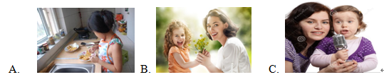
() 2. Where are the students going to visit?
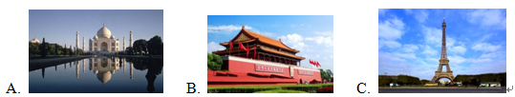
() 3. When will the concert begin?

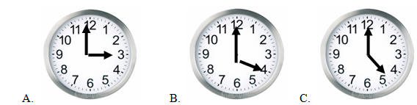
() 4. What are the children doing now?

A.  B.  C. 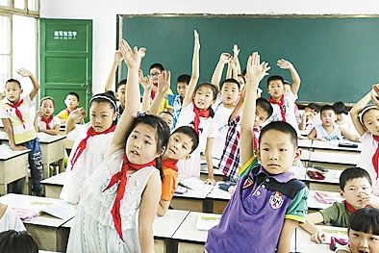
( ) 5. Which drink did the speaker just order?

A. B.  C. 

B. 听对话（本大题有10小题，每小题1分， 共10分）
回答每段对话后面的问题，在各题所选的三个选项中选出一个最佳答案。每段对话听两遍。
听第一段对话回答第6小题。
（ ）6. Why is the lady running and shouting?
A. She stole the men’s handbag.
B. She wants to catch the thieves.
C. She wants to catch the bus.
听第二段对话，回答第7小题。
() 7. Where did the dialogue probably take place?
A. At the hospital. B. At school. C. At a restaurant.
听第三段对话，回答第8小题。
() 8. What are the speakers doing now?
A. Waiting for a bus. B. Writing a letter C. Making a survey
听第四段对话，回答第9小题。
() 9. How is the weather now?
A. Hot B. Cool.. C. Cold
听第五段对话，回答第10小题。
() 10. What does Peter do on Sunday afternoon?
A. Taking singing lessons. B. Do his homework. C. Watch TV.
听第六段对话，回答11~12小题。
() 11. Who is Jack?
A. Linda’s teacher. B. Linda’s classmate. C. Linda’s husband.
() 12. When is the talk?
A. At 9:00a.m., July 2nd. B. At 9:00 a.m., July 22nd C. At 9:00 p.m., July 2nd
听第七段对话，回答13~15小题。
() 13. Whose blue bike is it?
A. Tina’s B. Henry’s C. Ben’s
() 14. How far is it from Ben’s home to school?
A. Five kilometers. B. Ten kilometers. C. Fifteen kilometers.
() 15. How will Ben go to school tomorrow?
A. By bus. B. By bike. C. On foot.
C. 听短文（本大题有5 小题，每小题1分， 共5分）
2018年珠海中考英语模拟压轴题听下面这篇短文，根据短文内容，在每小题所给的三个选项中，选出一个能完成所给句子的最佳选项。本题听两遍。
( ) 16. Billy goes to _________ early every morning.
A. a park B. a shop C. a post office
( ) 17. Billy brings __________back home.
A. a newspaper B. a piece of paper C. a piece of bread
( ) 18. The speaker ___________ before getting up.
A. eats breakfastB. reads the newspaper C. read letters
( ) 19. Billy _________ when he sees the bus coming.
A. barksB. runs to the bus C. runs inside the house
() 20. From the story, we learn the dog is __________.
A. lazy B. prettyC. clever
D. 听填信息。（本大题有5小题，每小题1分，共5分）
你将听到的是一篇短文，请根据所听内容完成表格。本题听两遍。
Today’s Homework
What to do: Write a 21. _______________ to father
Why to do this: To show love for father as 22. __________________ is coming.
What to write: About your love for your father
Something you 23. ____________________ to him face to face
The number of words: At least24. ________________ words
Due time: Before this 25. _________________
E-mail address: tomgreen@gmail.com

二、单项填空（本大题共20小题，每小题1分，共20分）
() 26. — Did you enjoy ________ party last night?
— Yes. We had ________great time.
A. a; a B. the; a C./;theD. the; /
() 27. Miss Lin teaches ________ English this term and English is ________ favorite subject.
A. us; my B. our; mine C. ourselves; meD. we; our
() 28. We saw some ________ on the farm yesterday.
A. cow B. horse C. sheep D. chicken
() 29. More than two ________ years ago, people knew little about the space.
A. thousand B. thousands
C. thousand of D. thousands of
() 30. My mom didn’t go to bed ________ I finished my homework.
A. if B. as soon asC. while D. until
() 31. Our city ________ a lot in the past few years.
A. will change B. has changed
C. changed D. changes
() 32.After walking for hours, they arrived ________ the top of the mountain ________ a cold winter afternoon.
A. in; on B. on; of C.at; in D. at; at
() 33. Computers are much ________ than before. Why don’t you buy a new one?
A. cheapB. cheaper C. cheapest D. the cheapest
() 34. There ________ a book and two red pens on the desk. They are Miss Lin’s.
A. has B. have C. is D. are
() 35. John ________his coat and went out. It was cold outside.
A. put outB. put off C. put upD. put on
() 36. When she ________ her bike, she fell off.
A. rode B. was riding C. would ride D. is riding
() 37. — Whose book is this?
— It ________ be Mary’s. Look! There is her name on it.
A. may B. can C. might D. must
() 38. ________ interesting news it is!
A. How B. What C. How an D. What an
() 39. — Do you mind ________ here?
— Sorry, I won’t.
A. not smoking B. not to smoke C. don’t smoke D. not to smoking
() 40. The apples ________ out because they ________ good.
A. sold; tastedB. were sold; were tasted
C. were sold; tastedD. sold; were tasted
() 41. —Have you told John about the meeting?
— Not yet. I will tell him if I________ him this afternoon.
A. will see B. see C. am seeing D. saw
() 42. —How long may I ________ the book?
—For a week.
A. keepB. borrow C. take D. want
() 43. — Could you tell me________ in the room?
— We are playing computer games, Mum.
A. what are you doing
B. what were you doing
C. what you are doing
D. what you were doing
() 44. This is the most beautiful present ________ I got on Christmas.
A. that B. which C. whenD. who
() 45. —We won the football match yesterday.
— ________!
A. Good luck B. Have a good time
C. I’m sorry to hear that D. Congratulations

三、完形填空(本大题共10小题，每小题1分，共10分)
Linda was looking for a gift for her little daughter. Suddenly she 46 before a store of dolls. “Girls like dolls,” she thought as she stepped into it.
Looking around, she saw a 47 doll—one with grey hair and a pair of glasses. In her mind appeared Doris, her mother.
When Linda was a little girl, she got her first doll from Doris for her birthday. Then the second, third… A doll a year from Doris never arrived 48 .
“Why always a doll?” This 49 had been in Linda’s mind until one day she knew the answer.
Little Doris dreamed to have a doll. Her parents promised one for her 50 birthday. Sadly, they both 51 in a traffic accident before it arrived. This never-received gift was the most 52 thing in her eyes.
Thinking of Doris’ story, Linda got an idea.
It was Doris’ 60th birthday. A parcel was sent to her, with a 53 that read,
Dear Doris,
I forgot to 54 you the parcel that you should have received on May 20, 1956, your fifth birthday. This gift inside has aged, but I felt that you might still wish to have it.
Love, Angel of Joy
Doris opened the parcel and saw a lovely grandma doll. She held the doll tightly that she had waited so many years for, with tears running down her face. The doll, given by “Angel of Joy”, made her the 55 “child” in the world.
( )46. | A. stopped | B. sat | C. went | D. moved
( )47. | A. mother | B. child | C. grandma | D. daughter
( )48. | A. early | B. late | C. sadly | D. lovely
( )49. | A. idea | B. mind | C. question | D. answer
( )50. | A. second | B. third | C. fifth | D. sixtieth
( )51. | A. left | B. stepped | C. dreamed | D. died
( )52. | A. helpful | B. important | C. useful | D. careful
( )53. | A. gift | B. word | C. card | D. parcel
( )54. | A. buy | B. send | C. leave | D. show
( )55. | A. happiest | B. saddest | C. loveliest | D. smallest

四、阅读理解（本大题共15小题，每小题2分，共30分）
A
Climb to the top of the exciting Sydney Harbor Bridge and look down from 134 meters high at the water below! This 3-hour climbing tour is fantastic! Book your tour now!
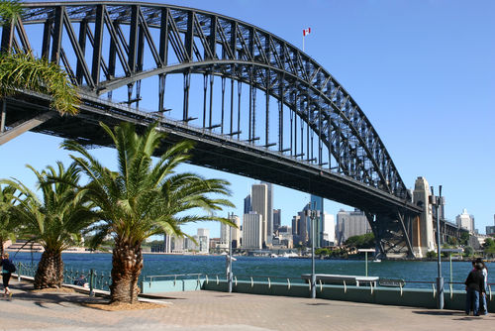
Tour includes:
A photo of you and your friends on top of the bridge.We also offer you:
Special clothes to protect you from the strong wind.
A radio to communicate with the tour leader.
Free drinks(for lunch tours only).
Prices are in Australian dollars.
Children must be with an adult. Each adult can take 2 children at most.
For more information, e-mail us at tour@touraustralia.com.
BRIDGE CLIMB | Morning/ Afternoon / Night Tour |  | Lunch Tour
BRIDGE CLIMB | Mon. – Fri. | Sat. – Sun. | Mon. – Sun.
From January 1 to August 31
Adults | $ 170 | $190 | $250
Children(10~16) | $110 | $130 | $190
From September 1 to December 31
Adults | $150 | $170 | $230
Children(10~16) | $90 | $110 | $170
()56. This may be a(n) ________.
A. interview B. magazine
C. notice D. advertisement
()57. It takes the tourist about ________ hours to finish the climbing tour.
A. two B. three C. four D. 134
()58. Tourists should wear ________ to protect them from the strong wind.
A. hats B. special clothes C. sunglasses D. raincoats
( )59. Mr. and Mrs. Johnson are going to take their son(aged 11) to the lunch tour this Sunday morning(June 28). They should pay ________ for their tour.
A. $450 B. $510C. $630D. $690
()60. Which of the following is TRUE?
A. Prices are in American dollars.
B. Children can join the tours alone if they are 10 years old.
C. The top of Sydney Harbor Bridge is about 134 meters high above the water.
D. All the tourists can get soft drinks without any money during the tours.
B
Ask someone what they have done to help the environment recently and they will almost mention recycling. Recycling in the homes is very important. However, having to recycle often means we already have more products than we need. We are just dealing with the results of that over-consumption in the greenest way, but it would be much better if we did not bring so many goods home.
The total amount of packaging(外包装) has increased by 12% between 2001 and 2007. It is 1/3 of a home’s waste in the UK. In many supermarkets, food products are packaged twice with plastic and paper. Too much packaging is doing serious damage to the environment. The UK, for example, is running out of land because of this unnecessary waste. If such packaging is burnt, it gives off greenhouse gases which go on to cause the greenhouse effect(温室效应). Besides, the plastic from the package puts some creatures(生物) in danger, especially birds and fish.
Recycling helps, but the recycling itself uses energy. The solution is not to produce such waste in the first place. Too many supermarkets encourage customers to buy more than they need. However, few of them have the idea that this cannot continue.
But this is not just about supermarkets. It is about all of us. We have been used to the idea that packaging means excellence while anything unpackaged is of poor condition. This is especially true of food. But this idea has spread to other products, which often have far more packaging than necessary.
There are signs of hope. As more of us recycle, we are beginning to realize just how many unnecessary goods are collected. We need to face the waste of our consumer culture(消费文化), but we have a mountain to climb.
()61. What does the underlined word “over-consumption” in Paragraph 1 refer to?
A. 过度包装 B. 回收废物
C. 过度消费 D. 过度生产
()62. Which of the following damage of over packaging is NOT mentioned?
A. It may waste land.
B. It may pollute the food.
C. It may do harm to the living things, like birds and fish.
D. It may make the greenhouse effect worse.
( )63. According to Paragraph 3, what is in the first place to help protect the environment?
A. Recycling.
B. Not to produce waste.
C. Not to buy products in the supermarkets.
D. Not to use energy.
()64. What do people think of packaged products?
A. Supermarkets encourage them to buy those products.
B. Packaged products are much cheaper.
C. It is unnecessary for food to have packaging.
D. People think packaged products are better than unpackaged ones.
()65. What does the writer tell us in the last paragraph?
A. Fighting waste is difficult.
B. People don’t waste any more.
C. Doing exercise is good, like climbing the mountain.
D. We should continue our consumer culture.
C
配对阅读 左栏是五个人喜爱的户外运动简介，右栏是七种天气。请将这五种运动与适当的天气配对。
()66. David loves skiing. Skiing on the Alps(阿尔卑斯山) in Switzerland is his dream. He’s going to achieve this dream in the coming Christmas holiday.  ()67. Jenny is a six-year-old girl. She likes to fly kites with her father on the grass in spring. It’s really fun.  ( )68. Jack is a cyclist in Hongkong. He practices riding his bike with his teammates almost every day, except when there is a storm. He loves riding his bike, especially in cool autumn days.  ( )69. Mary is on the school swim team. Summer is her favorite season because she can swim in the cool water to keep off the heat.  ()70. Kate works in New York. She is often stressed out, but jogging(慢跑) helps her to relax. She thinks jogging in the drizzle(毛毛雨) is the best. After jogging, she takes a shower and feels refreshed. | A. Summer vacation is coming. It will be sunny and hot these days. The temperature will be 30°C tomorrow. It’s the best time for swimming!  B. It is cloudy with drizzle in New York. The temperature will be 25°C.  C. A typhoon is approaching Hongkong this weekend. And it will bring some cool wind and rainstorms in this hot summer.  D. Heavy storms this week mean that skiers will enjoy large amounts of snow in Swiss Alps resorts this Christmas, changing the piste (滑雪道) conditions from "good" to "excellent".  E. The temperature has risen and it will be sunny and windy this weekend. Such weather is suitable for outdoor activities, such as bike riding and flying kites, after a long period time of rainy days in March.  F. Autumn lasts from October to December in Hongkong, which is cool and comfortable, known as the best season of Hongkong. During this season, the weather is neither too hot nor too cold. The temperature is from 18°C to 28°C.  G. A cold snap(寒潮) started sweeping over central China on Saturday and will continue moving east over the next three days, bringing an end to the recent fog.

五、看图填词。（每空1.5分，共15分）
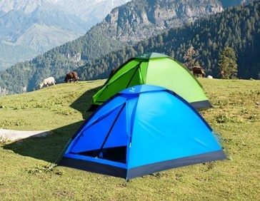
Last Saturday morning, I went camping with my friends. We were excited because it was a 71 day. 72 the way, we kept singing and making jokes with the sun shining.
However, in the afternoon, it was dark and windy. Soon, it started to 73 . Unluckily, none of us brought an 74 . We ran about but could find no place to hide.
Twenty minutes 75 and it was still raining. There were hours to go before we could 76 at the campsite(营地). It was even 77 that our compass (指南针)showed that we went to the wrong way. We had lost 78 way!
At about five o’clock, it stopped raining when we 79 got to the campsite. Though we were very tired, we set up our tents quickly.
This camping trip was probably not very successful 80 we got to know each other better.

六、读写综合（本大题分为A、B两部分，共20分）
A．信息归纳（本题共5小题，每小题1分，共5分）
请阅读下面这篇文章，根据所提供的信息，完成信息卡，把答案写在答题卡指定的位置上。
Life in China
Every day, News on TV, radio and online brings you stories from across China. Have you got a story about life in China? If you do, please put your story here.
( A)
Since the winter last year, the haze（雾霾）has happened
a lot of times. It has done great harm to our daily life. More and more people have to go to see the doctor because of the serious disease caused by the haze. Many traffic accidents happened and quite a lot of flights had to be put off just because of the haze weather. On March 18, 2016, Zhuhai experienced the most terrible weather in history. The haze was so heavy that drivers could hardly see the things even twenty meters away from them. Zhuhai Airport canceled 137 flights as the result of the weather. ( Wu Hai, Zhuhai)
( B)
It’s reported that 293 pedestrians （行人）die of traffic accidents every day in China. I myself ever experienced a very terrible accident.
Early last Thursday morning, I was walking on my way to school as usual. A little boy ran past me. He ran so fast when crossing the street that he didn’t notice a speeding car came round the corner. I was scared and shouted to him to stop, but it was too late. The boy was knocked down by the car. I hurried to the boy, crying for help. The boy was taken to the hospital as soon as the policemen and doctors arrived. Later, I learned the boy died because he lost too much blood. (Li Lan, Guangzhou)

Information card
The person who writes the first story | 81._____________________________
The date when 137 flights were canceled | 82._____________________________
The number of pedestrians that die of traffic accidents every day | 83.______________________________
The thing that knocked down the little boy | 84.______________________________
The reason why the little boy died | 85.______________________________

B.书面表达（本题15分）根据要求完成短文写作，并将作文写在答题卡的指定位置上。
假如你是一名叫林涛的中学生，看了上述报道后，你想表达自己的看法，请给栏目编辑写封电子邮件，内容包括：
1. 简述(B)篇报道；说说你读完该报道的感受。
2. 结合你的日常情况，谈谈你平时是如何避免交通事故发生的（2个做法）。
3. 就该报道的现象提出至少两条你的建议。
4. 呼吁人们遵守交通规则，珍爱生命。
要求：
（1）不得照抄原文，不得在作文中出现学校的真实名称和学生的真实姓名。
（2）语句通顺，书写规范，词数80左右，作文的开头结尾已给出，不计入总词数。
Dear Editor,
__________________________________________________________________________
______________________________________________________________________________________
Yours,
Lin Tao

2018年珠海中考英语模拟压轴题参考答案
听力理解:
ACBAC 6-10 BCAAC
11-15 BABAB 16-20 BABAC
21. letter 22. Father’s Day 23.haven’t said
24. 100/ one hundred/ a hundred 25. Friday
二、单项选择
26-30 BACAD 31-35 BCBCD
36-40 BDBAC 41-45 BACAD
三、完形填空
46-50 ACBCC 51-55 DBCBA
四、阅读理解
56-60 DBBDC 61-65 CBBDA
66-70 DEFAB
五、看图填词
71. sunny/ fine 72. On 73.rain 74. umbrella
75. passed76.arrive 77. worse 78. our/ the
79. finally/ successfully 80. but
六、读写综合
A. 信息归纳
81. Wu Hai
82. (On)March 18,2016
83. 293
84. A (speeding) car
85. (Because) he lost too much blood.

