此试题可能存在乱码情况，在查看时请点击右上角全屏查看
2017年丽江中考英语试题
英语 试题卷
（本试卷分四个部分。满分120分， 考试用时120分钟）
注意事项：
1.本卷为试题卷。考生必须在答题卡上解题。答案应写在答题卡的相应位置上，在试题卷，草稿纸上作答无效。
2.考试结束后，请将试题卷和答题卡一并交回。
第一部分 听力(共四节，满分30分)
做题时，先将答案标在试题卷的相应位置，听力测试结束后，请将试题卷上的答案转涂到答题卡上。
第一节 听句子，从题中所给的A、B、C三个选项中选出与所听句子内容相关的图画，每个句子听两遍。(共5小题，每小题1分，满分5分)
1.   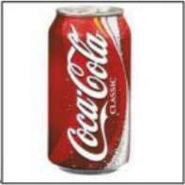
A B C
2. 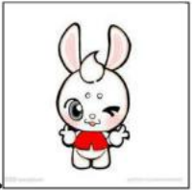  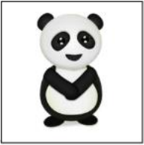
A B C
3. 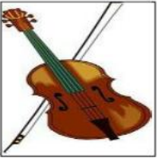 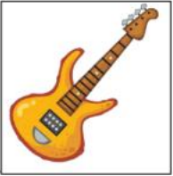 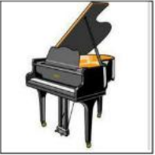
A B C
4.  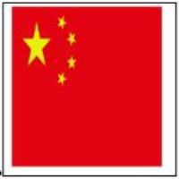 
A B C
5. 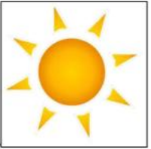 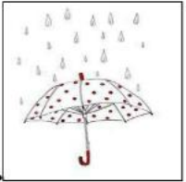 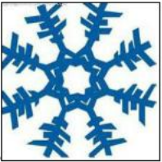
A B C
第二节 听句子，从题中所给的A、B、C三个选项中选出与所听句子内容相符的正确答语，每个句子听两遍。 (共5小题，每小题1分，满分5分)
6.A.Yes, he does . B.Yes, he did. C.Yes, he has.
7.A.That’s all right. B.It doesn’t matter. C.I stayed up late.
8.A.Congratulations. B.Thank you! C.Here you are.
9.A.He is working. B.He is friendly. C.He is a policeman.
10.A.I don’t like it. B.Help yourself. C.It’s very kind of you.
第三节 听对话，从题中所给的A、B、C三个选项中选出能回答问题的正确选项，每段对话听两遍。(共5小题，每小题2分，满分10分)
听第一段对话, 回答第11、12小题。
11.When du they meet?
A.In the morning. B.At noon. C.In the afternoon.
12.What are they going to do?
A.Play games. B.Have a math class. C.In the afternoon.
听第二段对话, 回答第13～15小题。
13.How did Nick come to Kelly’s office?
A.By taxi. B.By bus. C.On foot.
14.Why was it hard for Nick to catch a bus?
A.Because he was new to the city. B.Because there were a few buses at weekends.
C.Because a lot of people went out at weekends.
15.What would Nick like to drink?
A. A cup of coffee. B.A cup of tea. C. A cup of milk.
第四节 听短文，从题中所给的A、B、C三个选项中选出能完成下列信息表格
Place to go | ____16______
Things to bring | ____17______,hats and umbrellas.
Time to meet | At ____18______.
Activities | Climb mountains,pick____19_____.
 | We mustn’t ____20______.
16.A.A park B.A farm C. A village
17.A.Sunglasses B.Knives C.Drinks
18.A.8:00 B.9:00 C.10:00
19.A.pears B.apples C.oranges
20.A.go swimming B.go fishing C.go boating
第二部分 英语知识运用 ( 共二节, 满分30分)
第一节 单项填空 (共15小题，每小题1分, 满分15分)
从题中所给的A、B、C、D四个选项中选出能填入空白处的正确选项， 并将所选答案涂到答题卡的相应位置上。
21.Many people like watching Chinese Poetry Conference (诗词大会）____TV.
A.in B.of C.at D.on
22. 一Hello, is that Molly speaking ?
一_________.
A.You’re welcome B. Speaking, please C.This way ,please D. Glad to hear that.
23. —____ do you visit your grandparents?
—Once a month.
A.How often B.How long C. How soon D.How far
24.Tom,the baby is sleeping. Please ______ the radio a bit.
A.turn on B.turn off C.turn up D.turn down
25. —Jack,how was your summer vacation?
—Just so-so,I decided to go ___ for my next vacation.
A.something wonderful B.wonderful something
C.somewhere wonderful D.wonderful somewhere
26.You’d better ___ more time talking with your parents so that they can understand you better.
A.spend B.take C.cost D.pay
27. —_______?
— I want to buy a pair of sports shoes.
A.What’s wrong B.What can I do for you C. How much is it D.What does it look like
28.You’ll get good grades ___ you work hard.
A. although B.so C. if D.unless
29. —I saw Susan in the library just now.
—No,it __ be her.She went to Shanghai this morning.
A.must B.can’t C.may D.needn’t
30. —Don’t throw rubbish everywhere, please .Building a civilized(文明的）city is our duty.
—_______.
A.OK, I will B.You are joking C.Take it easy D.Sorry, I won’t
31.There are ___ sharing bikes in many cities. So there will be ___ pollution.
A.less and less; more and more B.less and less; fewer and fewer
C.more and more ; less and less D.fewer and fewer ; less and less
32. —What do you think of your hometown,Kate?
—It ____ a lot. It’s more beautiful than before.
A.has changed B.changes C.will change D.change
33.My father has made a _____ that he will buy a camera for me.
A. suggestion B.secret C.problem D.decision
34. —It’s a little cold .Would you mind closing the window?
— _________________.
A.Forget it B.No, you can’t C. Not at all D.Of course
35. —Could you tell me ______?
—The movie Fast and Furious(激情)8.
A.where you saw the movie B.which movie you like best
C.where did you see the movie D.which movie do you like best
第二节 完形填空（共10小题；每小题1.5分，满分15分）
从题中所给的A、B、C、D四个选项中选出能填入空白处的最佳选项，并将所选答案涂到答题卡的相应位置上。
Jim started painting when he was three years old, and when he was five, he was already very good at it. He __36__ many beautiful and interesting pictures, and people paid a lot of money for them. They said, “This boy is going to be __37__ when he grows up, and then we're going to sell these pictures for a lot more __38__.”
Jim’s pictures were different from __39__ other people's works, because he __40__ painted on all of the paper. He painted on half of it, and the other half was always empty.
“That’s very clever,” everybody said, “Nobody else does that like __41__ !”
One day, somebody bought one of Jim's pictures and then said to him, "Please __42__ me, Jim Why do you paint on the bottom half of your paper, __43__ not on the top half?”
“Because I'm small,” Jim said,“and my brushes don't __44__ very high. That’s __45__ I only paint on the bottom half of the paper.”
36.A.Painted B.bought C.found D.lost
37.A.pretty B.funny C.famous D.lucky
38.A.houses B.gifts C.food D.money
39.A.of B.from C.in D.with
40.A.ever B.already C.never D.with
41.A.him B.us C.her D.them
42.A.tell B.advise C.promise D.believe
43.A.and B.but C.or D.because
44.A.lie B.stand C.climb D.reach
45.A.when B.where C.why D.what
第三部分 阅读理解 （共三节，满分35分）
第一节 根据短文内容，判断正误(正确的填“T”,错误的填 “F” ，并将所选答案涂到答题卡的相应位置上。（共5小题；每小题1.5分，满分7.5分）
Shopping used to mean going to shops ,but nowadays, you can shop without even leaving your home. Just sit in front of your computer, click(点击）your mouse and your things will be sent to your house in several days. You can also use your mobile phone to buy things you want. Nov.11 was a big day for many people who like shopping online. On that day,many stores offer a big sale. The biggest Chinese online shopping sites are Taobao.com and Tmall.com.
Goods（商品） online are often much cheaper . Shopping online also saves you a lot of time.And you often have more kinds of goods online than in shopping centers. Another big advantage of online shopping is that it helps you get things easily from different cities, even different countries.
While enjoying online shopping, many people also have worries, especially for middle school student buyers. They often buy things that they don’t need.“Middle school students should pay more attention to their study. Searching for things to buy online wastes their time.” said teachers.
46.Nowadays, shopping becomes easier than before.
47.Many people like shopping online on November 11.
48.Shopping online can’t save time and money.
49.Teacher think middle school students should pay more attention to their study.
50.This article is about disadvantages of shopping online.
第二节 根据短文内容,从题中所给的A、B、C、D四个选项中选出最佳选项，并将所选答案涂到答题卡的相应位置上。（共10小题；每小题2分，满分20分）
A
“Early to bed and early to rise make a man healthy, wealthy and wise.” This is an old English saying . It means that when we go to bed early, we can get up early the next morning.Then we will become healthy. We will also become rich and clever.
This is true. To be healthy, we must have enough sleep . Experts (专家）say that adults should get seven to eight hours of sleep a night. Teenagers need nine to ten hours . And school-aged children may need more than ten hours of sleep. Children who do not have enough sleep can’t do their work very well. They won’t be wise and they may not become wealthy!
We also need exercise. Walking , running, swimming and playing games are all exercise. Exercise keeps us strong .It also helps the blood to move around the body. This is very important. Our blood takes the nutrition(营养）from food to all parts of our body.
The head also needs blood. So exercise that moves the blood to our head helps us think better!
51.If we get up early and go to bed early , we’ll _________ .
A.Become weak B.have more time C. be healthy D. have more work to do
52.Who needs most hours of sleep to keep healthy?
A.Adults B.Teenagers C.Experts D.School-aged children
53.A child ______ when he does not have enough sleep.
A.can’t study well B.will be wise C.will be wealthy D.will be active in class
54.A person needs exercise because ________.
A.he is strong enough B.it helps make him healthy
C.he has a lot of homework to do D.It can bring him much blood
55.Which of the following is Not TRUE?
A. Exercise helps the blood to move. B. Exercise is good for a person’s head .
C.If we have enough blood, we’ll be wise. D.It’s good for us to get up early and go to bed early.
B
Helping others is a great thing to do. You can learn new things and have fun .There are many ways of helping others in your community.You can help people, animals or the environment. It can make you feel good too! How can you help?
Charities(慈善机构）are organizations that help others, for example. UNICEF or the World Wildlife Fund. You can help charities by giving your time, giving money or giving things that you own .You can also help people or places you know.
Volunteering.
Volunteering is when you give your time to help others .It’s something which you do not have to do or for which you will not be paid. Some ways of volunteering are:
·visiting old people to talk to them or help them
·walking dogs at an animal shelter.(避难所）
·cleaning up a park.
Fundraising
Fundraising is when you collect money to help others. Some ways of fundraising are:
·making cakes or biscuits to sell.
·doing a sponsored (赞助）activity.For example,family and friends give you money if you finish a long walk. Donating
Donating is when you give your things or money to help others .Some ways of donating are:
·giving your old toys or clothes to a charity that helps sick children or poor people.
·giving your old books to a library.
·giving your money to a charity.
So, what can you do to help others?
56.You’ll ___ when you help other people.
A.feel uncomfortable B.have a great job C.feel good D.have a hard time
57.How many ways of volunteering are mentioned in the artcle?
A.Two B.Three C.Four D.Five
58.The underlined word “fundraising” means “____” in Chinese.
A.募款活动 B.慰问活动 C.志愿活动 D.捐物活动
59.Which of the following is a way of donating?
A.Cleaning up a park. B.Giving your old computer to a charity.
C.Taking care of sick people in hospital. D.Making pancakes or sandwiches to sell.
60.What is the best title for the passage?
A.Charities B.Ways of Volunteering C.A Great Thing to Do D.Helping Others. 第三节 根据短文内容，从短文后的选项中选出能填入空白处的最佳选项，选项中有两项为多余选项,并将所选答案涂到答题卡的相应位置上。（共5小题；每小题1.5分，满分7.5分）
There is a seed (种子）.He is so small that nobody wants to look at him. 61 .
One day , a wind brings him to a field in the sun. He looks around and a spatter of rain comes to him. Then he grows up. Four years later, a man sits under him. The man says, “Thank you for this. 62 .
“What are you talking about?”the seed asks. 63 No one speaks to him like that.
“Who is this?” the man asks.
“It’s me. I’m a seed.”
“A seed?” the man looks at the big tree. “ 64 You are a tree, a big tree!”
“Really?”
“Yes! People come here to have a rest under your shade(树荫）.”
Hearing this , the seed, now a tree, is very happy. “Oh! That means I’m not a small seed anymore. 65 Wow! Everybody comes to me for my shade because I am a big tree now!”
A.I can help people. B.You are not a seed. C.The man feels unhappy.
D.I really need some rest. E.The seed is planted in a field.
F.He thinks the man is laughing at him. G.So the seed doesn’t think he is important.
第四部分 写作 ( 共三节, 满分25分)
第一节 根据句意，用括号中所给词的适当形式填空, 并将答案写在答题卡的相应位置上。(共5小题，每小题1分, 满分5分)
66.It’s noisy outside. I can’t hear you ______________(clear)
67.The little girl is so smart . She can make a cake by _____________ without help.(she)
68.All the people in the word wish to enjoy a beautiful and ____ life.(peace)
69.As a book ______________, Helen volunteers her time to read books to children at school. (love)
70.The ___________ Games of China will be held in Tianjing from August 27. to September 8.(thirteen)
第二节 将下列句子中的汉语部分译成英语, 注意使用适当的形式，并将答案写在答题卡的相应位置上。 (共5小题，每小题1分, 满分5分)
71.Kevin’s birthday is coming . His parents are planning to make _____________ for him. (一顿大餐）
72.Many children use Internet to get useful information and to relax in their ________________. (空闲时间）
73.Sally is my best friend. We often help ______________ with schoolwork.(相互）
74.Life isn’t about _____________ the storm to pass. It’s about learning to dance in the rain.(等候）
75.The______________ is a bridge of cultures between China and many other countries.(丝绸之路）
第三节 书面表达(满分15分)
A Special Day
提示：在每个人的生活中，总会有些特别的日子。请根据所给题目 “A Special Day” 写一篇英语短文， 记叙你特别的一天。
要求：1.语言流畅、书写规范、卷面整洁，词数不少于60个；
- 文中不能使用你的真实姓名和校名，否则以零分计。
3.请将短文写在答题卡上。写在本试题卷上无效。

2017年丽江中考英语试题参考答案
