各位同学在查看时请点击全屏查看
2018年商丘中考英语模拟试题
（考试时间:90分钟 满分:100分）
一、听力。(每小题1分，共20分)
A)听对话回答问题，每段对话听两遍。
( )1. What may the man's son do?
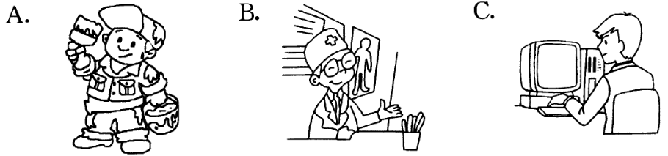
( )2. Why is the boy wearing jeans today?
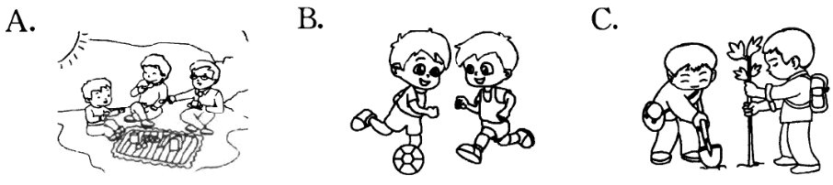
( )3. Where are they talking?
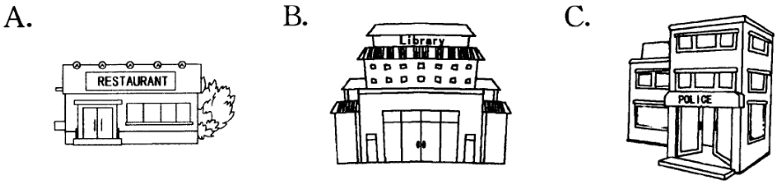
( )4. How does Tom learn Chinese?
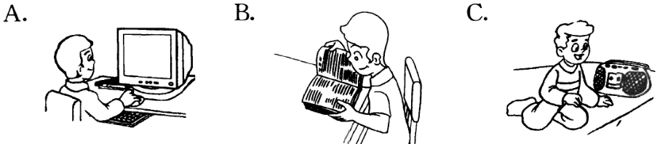
( )5. What's the date today?
A. March 9th. B. March 8th. C. March 7th.
( )6. How many times has Kate been to Hainan Island?
A. Once. B. Never. C. Twice.
( )7. How is the woman going to Beijing?
A. The man will drive the woman to Beijing.
B. She will go to.}Beijing by air.
C. Maybe she will take a taxi to Beijing.
( )8. Why didn't Jimmy go to Suzhou Amusement Park yesterday?
A. Because he was ill in hospital.
B. Because he had to look after his mother at home.
C. Because his mother was ill in hospital.
( )9. What did Kimi's father donate to the people with blood disease?
A. Blood. B. Blood cells. C. Clothes and books.
( )10. What's Peter's problem?
A. Spelling. B. Writing. C. Pronunciation.
B)听对话和短文回答问题，每段对话和短文听两遍。
听一段对话，回答11-12小题。
( )11. What did Li Hua use to look like?
A. Be short，have long hair and wear glasses.
B. Be tall，have short hair and wear gloves.
C. Be short，have short hair and wear glasses.
( )12. Who played the piano?
A. Li Hua. B. Jerry. C. Wang Hai.
听第一篇短文，回答13-15小题。
Town library
Where | The library is 13 .
What | It has 14 .
How long | I can keep them for 15 .
( )13. A. near my school
B. in the centre of the town
C. near my home
( )14. A. books，magazines and CDs
B. newspapers and e-books
C. books only
( )15. A. three weeks B. two weeks C. one month
听第二篇短文，回答16-20小题。
( )16. Where did the speaker travel?
A. To Thailand. B. To England. C. To Ireland.
( )17. How long did the speaker stay there?
A. For five days.
B. For six days.
C. For a whole week.
( )18. What did the speaker do on the second day?
A. Visited some museums.
B. Walked around the streets.
C. Went swimming.
( )19. In which season did the speaker travel?
A. In winter. B. In summer. C. In spring.
( )20. What did the speaker think of her trip?
A. It was boring. B. It was tiring. C. It was great.
二、单项选择。(每小题1分，共15分)
( )1.一After I graduate，I'll try to become university student.
一You're hard-working. I'm sure you can realize your dream.
A. a B. an C. the D./
( )2.一How do you like the two pairs of shorts?
一They don't fit me well. They are too long too short.
A. not only; but also B. both; and
C. neither; nor D. either; or
( )3.—What's wrong with your bike?
—It .
A. broke down B. broke out C. broke up D. broke over
( )4.—We failed in the singing competition.
— . Better times are waiting for you.
A. No way B. Best wishes
C. Cheer up D. Good job
( )5. The song reminds me of my old school days as soon as it .
A. is played B. plays
C. will be played D. will play
( )6.—Smoking is really bad for health.
—Teenagers in our school have they will refuse the first cigarette.
A. provided B. produced C. proved D. promised
( )7. A young man is found in the forest. He might three days ago.
A. die; die B. dead; die
C. died; dead D. dead; dead
( )8.—I always forget what I want to buy when I go to the market.
—Well，you can make a of things you want to buy.
A. habit B. wish C. list D. rule
( )9. I never doubt this exhibition is worth .
A. whether; to visit B. that; to visit
C. if ; visiting D. that; visiting
( )10. my surprise， of us was given a present at the party.
A. With; everyone B. With; every one
C. To; everyone D. To; every one
( )11. Li Hua is weak in English and he has what the teacher says in class.
A. difficult to understand B. difficult understanding
C. difficulty to understand D. difficulty understanding
( )12. Do you know Shanghai or not tomorrow?
A. whether are they leaving for
B. whether they are leaving for
C. if they are leaving for
D. if are they leaving for
( )13. We lost the match yesterday, but our coach didn't get angry. Instead, he us, because we tried our best.
A. was proud of B. was afraid of
C. was worried about D. was unhappy with
( )14.一The music by Tan Dun sounds .
一Yes, many of us are fond of it.
A. was written; wonderful B. written; wonderfu1
C. was written; wonderfully D. written; wonderfully
( )15.一The boy's father failed to find a job. . He got a cancer.
一How sad! We should give him a hand.
A. It never rains but pours
B. Every dog has its day
C. A miss is as good as a mile
D. The grass is always greener on the other side
三、完形填空。(每小题1分，共10分)
An ant is walking by the river. He looks at the river and says to himself , " 1 nice and cool this water looks! I must drink some of it. " But when he is drinking, he 2 into the river.
"Oh. Help! Help! "the ant cries.
A dove(鸽子)is sitting 3 the tree. She hears him and offers him a leaf," 4 up that leaf," she says, "and you will get to the bank(河岸). "
The ant climbs up onto the leaf, and the wind blows the leaf to the bank.
"Thank you，Dove. You're so 5 . You have saved my life, and I wish I could do 6 for you. Goodbye! " the ant says and runs home.
"Goodbye! " says the dove. "Be 7 not to fall into the river again. "
After a few days，the dove is building her nest(巢).And a man is raising his gun(枪)to shoot 8 .
The ant sees this, and runs 9 to bite the man's leg. "Ouch! Ouch! " The man 10 a terrible pain and drops his gun. The dove flies away quickly. So the man picks up his gun and leaves.
The dove comes to the ant and says, "Thank you, my little friend. You have saved my life. " The little ant is so glad，because he can help the dove.
( )1. A. Where B. What C. When D. How
( )2. A. falls B. drives C. looks D. runs
( )3. A. on B. in C. with D. down
( )4. A. Get B. Come C. Climb D. Put
( )5. A. quick B. kind C. patient D. worried
( )6. A. anything B. nothing C. everything D. something
( )7. A. careful B. happy C. easy D. dangerous
( )8. A. it B. her C. him D. them
( )9. A. slowly B. off C. fast D. upstairs
( )10. A. feels B. takes C. causes D. gives
四、阅读理解。(每小题2分，共20分)
A
When we think of money，we think of coins and paper bills. That is what money is today. But in the past people used many things in place of money. Some countries used cows. Other countries used salt，tobacco，tea，or stones. Today there are still some places in the world that people do not use paper money. One place is the island of Yap in the Pacific Ocean.
On the island of Yap，people use the heaviest money in the world-Yap stones. These are round, white stones with a hole in the middle. The Yap stones do not originate from the island. The men have to go to islands four hundred miles away to fetch them. Big stones can be twelve feet high-as big as two tall men. Small stones are as big as a dinner plate.
Rich people do not carry the Yap stones. Servants follow the rich. Each servant carries a stone on a pole over his shoulder. Today the people on the island use paper money for everyday shopping. But for other things they still prefer Yap stones.
( )1. On the island of Yap，people use as money.
A. stones B. cows C. dinner plates D. salt
( )2. What does the underlined word "originate" mean?
A. Grow. B. Come. C. Develop. D. Begin.
( )3. Now paper money are used on the island of Yap.
A. only by rich people B. in place of Yap stones
C. for shopping of everything D. for everyday shopping
( )4. The passage is mainly about .
A. money used around the world
B. the history of Yap Island
C. money used on Yap Island
D. different kinds of money
( )5. Which of the following is TRUE?
A. The Yap stones originate from the island of Yap.
B. The Yap stones are all twelve feet high.
C. The Yap stones have a hole in the middle.
D. People on Yap Island use small stones as dinner plates.
B
Music has many forms. Most countries have a style(风格)of their own. For example, Argentina(阿根廷)is famous for tango; the USA is well-known for jazz，which has become popular all over the world.
Jazz is natural and free. It's different from classical music，which follows European traditions. Jazz became popular music because of America. American blacks made the music of Jazz. At that time rich Americans bought blacks and made them work for a long time every day. The blacks often sang when they were working. Singing made the hard work go faster. And the music made everyone happy. It was an early form of jazz. Music has always been important in the blacks' life because they have a rich musical tradition. In the fields，they made up this kind of music. Soon，the music became a part of American music.
( )6. What does the underlined word "forms" mean?
A.表格 B.表现 C.种类 D.用处
( )7. What kind of music is Argentina famous for?
A. Tango. B. European music.
C. Classical music. D. Jazz.
( )8. Which kind of music follows European traditions?
A. Jazz. B. Pop.
C. Classical music. D. Rock.
( )9. Who made the music of Jazz?
A. Rich Americans.
B. American blacks.
C. American musicians.
D. American workers.
( )10. Why did the blacks often sing when they were working?
A. Because they liked music very much.
B. Because the rich Americans wanted them to do that.
C. Because they didn't like the work.
D. Because singing made them happy.
五、单词拼写。(每小题1分，共10分)
A)根据句意和汉语注释，写出单词的正确形式。
1. His father is very (严格的)with him in his study.
2. Simon likes to learn about the world (凭借)the Internet.
3. When the teacher asks him some questions，he can answer them (正确地).
4. Last week, the thick haze(雾霾)over the city (影响)our life greatly.
5. Obama's (胜利)was good news for black Americans.
B)根据句意，写出括号内所给单词的适当形式。
1. They have made a (decide) to build a big factory here.
2. We Chinese have made great (achieve) in modern space technology.
3. His (careless)stopped him from winning the maths competition.
4. It's usually considered impolite to ask (person)questions about others.
5.一My difficulty in learning English is how to get the (pronounce) right.
一You'd better follow the tape often.
六、动词填空。(每小题1分，共10分)
1. we must get mere before it (begin) to ram.
2.一Are you going anywhere?
一I (think)about travelling to Beijing，but now I have changed my mind.
3. After hearing the latest news，Tom suggested (sell)the house but Ann didn't agree.
4. I think this kind of problem (deal)with as soon as possible.
5. Mr Brown (prefer) hiking to swimming when he was in his twenties.
6. He felt that his life was no longer worth (live).
7. Did you hear my name (mention)?
8. In order not to be late for the meeting, my sister (force) herself to get up early this morning.
9. Let's work hard together! I believe we (succeed) in the future.
10. The Hope Middle School (name)after the businessman who donated money to build it，won't it?
七、翻译句子。(每小题2分，共10分)
1.那个淘气的男孩因为生病缺课多久了?

2.我们经常建议他不要熬夜，但是他充耳不闻。

3.我怀疑这部电影是否值得一看。

4.由于恶劣的天气，那些登山队员别无选择只能改变了主意。

5.每年的国庆节庆祝活动简直就像欢腾的海洋一样。

八、书面表达。(共10分)
学校英语社团在举办征文比赛，请你根据以下提示内容，写一篇题为“The person who has influenced me most”的英语文章。
内容要点:
1.对我影响最大的人是我的妈妈，她四十几岁;
2.她总是耐心倾听我的问题，并建议我如何解决问题;
3.作为一名医生，她常说再怎么仔细也不为过。她总是加班，把她的大部分时间都奉献给了工作;
4.所以，我认为她不仅是位好妈妈，也是名好医生。
5.我希望……
要求:1.内容须包含所有要点，语句通顺，意思连贯;
2.词数90左右;
3.第5要点的内容需展开合理想象，用2-3句话补充完整。
The person who has influenced me most

2018年商丘中考英语模拟试题参考答案
【听力材料】
A)听对话回答问题，每段对话听两遍。
1. W: Does your son like his new job?
M: Yes, he does. He is careful and he likes to work with numbers.
2. W: Why aren't you wearing school uniform today?
M: We'll go on a picnic this afternoon and jeans are more comfortable.
3. M: Do you have any books on teenage problems?
W: Yes. This way, please.
4. M: How does Tom learn Chinese?
W: He learns Chinese by listening to the radio.
5. M: Tomorrow is Women's Day. Let's give our mother a surprise.
W: That's great.
6. M: Have you ever been to Hainan Island, Kate?
W: No, but I'm going there with my friends next year.
7. M: Do you mind me driving a bit faster?
W: You'd better not. Take care since there is too much snow. I can get to the airport on time.
The plane for Beijing will leave at 5:00.
8. W: Jimmy, we enjoyed ourselves so much in Suzhou Amusement Park yesterday, but you didn't go. What a pity!
M: My mother was ill and I had to look after her in the hospital.
9. W: Your father is so kind, Kimi. He donated a lot of useful clothes and books to the people in poor areas.
M: Yes. He has even donated blood to help others and blood cells to the people with blood disease.
10. W: I often have a lot of problems with pronunciation of English words. What about you, Peter?
M: Well, I have many problems with spelling. I can't spell the words correctly.
B)听对话和短文回答问题，每段对话和短文听两遍。
听一段对话，回答11-12小题。
W: Li Hua, you've changed a lot!
M: Really? How?
W: You used to be short and have short hair. Now you're tall and have long hair.
M: Yes, that's right.
W: And you used to wear glasses.
M: Yes, I still do.
W: You used to play the piano, didn't you?
M: No, I played the guitar. My friend, Jerry, played the piano.
W: Oh, yes. I forgot.
听第一篇短文，回答13-15小题。
My name is Tony. I like going to our town library. The library is a large building in the centre of the town and it has all kinds of books and magazines you might want to read. It has novels and short stories. It also has CDs. I go there every Friday afternoon after school. I usually spend one and a half hours reading books and choosing what to borrow. The readers are allowed to keep them for two weeks and return them so that someone else can read or borrow them.
听第二篇短文，回答16-20小题。
Dear John and Mary,
Long time no see. How are you? Have you been travelling again? Recently I went on a trip to Thailand. Let me tell you about it. I stayed there for five days. The first day I visited some museums. Photos were not allowed, so you'll have to go and see them yourselves! On the second day, I went swimming. The sea was so clear and beautiful! But the sun hurt my skin badly. So I just walked around the following days. But I tried the Thai food, and it was so delicious! The last day I took a taxi to the airport. That was my trip. I really enjoyed it. Please tell me about your trip, especially about the food you ate.
Lots of love,
Victoria
一、1-5 CABCC 6-10 BBCBA 11-15 CBBAB 16-20 AACBC
二、1-5 ADACA 6-10 DBCDD 11-15 DBABA
三、1-5 DABCB 6- l0 DABCA
四、1-5 ABDCC 6-10 CACBD
五、(A) 1. strict 2. through 3. correctly 4. influenced 5. victory
(B) 1. decision 2. achievements 3. carelessness 4. personal 5. pronunciation
六、1. begins 2. thought 3. selling 4. will be dealt 5. preferred
6. living 7. mentioned 8. forced 9. will succeed 10. will be named
七、1.How long has the naughty boy been absent from school because of the illness?
2. We often advise him not to stay up late，but he just turns a deaf ear to it
3. I doubt if/whether this film is worth watching/seeing.
4. Those climbers had no choice but to change their mind because of the terrible weather.
5. Every year, the National Day celebrations are as good as the sea of happiness.
八、One possible version:
The person who has influenced me most
My mother is the person who has influenced me most. She is in her forties. She always listens to my problems patiently. And she advises me how to solve them. As a doctor, she often says she can't be too careful. She often works extra hours. She has devoted most of her time to her work. So I think she is not only a good mother but also a good doctor. I hope I can be a person like her. I also hope she will pay more attention to her own health. She'd better have more time to relax herself.

