2017年北京中考英语试题听力理解（共30 分）
一、听对话，从下面各题所给的A、B、C 三幅图片中选择与对话内容相符的图片。每段对话你将听
两遍。（共5 分，每小题1 分）
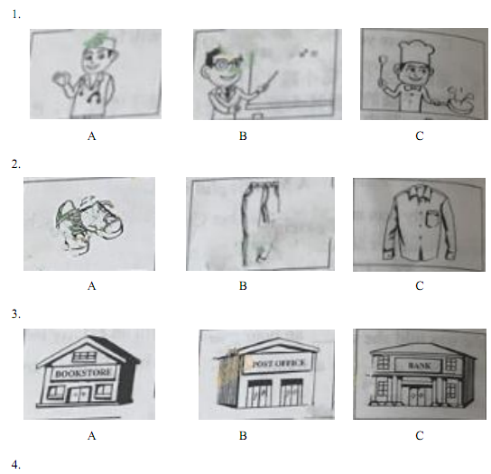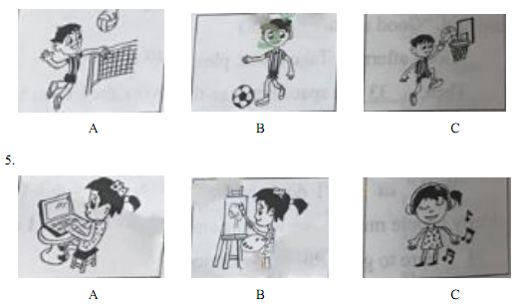
二、听对话或独白，根据对话或独白的内容，从下面各题所给的A、B、C 三个选项中选择最佳选项。
每段对话或独白你将听两遍。（共15 分，每小题1.5 分）
请听一段对话，完成第6 至第7 小题。
6. What does the woman want to drink?
A. Tea. B. Milk. C. Juice.
7. How much does the woman pay?
A. $7. B. $8. C. $9.
请听一段对话，完成第8 至第9 小题。
8. Where are the speakers going to have a picnic?
A. In the park. B. On the hill. C. At the seaside.
9. Who will join the speakers for the picnic?
A. The boy’s dad. B. The b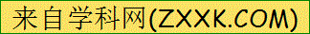oy’s grandpa. C. The boy’s grandma.
请听一段对话，完成第10 至第11 小题。
10. How did the boy go to the wild animal park?
A. By train. B. By car. C. By bus.
11. What did the boy do in the wild animal park?
A. He drew a picture. B. He fed an elephant. C. He saw a bird show.
请听一段对话，完成第12 至第13 小题。
12. What are the speakers mainly talking about?
A. Different reading skills.
B. Some benefits of reading.
C. The man’s reading habits.
13. What does the man think of reading?
A. He believes it is enjoyable.
B. He finds it a little difficult.
C. He thinks it takes too much time.
请听一段独白，完成第14 至第15 小题。
14. What can we know about the speaker?
A. She lives near her school.
B. She likes traveling abroad.
C. She wants to improve her English.
15. Why does the speaker send this message?
A. To describe her trip in London.
B. To tell the way to her house.
C. To introduce her hometown.
三、2017年北京中考英语试题听对话，记录关键信息。本段对话你将听两遍。（共10 分，每小题2 分）请根据所听到的对话内容和提示词语，将所缺的关键信息填写在答题卡的相应位置上。
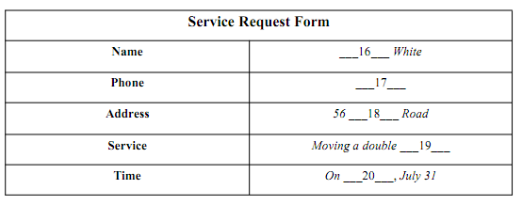
知识运用（共25 分）
四、2017年北京中考英语试题单项选择（共10 分，每小题1 分）
从下面各题所给的A、B、C、D 四个选项中，选择可以填入空白处的最佳选项。
21. My father is a worker. is very kind.
A. He B. She C. His D. It
22. More and more young people go skating winter.
A. at B. in C. on D. to
23. --- did you stop playing?
--- Because I was tired.
A. How B. Why C. When D. Where
24. The hotel is very old. It’s one of buildings in the city.
A. old B. older C. oldest D. the oldest
25. --- I hand in the report today?
--- No, you needn’t.
A. Can B. Must C. Shall D. Could
26. --- How do you usually go to school?
--- I to school on foot.
A. go B. went C. was going D. will go
27. My mother some washing when the telephone rang.
A. does B. did C. is doing D. was doing
28. Lily is my classmate. We each other since she came to our school.
A. know B. knew C. have known D. will know
29. The mobile phone in 1973.
A. invents B. is invented C. invented D. was invented
30. --- Judy, could you tell me_the schoolbag?
--- Oh, yes. I bought it in a store on the Internet.
A. where did you buy B. where will you buy
C. where you bought D. where you will buy
五、完形填空（共15 分，每小题1.5 分）
阅读下面的短文，掌握其大意，然后从短文后各题所给的A、B、C、D 四个选项中，选择最佳选项。
A Meaningful Gift
Emily was an eighth grader. To pass her Civics course（公民课程）, she had to do some volunteer
service in a nursing home for a week.
One Monday, Emily went to the nursing home after school. When she arrived, she was told she would
31 an hour every weekday with an elderly lady, Mrs. Blair. She was then led into a room, where an old
lady in a flowery dress was sitting on a sofa.
Emily 32 awkwardly（别扭地）in front of the lady. She cleared her throat and said, “Good afternoon.
I’m Emily.”
“Good afternoon, Emily. Take a seat, please.” Mrs. Blair replied.
Then, 33 filled the space between them. Emily wondered what to say.
“Tell me about yourself, Emily,” Mrs. Blair said suddenly.
“Well,” Emily started, “I don’t have any grandparents, so I can’t relate to elderly people much. I love theperforming arts. I’m here mainly because I have to 34 here to get a good grade for my Civics class.”
Mrs. Blair didn’t seem to 35 . “Many people, especially teens, don’t seem to care about old people
like me. Now you are here, and I’m going to change that about you. Ask me anything.”
Emily thought for a moment, and finally decided, “What was your job?”
“I was a Broadway star in the 1950s.” Mrs. Blair answered.
“Cool! Can you tell me about it?” Emily asked, amazed.
Mrs. Blair smiled. “Back then, only the lead actress had the honor to wear a 36 bracelet. I was
the lead in almost all of the plays, so I always wore the bracelet. Till this day, I still have it.”
Emily smiled along with Mts. Blair and listened to the other stories, attentively. She had become so
interested in Mrs. Blair’s 37 that she decided to come earlier the next day.
Tuesday, Wednesday, and Thursday passed by quickly. Then came Friday. As she was leaving, Emily
was really 38 to say goodbye.
“Don’t be sad. You can still visit me,” Mrs. Blair comforted her. She then handed a small box to Emily,“It’s my gift to you.”
Emily 39 opened the box and was surprised to see what was inside. “It’s the bracelet that you
wore. Thank you!” Emily said, with tears in her eyes. “I’m sure to visit you whenever I’m free.”
On the way home, Emily thought of her own love for the performing arts. She touched the bracelet and
made a 40 that she would keep her word to Mrs. Blair.
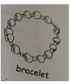
31.A. waste B. spend C. plan D. exercise
32. A. asked B. sat C. stood D. danced
33. A. warmth B. sadness C. happiness D. silence
34.A. study B. live C. volunteer D. play
35. A. mind B. fear C. insist D. regret
36. A. strange B. special C. common D. private
37. A. dreams B. hobbies C. stories D. jokes
38. A. upset B. confused C. surprised D. nervous
39. A. proudly B. secretly C. worriedly D. carefully
40. A. promise B. change C. judgment D. choice
阅读理解（共50 分）
六、2017年北京中考英语试题阅读下列短文，根据短文内容，从短文后各题所给的A、B、C、D 四个选项中，选择最佳选项。
（共30 分，每小题2 分）
A
Summer Programs at Museums
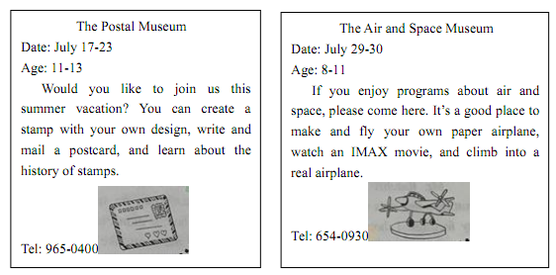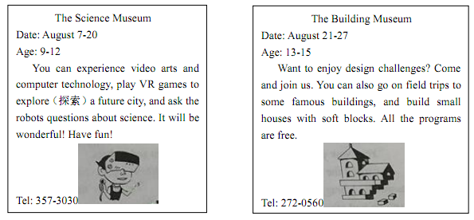
41. You can join in the programs at the Postal Museum any day _.
A. from July 17 to 23 B. from July 29-30
C. from August 7-20 D. from August 21 to 27
42. If you are interested in the program about video arts, you can phone _.
A. 965-0400 B. 654-0930 C. 357-3030 D. 272-0560
43. A 15-year-old student can take part in the programs at _.
A. the Building Museum B. the Postal Museum
C. the Air and Space Museum D. the Science Museum
44. In the Air and Space Museum, you can _.
A. create a stamp B. build a house
C. make a paper airplane D. explore a future city
B
The Sixth Time I Went to the Principal’s Office
When I was in the seventh grade, I had problems behaving. My heart was in the right place, but I
couldn’t always follow the rules. I played many tricks on my schoolmates. Once, I even pulled a girl’s hair
on the school bus to get her attention. As a result, I was repeatedly sent to the office of the principal（校长）.
Although I hated going there, I did not hate the principal, Mr. Ratcliff.
Mr. Ratcliff was a kind, elderly man. When he spanked（ 打屁股） me for putting some ants into a
classmate’s pencil box, it didn’t hurt at all, but it did hurt my feelings. I thought so much of him and
moments like that seemed to prove I was hopelessly bad.
When I got called to Mr. Ratcliff’s office for the sixth time, I had no idea what I had done. I felt
disappointed as I walked down there. I went into his office, sat down, and looked at the floor. Then he said
the last thing I expected to hear:” Kevin, I’ve heard you’ve been behaving really well lately. I want you to
know how proud I am of you, and I just called you down to my office to give you a peppermint.”
“Really?” I was surprised.
“Yes. Now you can take that peppermint and go back to class.”
I carried the peppermint with me as if it was a gold coin. When I got intomy classroom, I bragged （ 吹嘘） to my classmates about my turnaround,excitedly. I wasn’t so bad after all.
Mr. Ratcliff was really kind. He made me realize that I was just a kid who had problems with behavior.He bought some peppermints and took the time to notice me when I got something-anything-right. Mr.Ratcliff gave me some hope by giving me some love. I will just remember him for the rest of my life.
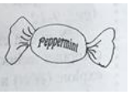
45. In his seventh grade, the writer _.
A. hated the principal B. had problems behaving
C. always followed the rules D. often helped his classmates
46. How did the writer feel when he went to the principal’s office for the sixth time?
A. Lonely. B. Excited. C. Confident. D. Disappointed.
47. The sixth time the writer went to the principal’s office, he got _.
A. a peppermint B. a model bus C. a pencil box D. a coin
48. The writer will always remember Mr. Ratcliff, because the principal _.
A. talked with him in the office B. played games with him
C. expected him to be a teacher D. gave him some hope and love
C
Buying Is Doing?
How important is shopping to you? How much time do you spend buying things? And how much time
do you spend organizing these things in your home? In the future, how much time will you spend in movie
theaters, at amusement parks, at shopping malls, or at convenience stores? When you add it all up, you will
probably see you spend a lot of your life consuming（消费）things. Consuming products is not necessarily
bad. However, if we spend too much time doing it, we should look at it carefully.
Imagine that you have a week off from school. You don’t have to go to class. However, in this week,
you cannot spend any money ----- no shopping, no movies, no eating out. How would you spend your time?
What things would bring you happiness? Perhaps you would take a walk with your best friend. Perhaps you
would help a child read. Or you might spend time with your family.
When we look back, it is likely that non-consuming experiences like these will be our most important
memories. Why? Non-consuming activities are active, not passive. They don’t come in a package. You makethe experience yourself. For example, each person who reads to a child will have a different experience. Theexperience changes with the reader, the child, and the book. Similarly, when you have a conversation with afriend, you are actively creating an experience. The conversation that you have with your friend cannot beexperienced or recreated by anyone else. However, if you watch a movie with a friend, you will each have apackage experience. It requires no action and little interaction between the two of you.
The environment we live in encourages us to have packaged experiences. We feel that we must consumebecause we believe that buying is doing. However, we can start a personal revolution （ 变革） againstconsumerism. How? By consuming less. We can ask ourselves what experiences bring us the greatestsatisfaction. Then we can organize our lives so that we have more of those kinds of experiences.
49. If consuming products takes too much time, we should .
A. spend less money B. think about it carefully
C. organize our things D. go to convenience stores
50. According to the passage, the writer believes that _.
A. we can say no to consumerism by consuming less
B. buying things can bring us the greatest satisfaction
C. the environment seldom influences our shopping choices
D. consuming experiences will be our most important memories
51. What is the writer’s main purpose in writing this passage?
A. To introduce some ways of enjoying our spare time.
B. To encourage people to have more active experiences.
C. To explain reasons behind people’s shopping behavior.
D. To share his personal experience in consuming products.
D
Say you’re sitting around with some friends playing video games and someone mentions a game that
happens to be one of your favorites. “Oh, that game’s easy. So not worth the time,” one of your friends says.The others agree. Although you enjoy the game quite a lot, not wanting to argue with them, you go alongwith the crowd.
You have just experienced what is commonly referred to as peer pressure（同伴压力）, also called peer
influence. You will adopt a certain type of behavior, dress, or attitude in order to be accepted as part of a
group of your “peers”. As a teen, you are likely to have experienced the effect of peer pressure in a number
of different areas.
We are all influenced by our peers at any age. For teens, as school and other activities take you away
from home, you may spend more time with your friends than with your family. As you become more
independent, your peers naturally play a greater role in your life.
According to Dr. Casey from Cornell University, teens are very quick and accurate in making decisions
on their own and in situations where they have time to think. However, when they make decisions in the
heat of the moment or in social situations, their decisions are often influenced by factors like peers. In a
recent study, teen volunteers played a video driving game, either alone or with friends watching. The
researchers discovered that the number of risks teens took more than doubled when their friends were
watching, compared with when they played alone. This shows that teens may find it more difficult to controlrisky behavior when their friends are around, or in situations where they are extremely angry.
Just as people can influence us to make unwise choices, they can also influence us to make good ones. Ateen might join in a volunteer project because his or her friends are doing it, or get good grades because hisor her friends think getting good grades is important. In fact, friends often encourage each other to study, ortry out for sports.
While we are always influenced by those around us, the decision to act or not is up to us. So when it
comes to decision making, the choice is up to you.
52. According to the passage, Dr. Casey probably agrees that teens .
A. like to play driving games with their friends
B. prefer situations where they have time to think
C. may take more risks when their friends are around
D. are slow in making decisions when they are on their own
53. The words “in the heat of the moment” in Paragraph 4 probably mean “”.
A. when teens avoid possible risks B. when teens trust their judgment
C. when teens lose control over their anger D. when teens give consideration to situations
54. What can we learn from the passage?
A. Teens are eager to be different from their peers.
B. Peer pressure has effects on both teens and adults.
C. Peer pressure does more harm than good to teens.
D. Tees think it challenging to get good grades at school.
55. Which of the following would be the best title for the passage?
A. Peer Pressure: Is It Necessary to Deal with It?
B. Peer Pressure: Is It Possible to Get Away from It?
C. Peer Pressure: Its Benefits to Teens and Friend Making
D. Peer Pressure: Its Influence on Teens and Decision Making
七、阅读短文，根据短文内容，从短文后的五个选项中选出能填入空白处的最佳选项。每个选项只能用一次。（共10 分，每小题2 分）
From the Other Side
Lara and Tara are twins. 56 , but they are very different in everything else. For example, hot food
is Lara’s favorite, and Tara has a sweet choice.
However, this isn’t the problem with the twin girls. They always argued that the opposite one was wrong.57 , while Tara insisted that mornings were fresh and it was difficult to stay up till midnight.
58 . To put an end to their fights, their parents decided to createa small drama. They wanted the girls to understand that they were both correct from their own point of view.Their parents covered the girls’ eyes with black ribbons, and brought them to the dining room. 59 .Lara was asked to stand on one side of the board and Tara on the other. They couldn’t see the other side of it.When the ribbons were taken away, they were surprised to see a huge board between them.
Now, their father asked Lara, “What’s the color of the board?” She replied, “It’s black!” 60.She replied, “It’s white!” The two girls began to argue again. While Lara was confident it was black, Tarawas sure it was white. Then, they were asked to exchange（交换）their places. They couldn’t believe theireyes. Tara, who insisted it was a white board, saw a black one. Similarly, Lara, who argued the board wasblack, was shocked to see a white one. They understood that each of them was right in her own view.Most of us are like Lara and Tara. We are right most times, but insist that others are wrong!
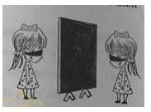
A. They look like each other
B. For years, their arguments continued
C. Their mother asked Tara the same question
D. In the room, a big board was placed in the middle
E. Lara thought it was terrible to get up early in the morning
八、阅读短文，根据短文内容回答问题。（共10 分，每小题2 分）
What’s in a Name?
Many American names come from England. But where did most English names come from?
Centuries ago, most people in England had only one name-- their first name. In the 11th century, five orsix of the 50 people in a village might be named William, and it was easy to get confused. But in the MiddleAges, people found a way to describe each person exactly. If there were four Williams in one village, onemight be referred to as William the son of John. A second might be called William from the hill. A third,William the blacksmith（铁匠）. And a fourth, William the brown haired. In conversation, people might referto the four Williams as William John’s son, William hill, William smith, and William brown.
It was 300 or 400 years before the extra （ 附加的） names gradually developed into last names, or
surnames. They were passed on from generation to generation. By the 1300s, Robert, the son of William
smith, had the name Robert smith, even if he was not a blacksmith like his father. As the last name became
widely accepted, the first letter was capitalized, as in Robert Smith. By the 15th century, most people of the
upper and middle classes had surnames.
Many surnames were based on father-son relations. The “son of” part was added to the father’s first
name, like Johnson, meaning John’s son. Sometimes it was shortened to just “s”, as in Jones or Evans.
Surnames like Hill described the place where a person lived. They are the most common type of surname. Athird kind of surname was based on a person’s job. Forester was someone who looked after the forest. In theMiddle Ages, occupation names such as Baker, Carpenter, and Miller became common. The fourth kind ofsurname was nickname（绰号）. A man whose surname was Bear might be as fierce as a bear.
Have you ever wondered why some surnames are so common? The most common surname in the
English language is Smith. Being able to make metals（金属）into tools was an important skill in the Middle
Ages, and many people were trained as blacksmiths. The most common American surnames are Smith,
Johnson, William and Brown.
61. Where do many American names come from?
62. When did people find a way to describe each person exactly?
63. How long did it take for extra names to develop into last names?
64. What is the fourth paragraph mainly about?
65. Why were many people trained blacksmith in the Middle Ages?
书面表达（共15 分）
九、文段表达（15 分）
66. 从下面两个题目中任选一题，根据中文和英文提示，完成一篇不少于50 词的文段写作。文中已给出内容不计入总词数。所给提示词语仅供选用。请不要写出你的校名和姓名。
题目①
假如你是李华，正在美国参加一个交换生项目。今天下午你应邀和朋友Jim 一家外出，请用英语给接待家庭的妈妈Mrs. Smith 写一个留言条，告诉她你们要去哪里，去做什么，以及你回家的时间和方式。
提示词语：park, movie theater, go boating, watch a movie
提示问题：Where are you going?
What are you going to do?
When and how will you get home?
Dear Mrs. Smith,
My friend Jim asks me to go out with his family this afternoon.__
Li Hua
题目②
宽容是一种美德。人与人之间难免会有磕磕绊绊。面对矛盾，多一份包容和谅解，生活就会多一缕阳光。
某英文网站正在开展以“包容、谅解”为主题的征文活动。假如你是李华，请用英语写一篇短文投稿，谈谈生活中你原谅他人的一次经历，主要内容包括：你们之间发生了什么，你为什么原谅对方，以及原谅对方之后的感受。
提示词语：hurt, realize, forgive（原谅）, happy
提示问题：What happened between you and him/her?
Why did you decide to forgive him/her?
How did you feel after forgiving him/her?
I still remember what happened between
