各位同学在查看时请点击全屏查看
2017年长治市中考英语试题
英语试题第I卷（共75分）
I. 情景反应（每小题1分，共5分）
本题共5个小题，每小题你将听到一组对话。请你从每小题所给的A、B、C三幅图片中，选出与你所听到的信息相关联的一项，并在答题卡上将该项涂黑。
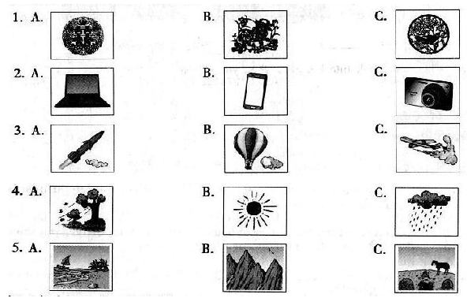
答案：1.A 2.B 3.C 4.B 5.C

II.对话理解(每小题1分，共5分)
本题共5个小题，每小题你将听到一组对话和一个问题。请你从每小题所给的A、B、C三个选项中，选出一个最佳选项，并在答题卡上将该选项涂黑。
( ) 6. A. Thursday B. Friday C. Saturday
( ) 7. A. The library B. The lab C. The playground
( ) 8. A. A policewoman B. An actress C. A doctor
( ) 9. A. A parent and a teacher B. A father and a daughter
C. A boss and a customer
( ) 10. A. She will keep a bird as a pet
B. She will get a bird and set it free
C. She will buy a bird for her father
答案：6.B 7.C 8.A 9.A 10.B [来源:Z|xx|k.Com]

III. 语篇理解(每小题1分，共5分)
本题你将听到一篇短文。请你根据短文内容和所提出的5个问题，从每小题所给的A、B、C三个选项中，选出一个最佳选项，并在答题卡上将该项涂黑。
（ ） 11. Which country was Mark born in？
A. America. B. China. C. England.
（ ） 12. When did his mom ask him to buy fish?
A. On Christmas Eve. B. On New Year’s Day. C. On Spring Festival Eve.
（ ） 13. What did he mean by saying “Xian Sheng Yu” ?
A. The fisherman’s name. B. Fresh fish. C. The name of a dish.
（ ） 14. Why did the people at the fish store laugh at him?
A. Because he told a Chinese joke.
B. Because he spoke funny Chinese.
C. Because the fisherman made fun of him.
（ ） 15. What does Mark want to tell us by sharing his story?
A. We needn’t care about what others think of us.
B. It is important to speak more than one language.
C. Nobody is supposed to forget his own traditional culture.
IV. 听力填空（每小题 1 分，共 5 分）
本题你将听到一篇短文。请你根据所听内容，完成下面的表格，并将获取的信息填写到答题卡相应的位置上。每空一词。
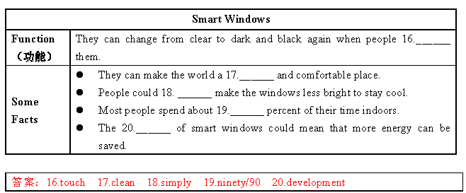
IV. 单项选择（每小题 1 分，满分 10 分）
请你从每小题所给的 A、 B、 C 三个选项中，选出可以填入空白处的最佳选项，并在答题卡上将该项涂黑。
( ) 21. Believe in ___ is a very important rule for you to get along well with others.
A. myself B. himself C. yourself
答案： C
( ) 22. You should look into his eyes when you talk to somebody. It shows your ___.
A. shyness B. politeness C. quietness
答案：B。
( ) 23. Skimming is a kind of reading strategy. It means reading an article ___ to find the main idea without reading every word.
A. quickly B. carefully C. clearly
答案： A。
( ) 24. Our teachers have been with us for nearly three years ___ we came to junior high school. We should thank them for what they have done for us.
A. until B. before C. since
答案： C。 [来源:学*科*网Z*X*X*K]
( ) 25. If your best friend tells you his secret, it’s ___ for you to keep them for him. By doing this, you can win others’ trust.
A. special B. necessary C. possible
答案：B。
( ) 26. When you’re invited to have dinner at home by an American friend, you should be ___ or a little later. It’s different from our Chinese custom.
A. on time B. on business C. on show
答案：A。
( ) 27. No matter what problems we meet, we should try to solve them, and even though we fail, teachers and parents
___ us.
A. are strict with B. are worried about C. are proud of
答案： C。
( ) 28. When going upstairs or downstairs, we need to walk on the right, leaving the left space for the people who ___.
A. hurry up B. look around C. run away
答案： A。
( ) 29. Miss Li, ___, is active all the time. Although she has not been well these days, her class is still full of laughter.
A. as you know B. all in all C. to start with[来源:.Com]
答案：A。
( ) 30. — After we enter the high school, we will have the courses about life management. We can choose what we like. I wonder ___.
—Physics. I want to study science in the future.
A. what choosing courses is for
B. what courses you want to take
C. what you think of choosing coursed.
答案：B。
VI. 补全对话（每小题 1 分，共 5 分）
根据对话内容，从对话后方框内的选项中选出能填入空白处的最佳选项，使对话意思完整，并在答题卡上将该
项涂黑。选项中有两项为多余项。
（ At break, Amy meets Ken in the hallway）
Amy: Hi, Ken. Jane’s birthday is coming. Have you received her invitation?
Ken: Yes. ___31___
Amy: Me too. I’m just thinking about the gift. ___32___
Ken: Well, she likes writing. Why not get her pens and books?
Amy: ___33___ I think she’ll be happy to get them.
Ken: Yeah. By the way, how will you buy the gift? Will you ask your parents for money?
Amy: ___34___ I’ve already saved my pocket money.
Ken: You’re right. I think we should learn to manage pocket money. I just spend it on the things I really need.
Amy: That’s true. ___35___
Ken: What a kind girl! Learning to save and use money are both important to us.
31. _______ 32. _______ 33. _______ 34. _______ 35. _______
A. Yes, please.
B. Sounds good.
C. Of course not.
D. How about you?
E. Can you come to my party?
F. Have you got any good ideas?
G. I also use it to help others in need.
答案：
31. D 32. F 33. B 34. C 35. G
VII. 完形填空（每小题1分，共10分）
阅读下列短文，掌握其大意，然后从每小题所给的A、 B、 C三个选项中，选出一个最佳选项，并在答题卡上将
该项涂黑。
Maxime and Lise are a young French couple. They are ready to travel across China from Beijing to Yunnan Province on a tandem bicycle (双人自行车). They have two main purposes and one of them is that they want to encourage green ___36___ through it.
Maxime, 26, works helping farmers raise their cows, ___37___ his wife Lise, 26, is a teacher. The two also like sharing their travel stories on Facebook.
“We choose a tandem bicycle because it makes it ___38___ to communicate with each other about interesting people and things we come across during the journey. ___39___, bicycling is healthier. And it’s a cheaper and more environment-friendly way of traveling than ___40___ cars, motors and so on,” the couple said.
As for the other ___41___ of their journey, the two said they wanted to get people’s good ideas on topics such as health,economy (经济) and politics. When they were asked ___42___ they chose to visit China, they said it was because they often talked about its long history and beauty and how much of the country is competitive (有竞争力的) in the world.
“We know China is a country with a large population and will be the ___43___ of the economy around the world in the future. We want to get a better understanding of the country and its people. We ___44___ the country,” they said.
The couple will be on their journey to China soon. We hope they can make more people further ___45___ China by sharing what they see and hear on the way. Meanwhile, we hope they enjoy their travel in China.
( ) 36. A. food B. farming C. travel
( ) 37. A. while B. though C. because
( ) 38. A. busier B. easier C. earlier
( ) 39. A. Besides B. Instead C. However
( ) 40. A. buying B. using C. making
( ) 41. A. order B. result C. purpose
( ) 42. A. how B. why C. when
( ) 43. A. leader B. player C. learner
( ) 44. A. need B. miss C. love[来源:学科网]
( ) 45. A. dream about B. hear about C. know about

答案：
36. C 37. A 38. B 39. A 40. B
41. C 42. B 43. A 44. C 45. C
VIII. 阅读理解（一）（每小题 2 分，共 30 分）
（ A）
请阅读下列五个故事简介，将其与上面书橱中陈列的书籍相匹配，并在答题卡上将对应的选项涂黑。其中有一项为多余选项。
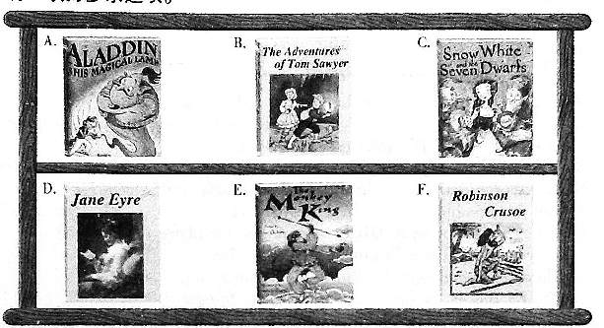
46. Every day the bad Queen asks her mirror: “Mirror, Mirror, on the wall, who’s the most beautiful of us all?” And every day the mirror replies, “You are!”…until one day it says, “The Princess!” So the Queen is so angry that she decides to kill the Princess who has skin as white as snow. She doesn’t expect the girl to find not one but seven tiny men.
47. Finally, the man gets to a lonely island. Luckily, he gets some tools, food and drinks, knives and guns from the broken ship he took. Later, he finds a cave (山洞) to live in. But one day, he finds some large footprints in the sand. Is there anyone else on the land? Who is running towards his cave?
48. Without parents, the girl is taken to a boarding school. Though she has a hard time there, she gets education and later becomes a teacher. However, she gets so bored with her life that she is thirsty for the outside world. So she sends an ad for a job. Will she get a reply? Will she get everything she fights for—freedom, fairness and true love?
49. When the young man meets his long-lost uncle, he finds a magic lamp that changes his life. Inside is a genie(精灵) with the power to make wishes come true. But can even the genie help the young man win the beautiful young girl? And is his long-lost uncle all he seems…?
50. Here is the boy who is like you in some ways. He thinks school life is boring and looks forward to something exciting. One day, he enters a cave with his friend. They walk deeper and deeper into the cave. Unluckily, their candle is put ou and they get lost in the dark. Can they get out of the cave? With other exciting things will they experience?

答案：
（ B）
请阅读下面短文，从每小题所给的 A、 B、 C 三个选项中，选出一个最佳选项，并在答题卡上将该项涂黑。
High-speed trains, Alipay（ 支付宝） , shared bikes and online payment are seen as the new Four Great Achievements of China by young foreigners, according to a video survey by the Silk Road Research Institute of Beijing Foreign Studies University. In the video, young people from 20 countries along Belt and Road Routes （ 一带一路） were asked to name great inventions that had influenced their lives in China. The following is what they said from 4 young people of them.
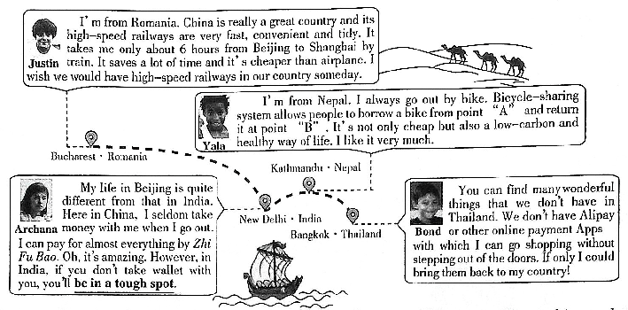
( ) 51. What does Justin think of the high-speed railways in China according to his words?
A. Fast and tidy.
B. Convenient and wonderful.
C. Cheap and amazing.
( ) 52. What do “A” and “B” refer to (指) inYala’s words ?
A. Two bikes. B. Two riders. C. Two places.
( ) 53.What does the underlined phrase “be in a tough spot” mean?
A. Get into trouble. B. Lose your way. C. Stay in silence.
( ) 54. Which of the following is TRUE according to the above information?
A. Bicycle-sharing system provides bikes for free.
B. There’re no high-speed railways in Romania now.
C. Zhi Fu Bao is the only way of paying for things.
( ) 55. What conclusion（ 结论） can we draw about the new four great achievements?
A. They were created by young foreign people.[来源:.Com]
B. They are the signs that China is improving rapidly.
C. They were brought to the countries along Belt and Road Routes.

答案：
51.A 52. C 53.A 54. B 55. B
（ C）
阅读下面短文，根据短文内容，从方框内所给的选项中选出能填入空白处的最佳选项，使短文意思通顺，并在
答题卡上将选项涂黑。选项中有一项为多余项。
What is life’s greatest gift? It is choice. Choice is the ability to choose some actions from a set of things to achieve a goal. ___56___ The reason is that it turns us from dumb animals into artists. Choice becomes the tool we use to sculpt （ 雕刻） our life. The tool doesn’t come free, however, for the price of choice is responsibility. ___57___ it is enjoyment.
Choice is power. Choice is at the heart of life. It’s the creative power of life. Life is always changing and we have to make lots of choices. ___58___ We often need to check where we are on our journey. We need to ask questions: Am I moving closer to my goals? If not, what action will I take now to make myself realize my goals?
___59___ And our life becomes more convenient or comfortable because of them. For example, you decide which stores to shop at and which bus station to go on. But the decisions that we make to sculpt our lives are much more important than deciding where to shop. The more we understand the difference between small and big decisions, the more pleasure we will get.
Life is like a chess game. ___60___ All chess lovers realize that it isn’t necessary to win to enjoy the game. Make the
best moves you can under the conditions. Then you can enjoy your life.
A. Why is choice so great?
B. The pleasure is in the playing.
C. In fact, we have to make choices every day.
D. But when we accept and carry it out, we get a great return.
E. Because making right choices is more important than working hard.
F. Every choice we make leads us closer to or farther from our goals.
答案：
第 II 卷 （共 45 分）
IX. 阅读理解（二）（每小题 2 分，共 20 分）
(A)
请阅读下面短文，根据短文内容，在下面的表格中填入与文章意思最符合的单词，并将答案写在答题卡相应的位置上。每空一词。
Do you ever feel like you are just rushing from one subject to another? When things happen so fast, maybe you can’t understand clearly what you are doing or learning, so it is important to stop yourself to think about what you have been doing or learning.
Self-reflection（ 反省） means slowing down and calming（ 使平静） yourself, including calming your mind. By calming down and going slowly, you give your brain a chance to think about what it has already received. Some people prefer to do self-reflection only in their mind. Others keep a diary. What’s more, taking notes is also OK. Each method works, depending on your own personal learning. You can follow the steps to do so self-reflection.
First, choose the proper time to do it. School textbooks are divided into units of study. This makes it easier to begin self-reflection. Look for time when you complete a unit of study. Sometimes you know the unit is over because there is some kind of test. Use these natural breaks to stop and do self-reflection.
Then, find a quiet place and take out your reflection diary. Write down some notes on the new things that you learned in the unit. Let your mind think about the notes you have written and make some connections.
Finally, think about things that you are not sure of. Maybe you learned a new way to work out a math problem, but you’re not sure when to use it. Writing down your questions will help you remember to look for answers the next time you are working with the same topic.
Successful students always know self-reflection is important. If you have never taken the time to do self-reflection, try it now.
Self-reflection Makes You a Better Learner
Introduction |  It means slowing down and making yourself clam.   You can think about what you have learned by calming down and going ___61___.   You can do it only in your mind, and you can also keep a diary or ___62___ notes to do it.
How to do it |  It’s a proper time to start it ___63___ a unit is over.   Write down and think about what you have learned in the unit and make some connections.   Write down your questions about something you’re not sure of. It’s ___64___ to work with the  same topic the next time.
Conclusion | Successful students always know the ___65___ of self-reflection. Try it now!

答案：
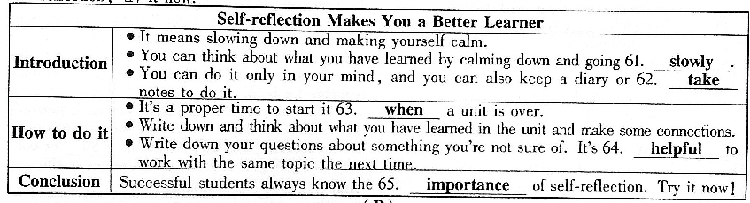

（ B）
阅读下面图文，简要回答所给问题，并将答案写在答题卡相应的位置上。
Living in the age of “Internet”, more and more electronic products and Apps have changed people’s lifestyles in many ways , such as reading habits and sports events.
Electronic Reading
Instead of reading paper books, more people like to use electronic devices (设备) to read in China now. The reading time spent on them is getting longer. ChartⅠshows different reading time from a survey. However, even though people spend much time on e-books, the traditional paper books are still popular among readers. Research has shown that readers remember more information from paper books than e-books. To our great joy, the number of books that each person read in
2016 in China reached 7.86, which increased a lot more than before.
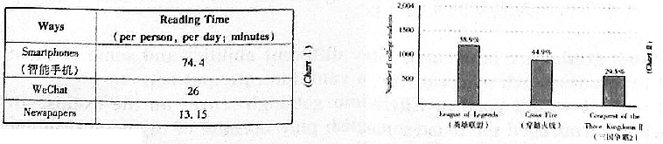
Electronic Sports
Just like soccer, basketball and baseball, e-sports has become very popular around the world. E-sports is short for electronic sports. It is more than just children playing games in their bedrooms. In e-sports, teams of gamers play electronic games in front of many people and compete. And they need to put in a lot of hard work and training. ChartⅡshows the top three most followed e-sports among Chinese college students from a survey last year.
Actually, e-products play an important role in our daily life. They have not only changed our life but also made the world colorful. One coin has its two sides. As teenagers, if we put the e-products into good use, they can add more fun to our life and become good helpers to our study.
66. According to the passage, why are the paper books still popular among readers?
____________________________________________________________________________
67. ChartⅠshows the reading time on WeChat is more than that on newspapers. How much more time?
____________________________________________________________________________
68. Do you like reading paper books or electronic books? Why?
____________________________________________________________________________
69. We can draw a conclusion that many young people want to be a hero in their mind from ChartⅡ. How can you know it?
____________________________________________________________________________
70. In the age of “Internet ” , what influence do you think the e-products have on us?
____________________________________________________________________________
解析：
66. Because readers remember more information from paper books than e-books 根据文章第二段倒数两句可得答案。
67. (It’s) 12.85 minutes.从表 1 可看出答案。
68. Paper books. Because they are better for my eyes than e-books. / E-books. Because they are convenient. / ...结合文章 合理作答。
69. The chart shows the top three e-sports among college students are all about heroes. / Because 58.9% of college students play the League of Legends. / ... 从表二可看出答案。
70. They have not only changed our life but also made the world colorful. / They have provided more ways to get information. / ... 结合自身实际合理作答即可。

X. 词语运用（每小题 1 分，共 10 分）
根据语篇内容，用方框中所给词的正确形式填空，使短文通顺、 正确、 连贯，并将答案填写到答题卡相应的位置上。方框中有两个词为多余项。
by who life take that serious or one they send happy influence
once had an unforgettable experience that has affected and directed the way I think and act now.
When I was about seven years old, my grandfather 71._______ me to a fish pond on a farm and told me to throw a stone into the water. He told me to watch the circles created 72.______ the stone. Then he asked to think of myself at that stone. “You may create lots of circles in your life, but the waves 73. ______ come from those circles will disturb(干扰) the peace of all the people around you,” he said 74.______. “Remember that your circle may spread to many other circles, meaning that your thoughts or actions may disturb others’ 75.______. You are responsible for what put in your circle. If you want, the good or peace that comes from your circle 76.______ to others. At the same time, the anger or jealousy (嫉妒) coming from your circle will also spread to other circles. You should allow the good feelings 77._______ others, not the bad ones, because you are responsible for both.”
That was the 78.______ time I heard my grandfather tell me these. I had realized that each person’s 79.______ or anger can move out into the world. If we are filled with doubt or anger, we cannot create world peace. We spread the feelings and thoughts that we hold inside, whether we speak 80.______ or not. These circles are spreading into the world, creating beauty or making troubles to other circles of life.
答案：
XI. 书面表达（共 15 分） 请将短文写在答题卡相应的位置上。
在我们成长的过程中，有过各种各样的经历，其中，“考试”也是一种经历，“成绩”更是一直“伴随”着我们。为使同学们学会客观、理性地看待问题，九年级三班以“考试成绩重要吗，它是否等同于实际能力？”为题展开了辩论。
假设你是正方或反方的一员（ 只需选择一方），请围绕你的观点，结合亲身经历来说服同学们。
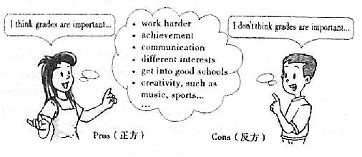
要求： 1. 词数不少于 80 词；
2. 提示词正、反方均可使用，仅供参考；
3. 文中不得出现真实的人名、校名。
Pros（正方） Cons（反方）
__________________________________________________________________________________
__________________________________________________________________________________
____________________________________________________________________________________________________________________________________________________________________
__________________________________________________________________________________
__________________________________________________________
A possible version:
I don’t think grades are important. Students have different abilities and some of them can’t be measured by grades, such as creativity, abilities to communicate and act.
To start with, I wasn’t good at English and seldom got high scores on the exams. But one day, my teacher encouraged me to perform in an English play because of my good pronunciation and lively expressions. To perform well, I studied my lines many times and even dressed up like the character. While we were performing, I could hear my classmates cheering. How excited! Later, my teacher praised me for my wonderful acting and this made me more confident and interested in English.
All in all, grades can be a way to measure students’ achievements in schoolwork. However, different interests and abilities can make a student a full man.

